UNITED STATES

SECURITIES AND EXCHANGE COMMISSION

Washington, D.C. 20549

FORM 6-K

REPORT OF FOREIGN PRIVATE ISSUER PURSUANT TO RULE 13a-16 OR 15d-16 UNDER THE SECURITIES EXCHANGE ACT OF 1934

For the month of May 2026

Commission file number: 001-37891

AC IMMUNE SA

(Exact Name of Registrant as Specified in Its Charter)

EPFL Innovation Park

Building B

1015 Lausanne, Switzerland

(Address of Principal Executive Offices)

Indicate by check mark whether the registrant files or will file annual reports under cover of Form 20-F or Form 40-F.

Form 20-F ☒ Form 40-F ☐

INFORMATION CONTAINED IN THIS REPORT ON FORM 6-K

Annual General Meeting

On May 15, 2026, AC Immune SA (the “Company”) published its Annual General Meeting (“AGM”) Invitation and General Meeting Proxy Card for the 2026 AGM to be held on June 11, 2026.

A copy of the AGM Invitation and General Meeting Proxy Cards are attached as Exhibits 99.1, 99.2 and 99.3 to this Report on Form 6-K.

Martin Zügel Appointed Interim CEO

As previously announced, at the Company’s next AGM to be held on June 11, 2026, Dr. Andrea Pfeifer has decided to retire from her role as Chief Executive Officer (“CEO”) after 23 years at the Company. The Board of Directors (the “Board”) has appointed the Chair, Dr. Martin Zügel, to serve as Interim CEO while the ongoing search for a permanent successor continues. Dr. Zügel has served as Chair of the Board since 2025, a position which will not change as a result of his appointment as Interim CEO. As a consequence of his appointment as Interim CEO of the Company, Dr. Zügel resigned from his position as member of each of the Audit & Finance Committee (the “AFC”) and the Compensation, Nomination & Corporate Governance Committee (the “CNC”). For Dr. Zügel’s full bio, see the Company’s Annual Report on Form 20-F filed with the SEC on March 13, 2026, under the heading “Item 6. Directors, Senior Management and Employees”.

Monika Bütler Appointed Lead Independent Director

Concurrently with the appointment of Dr. Zügel as Interim CEO, the Board appointed Dr. Monika Bütler as Lead Independent Director to ensure appropriate governance oversight. Further information regarding the role and responsibilities of the Lead Independent Director can be found in the AGM invitation. For Dr. Bütler’s full bio, see the Company’s Annual Report on Form 20-F filed with the SEC on March 13, 2026, under the heading “Item 6. Directors, Senior Management and Employees”.

Carl June Appointed Member of the Audit & Finance Committee

While the CNC may operate with a minimum of two members, the AFC needs to consist of a minimum of three members. The Board has therefore appointed Dr. Carl June as member of the AFC effective May 12, 2026. The AFC will therefore be composed of Dr. June, Renée Aguiar-Lucander and Dr. Bütler. For Dr. June’s full bio, see the Company’s Annual Report on Form 20-F filed with the SEC on March 13, 2026, under the heading “Item 6. Directors, Senior Management and Employees”.

 |  |  |  |  |  |  | EXHIBIT INDEX
Exhibit
Number |  |  |  |  |  |  |  | Description
 | 99.1* |  |  |  | Invitation to the Ordinary Shareholders’ Meeting
 | 99.2* |  | 2026 |  |  | Annual General Meeting Proxy Card (Common Share Record Holders)
 | 99.3* |  | 2026 |  |  | Annual General Meeting Proxy Card (Brokers)
 | 99.4 |  |  | Consolidated Financial Statements (IFRS) as at and for the years ended December 31, 2025, 2024 and 2023 (incorporated by reference to
 |  |  |  | Item 18 of Part III of AC Immune’s Annual Report on Form 20-F for the fiscal year ended December 31, 2025 filed on March 13, 2026)
99.5 |  |  | 2025 |  |  | Annual Report (incorporated by reference to Exhibit 99.2 to the AC Immune Report of Foreign Private Issuer on Form 6-K filed on

March 13, 2026)

*Filed herewith.

SIGNATURE

Pursuant to the requirements of the Securities Exchange Act of 1934, the registrant has duly caused this report to be signed on its behalf by the undersigned, thereunto duly authorized.

AC IMMUNE SA

By: /s/ Andrea Pfeifer

Name: Andrea Pfeifer

Title: Chief Executive Officer

By: /s/ Christopher Roberts

Name: Christopher Roberts

Title: Chief Financial Officer

Date: May 15, 2026

Exhibit 99.1




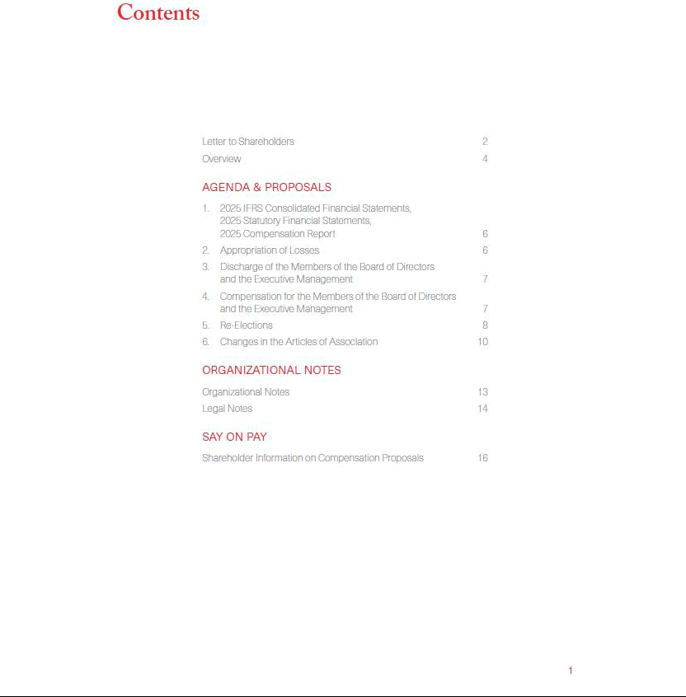

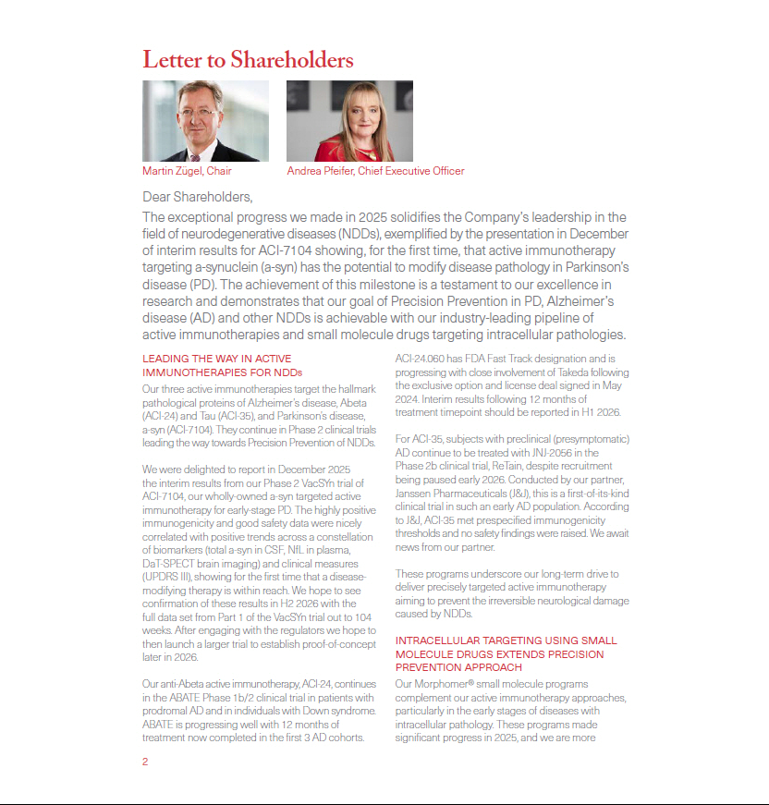

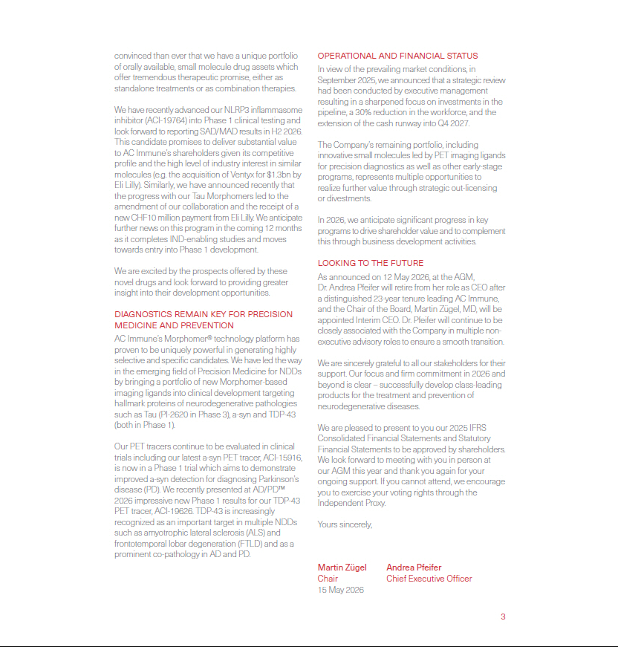

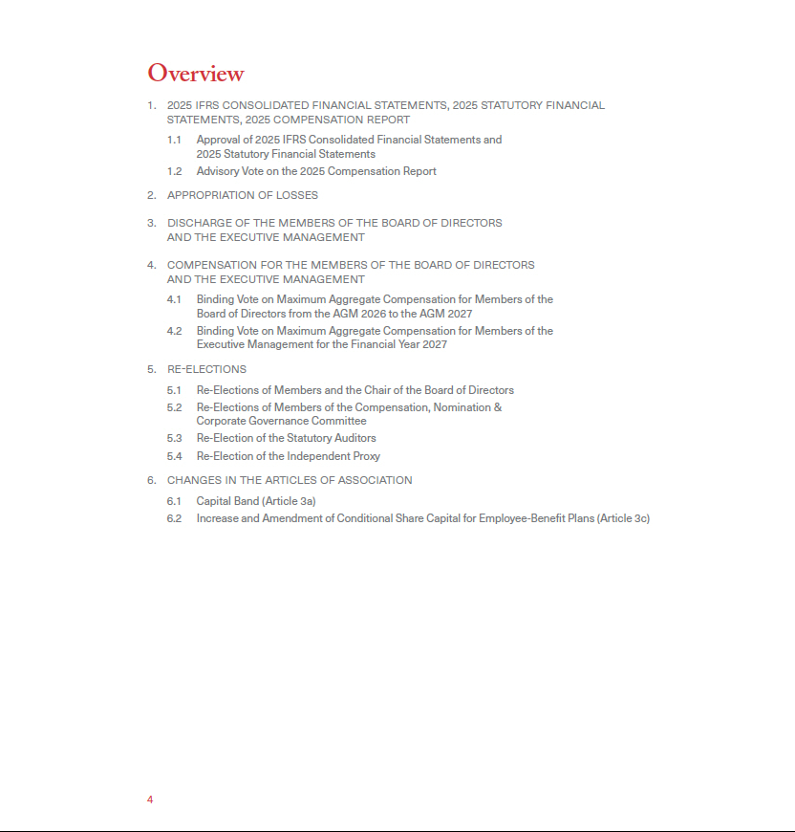



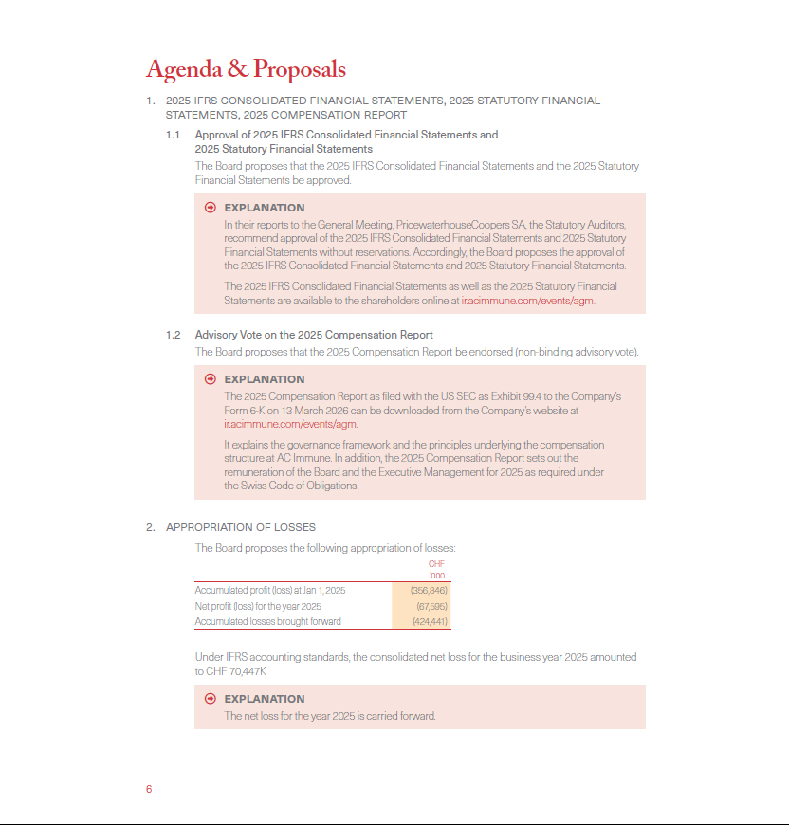

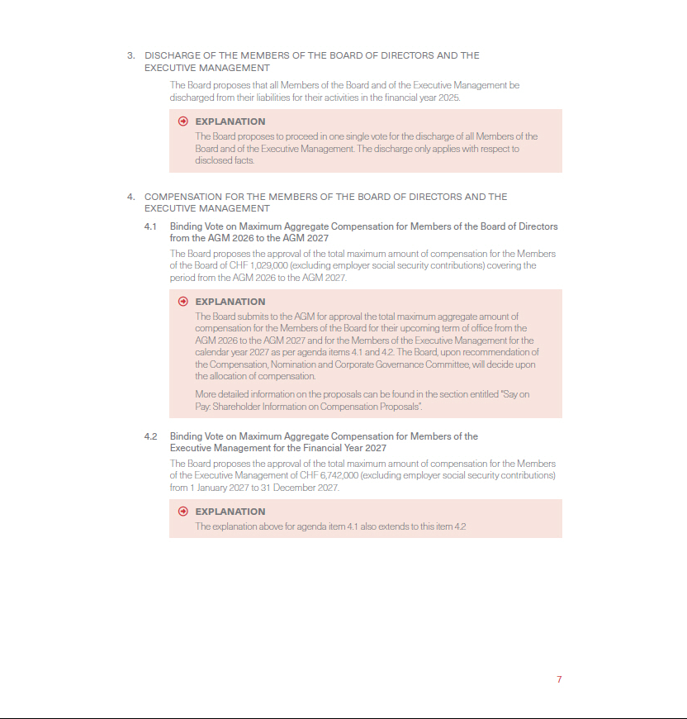

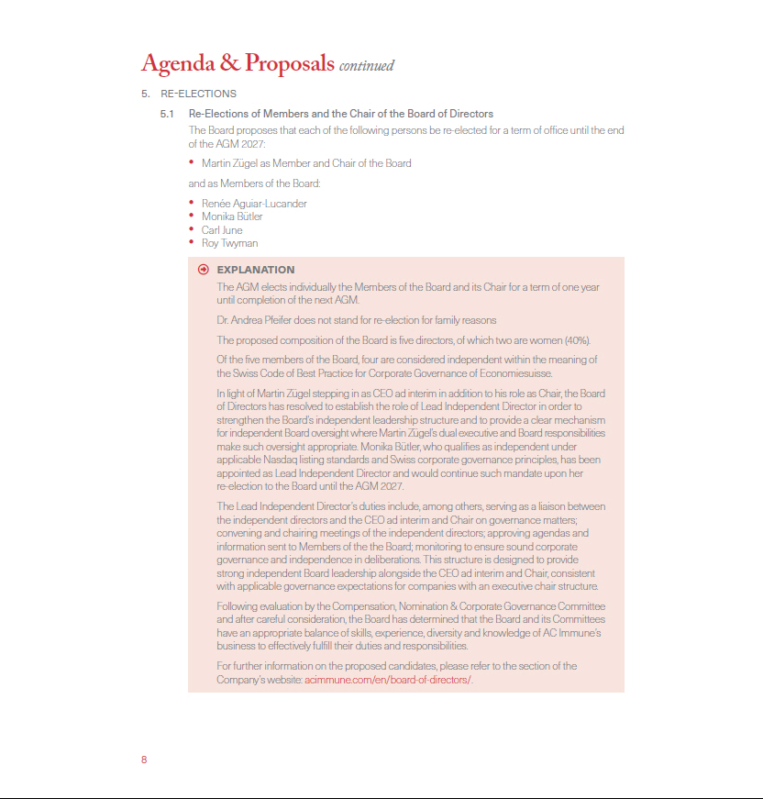

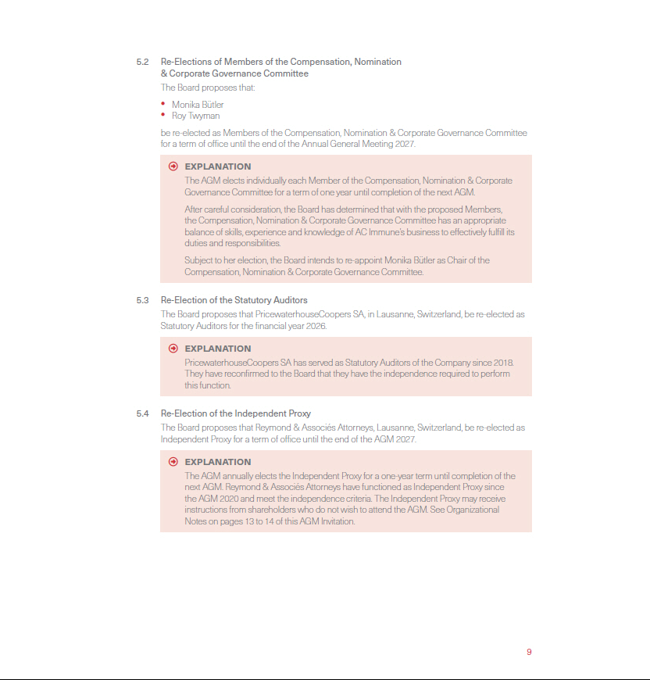

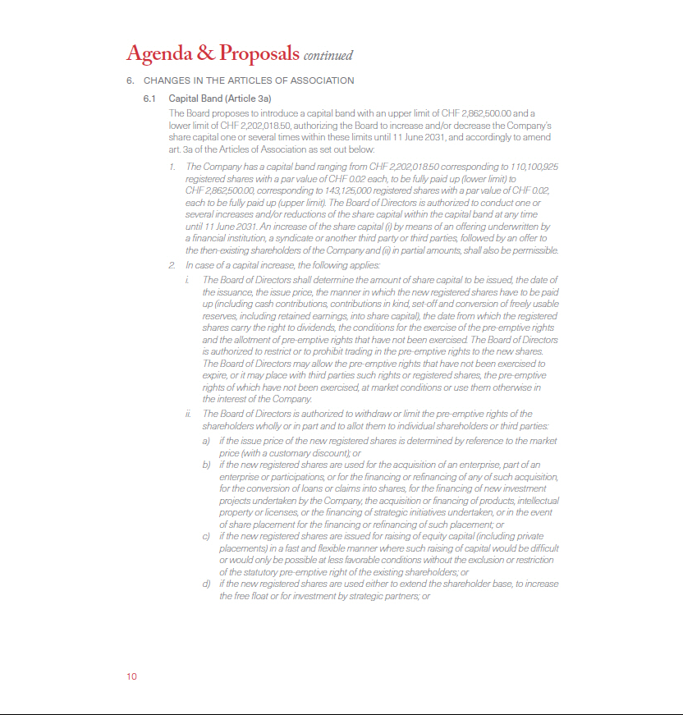

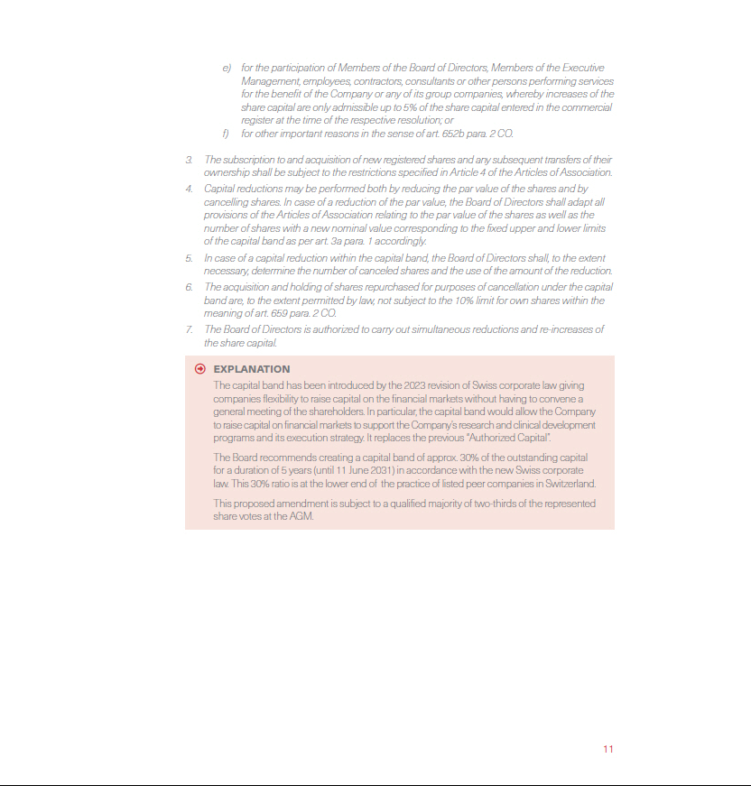

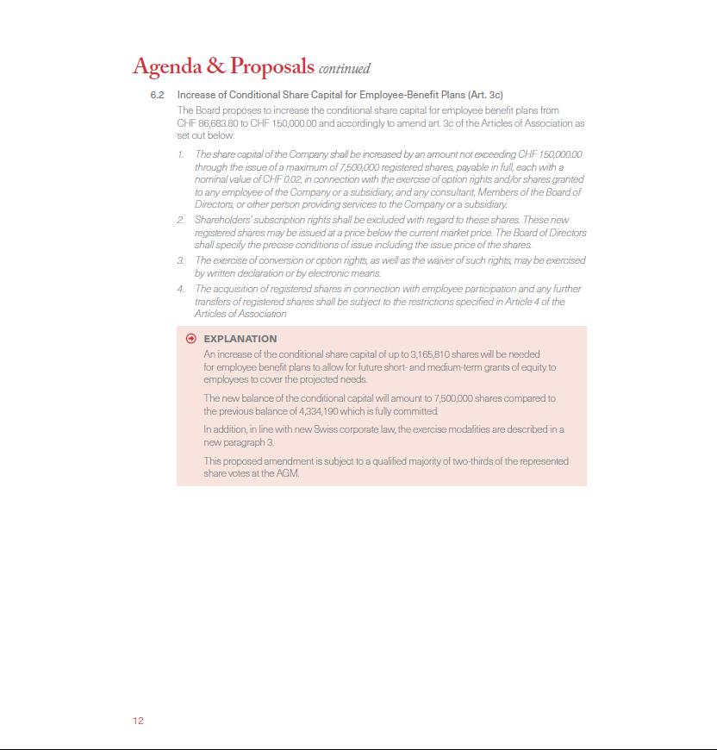

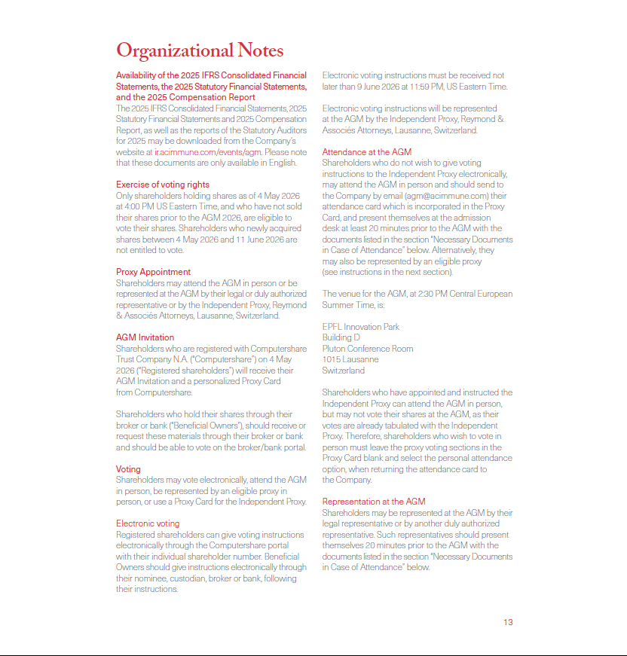

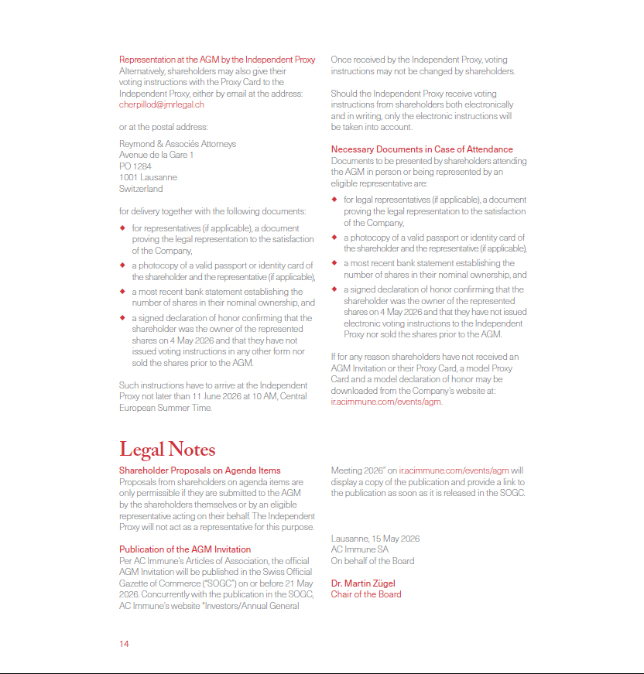



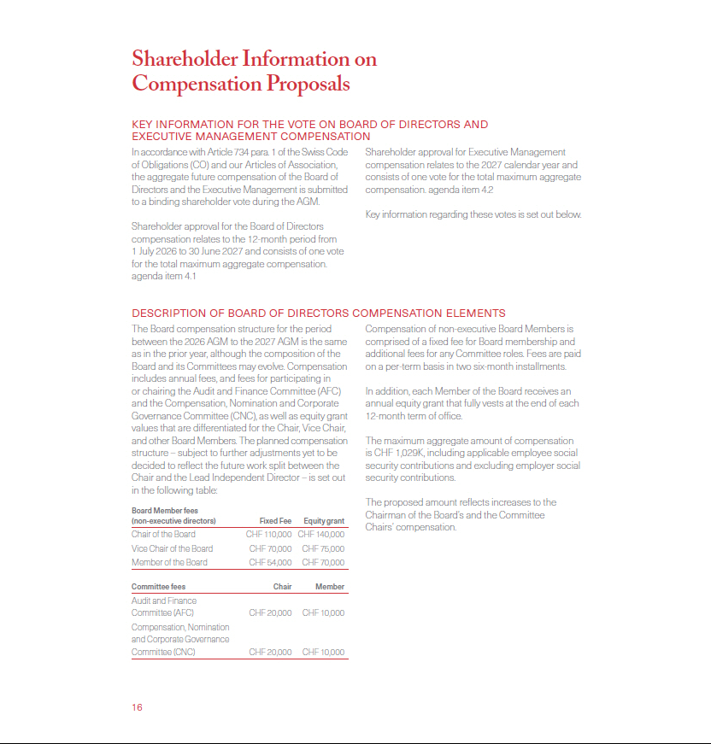

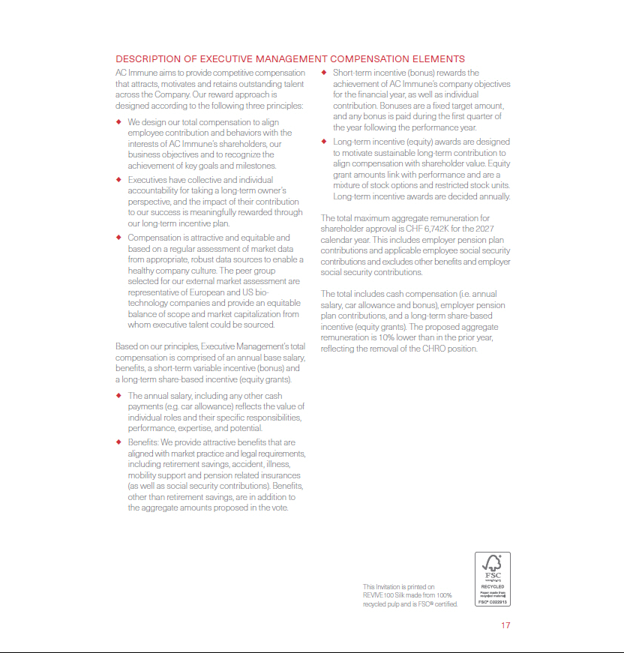

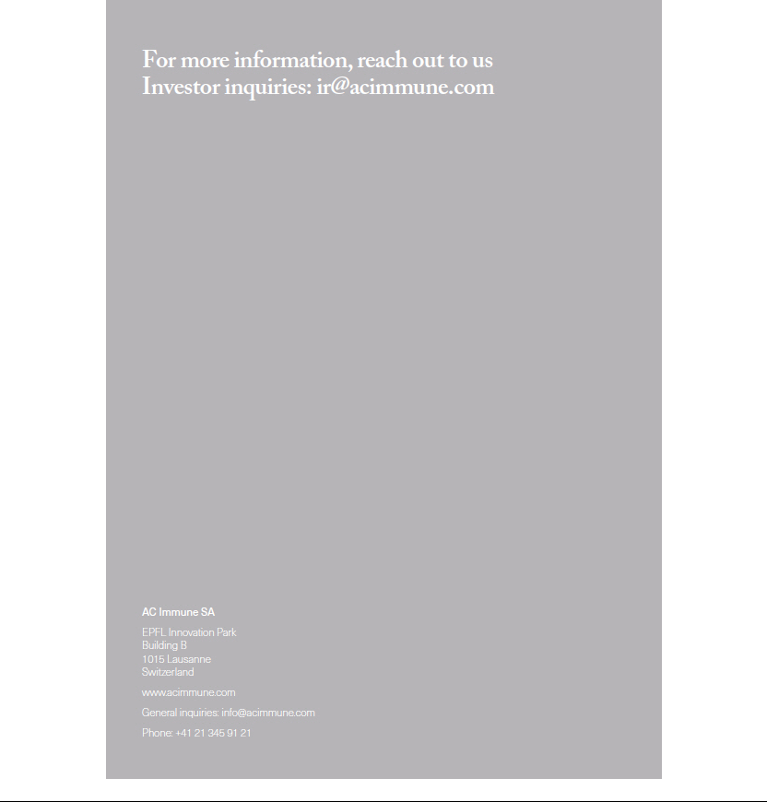

Exhibit 99.2
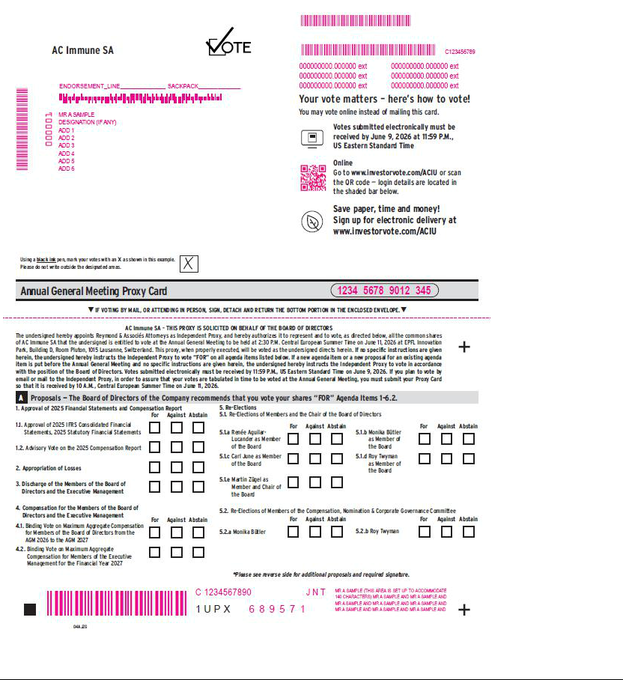

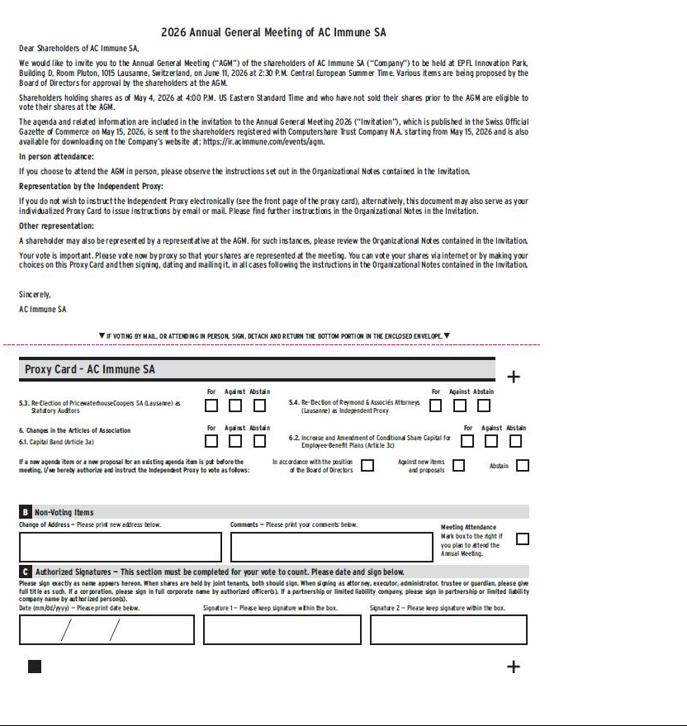

Exhibit 99.3


