​
​
UNITED STATES
SECURITIES AND EXCHANGE COMMISSION
Washington, D.C. 20549
​
FORM 6-K
​
REPORT OF FOREIGN PRIVATE ISSUER PURSUANT TO RULE 13a-16 OR 15d-16 UNDER THE SECURITIES EXCHANGE ACT OF 1934
​
For the month of August, 2026
​
Commission file number: 001-37891
​
AC IMMUNE SA
(Exact Name of Registrant as Specified in Its Charter)
​
EPFL Innovation Park
Building B
1015 Lausanne, Switzerland
(Address of Principal Executive Offices)
​
Indicate by check mark whether the registrant files or will file annual reports under cover of Form 20-F or Form 40-F.
​
Form 20-F ☒ Form 40-F ☐
​
​
​
​

​
This Report on Form 6-K (excluding Exhibit 99.3 herewith) shall be deemed to be incorporated by reference into the registration statements on Form F-3 (File Nos. 333-227016, 333-249655 and 333-277940) and Form S-8 (File Nos. 333-213865, 333-216539 and 333-233019) of AC Immune SA and to be a part thereof from the date on which this report is filed, to the extent not superseded by documents or reports subsequently filed or furnished.
​
​

​
SIGNATURE
Pursuant to the requirements of the Securities Exchange Act of 1934, the registrant has duly caused this report to be signed on its behalf by the undersigned, thereunto duly authorized.
​
​ | ​ | ​
​ | AC IMMUNE SA
​ | ​
​ | By: | /s/ Martin Zuegel
​ | ​ | Name: Martin Zuegel
​ | ​ | Title: Interim Chief Executive Officer
​ | ​ | ​
​ | ​ | ​
​ | By: | /s/ Christopher Roberts
​ | ​ | Name: Christopher Roberts
​ | ​ | Title: Chief Financial Officer
​ | ​ | ​
Date: August 5, 2026 | ​ | ​
​
​
​

​
EXHIBIT INDEX
​
​ | ​ | ​
Exhibit  Number | ​ ​ ​ | Description
99.1 | ​ | Interim Condensed Consolidated Financial Statements (Unaudited) (IFRS) as of and for the six months ended June 30, 2026
99.2 | ​ | Management’s Discussion and Analysis of Financial Condition and Results of Operations
99.3 | ​ | Press Release dated August 5, 2026
99.4 | ​ | Articles of Association of AC Immune SA
​
​

Exhibit 99.1
Condensed Consolidated Balance Sheets (Unaudited)
(In CHF thousands)

​ | ​ | ​ | ​ | ​ | ​ | ​
​ | ​ | ​ | ​ | As of
​ | ​ | ​ | ​ | June 30, | ​ | December 31,
​ | ​ ​ ​ | Note | ​ ​ ​ | 2026 | ​ ​ ​ | 2025
Assets |  | ​ |  | ​ |  | ​
Non-current assets |  | ​ |  | ​ |  | ​
Property, plant and equipment |  | 5 |  | 1,919 |  | 1,989
Right-of-use assets |  | 6 |  | 4,080 |  | 4,540
Intangible asset |  | 8 |  | 50,416 |  | 50,416
Long-term financial assets |  | 6 |  | 585 |  | 584
Total non-current assets | ​ | ​ |  | 57,000 |  | 57,529
​ | ​ | ​ | ​ | ​ | ​ | ​
Current assets | ​ | ​ |  | ​ |  | ​
Prepaid expenses |  | 9 |  | 4,399 |  | 3,972
Accrued income |  | ​ |  | 209 |  | 360
Other current receivables |  | 3.2 |  | 3,514 |  | 978
Accounts receivable | ​ | 3.1 | ​ | 9,922 | ​ | —
Short-term financial assets |  | 10 |  | 47,600 |  | 64,617
Cash and cash equivalents |  | 10 |  | 27,757 |  | 26,795
Total current assets | ​ | ​ |  | 93,401 |  | 96,722
Total assets | ​ | ​ |  | 150,401 |  | 154,251
​ | ​ | ​ | ​ | ​ | ​ | ​
Shareholders' equity and liabilities | ​ | ​ |  | ​ |  | ​
​ | ​ | ​ | ​ | ​ | ​ | ​
Shareholders’ equity | ​ | ​ |  | ​ |  | ​
Share capital |  | ​ |  | 2,263 |  | 2,253
Share premium |  | ​ |  | 483,550 |  | 481,863
Treasury shares |  | 11 |  | (213) |  | (218)
Currency translation differences | ​ | ​ | ​ | 9 | ​ | 7
Accumulated losses | ​ | ​ |  | (450,440) |  | (439,021)
Total shareholders’ equity | ​ | ​ |  | 35,169 |  | 44,884
​ | ​ | ​ | ​ | ​ | ​ | ​
Non-current liabilities | ​ | ​ |  | ​ |  | ​
Long-term deferred income | ​ | 3.2 | ​ | 1,830 | ​ | —
Long-term deferred contract revenue | ​ | 3.1 | ​ | 806 | ​ | 2,339
Long-term lease liabilities |  | 6 |  | 3,267 |  | 3,689
Net employee defined benefit liabilities |  | ​ |  | 9,090 |  | 8,646
Total non-current liabilities | ​ | ​ |  | 14,993 |  | 14,674
​ | ​ | ​ | ​ | ​ | ​ | ​
Current liabilities | ​ | ​ |  | ​ |  | ​
Trade and other payables |  | ​ |  | 1,513 |  | 2,068
Accrued expenses |  | 7 |  | 7,122 |  | 8,067
Short-term deferred income | ​ | 3.2 | ​ | 1,292 | ​ | —
Short-term deferred contract revenue | ​ | 3.1 | ​ | 89,477 | ​ | 83,706
Short-term lease liabilities |  | 6 |  | 835 |  | 852
Total current liabilities | ​ | ​ |  | 100,239 |  | 94,693
Total liabilities | ​ | ​ |  | 115,232 |  | 109,367
Total shareholders’ equity and liabilities | ​ | ​ |  | 150,401 |  | 154,251
​
The accompanying notes are an integral part of these Interim Condensed Consolidated Financial Statements (Unaudited).
​
​
Condensed Consolidated Statements of Income/(Loss) (Unaudited)
(In CHF thousands except for per share data)

​ | ​ | ​ | ​ | ​ | ​ | ​ | ​
​ | ​ | ​ | ​ | For the Six Months |  |  | ​
​ | ​ | ​ | ​ | Ended June 30, |  |  | ​
​ | ​ | Note | ​ | 2026 | ​ | 2025 | ​
Revenue | ​ ​ ​ | ​ | ​ ​ ​ | ​ | ​ ​ ​ | ​ | ​ ​ ​
Contract revenue |  | 3 |  | 16,232 |  | 2,296
Total revenue | ​ | ​ |  | 16,232 |  | 2,296 | ​
​ | ​ | ​ |  | ​ |  | ​ | ​
Operating expenses | ​ | ​ |  | ​ |  | ​ | ​
Research & development expenses |  | ​ |  | (22,220) |  | (32,742)
General & administrative expenses |  | ​ |  | (7,714) |  | (8,334)
Other operating income/(expense), net |  | ​ |  | 107 |  | 21
Total operating expenses | ​ | ​ |  | (29,827) |  | (41,055) | ​
Operating loss | ​ | ​ |  | (13,595) |  | (38,759) | ​
​ | ​ | ​ | ​ | ​ | ​ | ​ | ​
Financial income |  | ​ |  | 399 |  | 1,145
Financial expense |  | ​ |  | (126) |  | (103)
Exchange differences |  | ​ |  | 395 |  | (2,501)
Finance result, net | ​ | 13 |  | 668 |  | (1,459) | ​
​ | ​ | ​ | ​ | ​ | ​ | ​ | ​
Loss before tax | ​ | ​ |  | (12,927) |  | (40,218) | ​
Income tax expense |  | ​ |  | — |  | —
Loss for the period | ​ | ​ |  | (12,927) |  | (40,218) | ​
​ | ​ | ​ | ​ | ​ | ​ | ​ | ​
Loss per share: | ​ | 4 |  | ​ |  | ​ | ​
Basic and diluted loss per share for the period attributable to equity holders |  | ​ |  | (0.13) |  | (0.40)
​
Condensed Consolidated Statements of Comprehensive Income/(Loss) (Unaudited)
(In CHF thousands)

​ | ​ | ​ | ​ | ​ | ​ | ​
​ | ​ | ​ | ​ | For the Six Months
​ | ​ | ​ | ​ | ended June 30,
​ | ​ ​ ​ | Note | ​ ​ ​ | 2026 | ​ ​ ​ | 2025
Loss for the period | ​ | ​ |  | (12,927) |  | (40,218)
Items that will be reclassified to income or loss in subsequent periods (net of tax): | ​ | ​ |  | ​ |  | ​
Currency translation differences | ​ | ​ |  | 2 |  | 9
Other comprehensive income/(loss) | ​ | ​ |  | 2 |  | 9
Total comprehensive loss, net of tax | ​ | ​ |  | (12,925) |  | (40,209)
​
The accompanying notes are an integral part of these Interim Condensed Consolidated Financial Statements (Unaudited).
​
2
Condensed Consolidated Statements of Changes in Equity (Unaudited)
(In CHF thousands)

​ | ​ | ​ | ​ | ​ | ​ | ​ | ​ | ​ | ​ | ​ | ​ | ​ | ​ | ​
​ | ​ ​ ​ | ​ | ​ ​ ​ | ​ | ​ ​ ​ | ​ | ​ ​ ​ | ​ | ​ ​ ​ | ​ | ​ ​ ​ | Currency | ​ ​ ​ | ​
​ | ​ | ​ | ​ | Share | ​ | Share | ​ | Treasury | ​ | Accumulated | ​ | translation | ​ | ​
​ | ​ ​ ​ | Note | ​ ​ ​ | capital | ​ ​ ​ | premium | ​ ​ ​ | shares | ​ ​ ​ | losses | ​ ​ ​ | differences | ​ ​ ​ | Total
Balance as of January 1, 2025 | ​ | ​ | ​ | 2,226 |  | 478,506 |  | (218) |  | (368,239) |  | (5) |  | 112,270
Loss for the period | ​ | ​ | ​ | — |  | — |  | — |  | (40,218) |  | — |  | (40,218)
Other comprehensive income |  | ​ |  | — |  | — |  | — |  | — |  | 9 |  | 9
Total comprehensive loss |  | ​ |  | — |  | — |  | — |  | (40,218) |  | 9 |  | (40,209)
​ |  | ​ |  | ​ |  | ​ | ​ | ​ | ​ | ​ | ​ | ​ | ​ | ​
Share-based payments |  | 12 | ​ | — |  | — |  | — |  | 2,679 |  | — |  | 2,679
Issuance of shares, net of transaction costs: |  | ​ |  | ​ |  | ​ |  | ​ |  | ​ |  | ​ |  | ​
restricted share awards |  | ​ |  | 10 |  | 1,172 |  | — |  | (1,181) |  | — |  | 1
exercise of options | ​ | ​ | ​ | 0 | ​ | 2 | ​ | — | ​ | — | ​ | — | ​ | 2
Balance as of June 30, 2025 |  | ​ |  | 2,236 |  | 479,680 |  | (218) |  | (406,959) |  | 4 |  | 74,743
​

​ | ​ | ​ | ​ | ​ | ​ | ​ | ​ | ​ | ​ | ​ | ​ | ​ | ​ | ​
​ | ​ ​ ​ | ​ | ​ ​ ​ | ​ | ​ ​ ​ | ​ | ​ ​ ​ | ​ | ​ ​ ​ | ​ | ​ ​ ​ | Currency | ​ ​ ​ | ​
​ | ​ | ​ | ​ | Share | ​ | Share | ​ | Treasury | ​ | Accumulated | ​ | translation | ​ | ​
​ | ​ ​ ​ | Note | ​ ​ ​ | capital | ​ ​ ​ | premium | ​ ​ ​ | shares | ​ ​ ​ | losses | ​ ​ ​ | differences | ​ ​ ​ | Total
Balance as of January 1, 2026 | ​ | ​ |  | 2,253 |  | 481,863 |  | (218) |  | (439,021) |  | 7 |  | 44,884
Loss for the period | ​ | ​ |  | — |  | — |  | — |  | (12,927) |  | — |  | (12,927)
Other comprehensive income |  | ​ |  | — |  | — |  | — |  | — |  | 2 |  | 2
Total comprehensive loss | ​ | ​ |  | — |  | — |  | — |  | (12,927) |  | 2 |  | (12,925)
​ | ​ | ​ |  | ​ |  | ​ | ​ | ​ | ​ | ​ | ​ | ​ | ​ | ​
Share-based payments | ​ | 12 |  | — |  | — |  | — |  | 2,628 |  | — |  | 2,628
Proceeds from sale of treasury shares in public offerings, net of underwriting fees and transaction costs | ​ | ​ | ​ | — | ​ | 563 | ​ | 5 | ​ | — | ​ | — | ​ | 568
Issuance of shares, net of transaction costs: | ​ | ​ |  | ​ |  | ​ |  | ​ |  | ​ |  | ​ |  | ​
restricted share awards | ​ | ​ |  | 10 |  | 1,110 |  | — |  | (1,120) |  | — |  | —
exercise of options | ​ | ​ | ​ | 0 | ​ | 14 | ​ | — | ​ | — | ​ | ​ | ​ | 14
Balance as of June 30, 2026 | ​ | ​ |  | 2,263 |  | 483,550 |  | (213) |  | (450,440) |  | 9 |  | 35,169
​
The accompanying notes are an integral part of these Interim Condensed Consolidated Financial Statements (Unaudited).
​
3
Condensed Consolidated Statements of Cash Flows (Unaudited)
(In CHF thousands)

​ | ​ | ​ | ​ | ​ | ​ | ​ | ​
​ | ​ | ​ | ​ | For the Six Months |  |  | ​
​ | ​ | ​ | ​ | Ended June 30, |  |  | ​
​ | ​ | Note | ​ | 2026 | ​ | 2025 | ​
Operating activities | ​ ​ ​ | ​ | ​ ​ ​ | ​ | ​ ​ ​ | ​ | ​ ​ ​
Loss for the period | ​ | ​ |  | (12,927) |  | (40,218) | ​
Adjustments to reconcile net loss for the period to net cash flows: | ​ | ​ |  | ​ |  | ​ | ​
Depreciation of property, plant and equipment |  | 5 |  | 551 |  | 724
Depreciation of right-of-use assets |  | 6 |  | 460 |  | 511
Finance (income)/expense, net |  | 13 |  | (479) |  | 1,239
Share-based compensation expense |  | 12 |  | 2,628 |  | 2,679
Change in net employee defined benefit liability |  | ​ |  | 444 |  | 192
Interest expense |  | 13 |  | 125 |  | 102
(Gain)/loss on sale of fixed assets | ​ | ​ |  | — |  | (15) | ​
Changes in working capital: | ​ | ​ |  | ​ |  | ​ | ​
(Increase)/decrease in prepaid expenses |  | 9 |  | (427) |  | 1,760
(Increase)/decrease in accrued income |  | ​ |  | 151 |  | 589
(Increase)/decrease in accounts receivable | ​ | 3.1 | ​ | (9,920) | ​ | — | ​
(Increase)/decrease in other current receivables |  | 3.2 |  | (3,070) |  | (450)
(Decrease)/increase in accrued expenses |  | 7 |  | (945) |  | (620)
(Decrease)/increase in deferred contract revenue, short-term | ​ | 3.1 | ​ | 5,771 | ​ | (1,331) | ​
(Decrease)/increase in deferred income, short-term |  | 3.2 |  | 1,292 |  | —
(Decrease)/increase in trade and other payables |  | ​ |  | (607) |  | 242
(Decrease)/increase in deferred contract revenue, long-term | ​ | 3.1 | ​ | (1,533) | ​ | (964) | ​
(Decrease)/increase in deferred income, long-term | ​ | 3.2 | ​ | 1,830 | ​ | — | ​
Cash provided by/(used in) operating activities | ​ | ​ |  | (16,656) |  | (35,560) | ​
Interest received |  | ​ |  | 1,135 |  | 1,250
Interest paid |  | ​ |  | (119) |  | (94)
Finance expenses paid |  | ​ |  | (6) |  | (10)
Net cash flows provided by/(used in) operating activities | ​ | ​ |  | (15,646) |  | (34,414) | ​
​ | ​ | ​ |  | ​ |  | ​ | ​
Investing activities | ​ | ​ |  | ​ |  | ​ | ​
(Deposits)/maturities of short-term financial assets, net |  | 10 |  | 17,017 |  | 27,801
Purchases of property, plant and equipment |  | 5 |  | (429) |  | (735)
Proceeds from sale of property, plant and equipment | ​ | ​ | ​ | — | ​ | 15 | ​
Rental deposits | ​ | 6 | ​ | — | ​ | (170) | ​
Net cash flows provided by/(used in) investing activities | ​ | ​ |  | 16,588 |  | 26,911 | ​
​ | ​ | ​ |  | ​ |  | ​ | ​
Financing activities | ​ | ​ |  | ​ |  | ​ | ​
Proceeds from sale of treasury shares in public offerings, net of underwriting fees and transaction costs | ​ | ​ | ​ | 568 | ​ | — | ​
Proceeds from issuance of common shares – equity plan, net of transaction costs |  | ​ |  | 14 |  | 3
Principal payments of lease obligations |  | 6 |  | (440) |  | (508)
Net cash flows provided by/(used in) financing activities | ​ | ​ |  | 142 |  | (505) | ​
​ | ​ | ​ |  | ​ |  | ​ | ​
Net increase/(decrease) in cash and cash equivalents | ​ | ​ |  | 1,084 |  | (8,008) | ​
​ | ​ | ​ | ​ | ​ | ​ | ​ | ​
Cash and cash equivalents at January 1 | ​ | ​ |  | 26,795 |  | 36,275 | ​
Exchange gain/(loss) on cash and cash equivalents | ​ | ​ |  | (122) |  | (2,545) | ​
Cash and cash equivalents at June 30 | ​ | ​ |  | 27,757 |  | 25,722 | ​
​ | ​ | ​ | ​ | ​ | ​ | ​ | ​
Net increase/(decrease) in cash and cash equivalents | ​ | ​ |  | 1,084 |  | (8,008) | ​
​ | ​ | ​ | ​ | ​ | ​ | ​ | ​
Supplemental non-cash activity | ​ | ​ |  | ​ | ​ | ​ | ​
Capital expenditures in Trade and other payables or Accrued expenses |  | ​ |  | 52 |  | 3
​
The accompanying notes are an integral part of these Interim Condensed Consolidated Financial Statements (Unaudited).
​
​
4
Notes to the Interim Condensed Consolidated Financial Statements (Unaudited)
(in CHF thousands, except share and per share amounts)
1. | Corporate information
AC Immune SA was founded in 2003. The Company controls a fully-owned subsidiary, AC Immune USA, Inc. (“AC Immune USA” or “Subsidiary” and, together with AC Immune SA, “AC Immune,” “ACIU,” “Company,” “we,” “our,” “ours,” “us”), which was organized under the laws of Delaware, USA in June 2021. The Company and its Subsidiary form the Group.
AC Immune SA is a clinical-stage biopharmaceutical company leveraging our two proprietary technology platforms to discover, design and develop novel proprietary medicines and diagnostics for prevention and treatment of neurodegenerative diseases (NDD) associated with protein misfolding. Misfolded proteins are generally recognized as the leading cause of NDD, such as Alzheimer’s disease (AD) and Parkinson’s disease (PD), with common mechanisms and drug targets, such as amyloid beta (Abeta), Tau, alpha-synuclein (a-syn) and TDP-43. Our corporate strategy is founded upon a three-pillar approach that targets (i) AD, (ii) focused non-AD NDD including Parkinson’s disease, ALS and NeuroOrphan indications and (iii) diagnostics. We use our two unique proprietary platform technologies, SupraAntigen (conformation-specific biologics) and Morphomer (conformation-specific small molecules), to discover, design and develop novel medicines and diagnostics to target misfolded proteins.
The Interim Condensed Consolidated Financial Statements of AC Immune SA as of and for the six months ended June 30, 2026 were authorized for issuance by the Company’s Audit and Finance Committee on August 3, 2026.
​

2. | Basis of preparation and changes to the Company’s accounting policies
Statement of compliance
These Interim Condensed Consolidated Financial Statements as of June 30, 2026 and for the six months ended June 30, 2026 and 2025, have been prepared in accordance with International Accounting Standard 34 (IAS 34), Interim Financial Reporting, as issued by the International Accounting Standards Board (IASB), and such financial information should be read in conjunction with the audited consolidated financial statements in AC Immune’s Annual Report on Form 20-F for the year ended December 31, 2025.
Basis of measurement
These Interim Condensed Consolidated Financial Statements have been prepared under the historical cost convention.
Functional and reporting currency
These Interim Condensed Consolidated Financial Statements and accompanying notes are presented in Swiss Francs (CHF), which is AC Immune SA’s functional currency and the Group’s reporting currency. The Company’s subsidiary has a functional currency of the US Dollar (USD). The following exchange rates have been used for the translation of the financial statements of AC Immune USA:
​
​ | ​ | ​ | ​ | ​ | ​ | ​
​ | ​ ​ ​ | For the
​ | ​ | Six Months Ended June 30, |  |  | ​ | Year Ended December 31,
​ | ​ | 2026 | ​ ​ ​ | 2025 | ​ | 2025
CHF/USD |  | ​ |  | ​ |  | ​
Closing rate, USD 1 |  | 0.817 |  | 0.807 |  | 0.800
Weighted-average exchange rate, USD 1 |  | 0.795 |  | 0.873 |  | 0.840
​
5
Critical judgments and accounting estimates
The preparation of the Company’s Interim Condensed Consolidated Financial Statements in conformity with IAS 34 requires management to make judgments, estimates and assumptions that affect the amounts reported in the Interim Condensed Consolidated Financial Statements and accompanying notes, and the related application of accounting policies as it relates to the reported amounts of assets, liabilities, income and expenses.
The areas where AC Immune has had to make judgments, estimates and assumptions relate to (i) revenue recognition on Licensing and Collaboration Agreements (LCAs), (ii) clinical development accruals, (iii) net employee defined benefit liability, (iv) share-based compensation, (v) right-of-use assets and lease liabilities and (vi) our IPR&D asset (intangible asset). Actual results may differ from these estimates. Estimates and underlying assumptions are reviewed on an ongoing basis. Revisions to accounting estimates are recognized in the period in which the estimates are revised and in any future periods affected.
Fair value of financial assets and liabilities
The Company’s financial assets and liabilities are composed of receivables, short-term financial assets, cash and cash equivalents, trade payables, and lease liabilities. The fair value of these financial instruments approximates their respective carrying values due to the short-term maturity of these instruments, and are held at their amortized cost in accordance with IFRS 9, unless otherwise explicitly noted.
Accounting policies, new standards not yet effective, interpretations and amendments adopted by the Company
The accounting policies adopted in the preparation of the Interim Condensed Consolidated Financial Statements are consistent with those followed in the preparation of the Company’s annual consolidated financial statements for the year ended December 31, 2025.
In May and December 2024, the IASB issued narrow scope amendments to IFRS 9 Financial Instruments and IFRS 7 Financial Instruments: Disclosures. These amendments clarify the requirements for determining contractual cash flows of financial assets, financial liabilities and lease liabilities, as well as guidance on contracts referencing nature-dependent electricity. These amendments are effective January 1, 2026. These amendments have been applied retrospectively and the adoption of these amendments did not have material effects on the Company's financial statements. The Company has elected to derecognize financial liabilities upon the settlement date for all of its electronic payment systems.
In April 2024, the IASB issued IFRS 18 Presentation and Disclosure in Financial Statements (IFRS 18). The new standard on presentation and disclosure in the financial statements will change the structure of the consolidated statements of income/(loss), require disclosures for certain profit or loss performance measure that are reported outside of the financial statements, and will enhance principles on aggregation and disaggregation within the notes to the financial statements.
IFRS 18 introduces new requirements for presentation within the consolidated statements of income/(loss), including specified totals and subtotals and classification of all income and expenses into one of five categories: operating, investing, financing, income taxes and discontinued operations. Although the new standard will have no impact on the Company’s net loss, the Company expects that the grouping of income and expenses in the consolidated statements of income/(loss) into the new categories will impact how operating profit (loss) is determined. Foreign exchange differences as well as interest income and expenses currently aggregated in net financial result will need to be disaggregated and classified in the category where the related income and expense from the underlying item is classified.
​
From the statement of cash flows perspective, the starting point for calculating cash flows from operating activities will change to operating profit (loss). Additionally, there will be changes to how interest received and interest paid are presented. Interest paid will be presented as financing cash flows and interest received as investing cash flows, which is a change from current presentation as part of operating cash flows.
6
Other aspects of the standard which are still being assessed, but are not expected to have a material impact on presentation or disclosure include: New disclosures for management-defined performance measures (MPMs); the breakdown of nature of expenses for lines presented by function in the operating category of the consolidated statements of income/(loss).
The Company intends to adopt IFRS 18 for the reporting period commencing January 1, 2027. Upon adoption, a reconciliation will be disclosed for each line item in the consolidated statement of loss between the restated amounts and the amounts previously published upon transition of IAS 1 to IFRS 18. The Company is still assessing the detailed impact that the transition to IFRS 18 will have on the financial statements.
​
Going concern
The Company believes that it will be able to meet all of its obligations as they fall due for at least 12 months from the filing date of this Form 6-K, after considering the Company’s cash position of CHF 27.8 million and short-term financial assets of CHF 47.6 million as of June 30, 2026. Hence, these unaudited Interim Condensed Consolidated Financial Statements have been prepared on a going-concern basis.
To date, the Company has financed its cash requirements primarily from its public offerings, share issuances, contract revenues from its LCAs and grants. The Company is a clinical stage company and is exposed to all the risks inherent to establishing a business. Inherent to the Company’s business are various risks and uncertainties, including the substantial uncertainty as to whether current projects will succeed and our ability to raise additional capital as needed. These risks may require us to take certain measures such as delaying, reducing or eliminating certain programs. The Company’s success may depend in part upon its ability to (i) establish and maintain a strong patent position and protection, (ii) enter into collaborations with partners in the pharmaceutical and biopharmaceutical industries, (iii) successfully move its product candidates through clinical development, (iv) attract and retain key personnel and (v) acquire capital to support its operations.
​
Contract revenues and other operating income
For the six months ended June 30, 2026, AC Immune generated CHF 16.2 million in contract revenue compared with CHF 2.3 million in the prior comparable period.
​
​
​ | ​ | ​ | ​ | ​
​ | ​ | For the Six Months
​ | ​ | Ended June 30,
in CHF thousands | ​ ​ ​ | 2026 | ​ ​ ​ | 2025
Takeda |  | 5,232 |  | 2,296
Lilly | ​ | 11,000 | ​ | —
Total contract revenue |  | 16,232 |  | 2,296
​
​
3.1Licensing and collaboration agreements
For a discussion of our licensing and collaboration agreements for the fiscal year ended December 31, 2025, please refer to Note 14.1 “Licensing and Collaboration agreements” of our Annual Report on Form 20-F for the year ended December 31, 2025 filed on March 13, 2026.
Anti-Abeta Active Immunotherapy in AD – 2026 amendment agreement Takeda Pharmaceuticals, USA, Inc.
In February 2026, pursuant to the existing agreement described below, the Company signed an amendment to initiate the final Cohort in the ongoing phase 1b/2 ABATE trial of anti-Abeta active immunotherapy (“Cohort AD4” or “AD4”). Under the terms of the agreement, AC Immune is eligible to earn milestone payments upon pre-defined clinical achievements over the course of the study.
7
AC Immune assessed this arrangement in accordance with IFRS 15 and concluded that the scope and price of this arrangement were defined at their standalone selling price in the original agreement below with no material right given. As a result, the activation of this amendment has been treated as a separate contract, and the responsibility for development, CMC, and regulatory activities of AD4 is considered a distinct performance obligation. This performance obligation is to be recognized over time, with the transaction price constrained by the achievement of future milestones throughout the study.
The Company achieved the first milestone under this arrangement in April 2026 upon the treatment of first patient in Cohort AD4 in ABATE in the amount of $12.0 million (CHF 9.5 million at the transaction date of April 30, 2026). The Company will recognize revenue related to the fulfilment of its obligation over time, using an input method reflecting the costs incurred relative to the total costs expected to be incurred. During the six months ended June 30, 2026, the Company recorded contract revenue of CHF 3.1 million related to this milestone, and deferred revenue of CHF 6.4 million, all of which is classified within short-term deferred contract revenue as the Company expects to realize the remainder within 12 months of the reporting date. The $12.0 million (CHF 9.8 million) milestone is outstanding in accounts receivable as of June 30, 2026.
Anti-Abeta Active Immunotherapy in AD – 2024 agreement Takeda Pharmaceuticals, USA, Inc.
In May 2024, the Company entered into a worldwide option and license agreement with Takeda Pharmaceuticals, USA, Inc. (Takeda) for our active immunotherapies targeting Abeta, including ACI-24.060 for the treatment of AD. AC Immune will be responsible for completing the ABATE trial. Following option exercise, Takeda would conduct and fund all further clinical development and be responsible for all global regulatory activities as well as worldwide commercialization. Under the terms of the agreement, AC Immune received an upfront payment of USD 100.0 (CHF 92.3) million in May 2024 and is eligible to receive an option exercise fee in the low-to-mid nine-figure USD range and additional potential development, commercial and sales-based milestones of up to approximately USD 2.1 (CHF 1.7) billion if all related milestones are achieved over the course of the agreement. Upon commercialization, AC Immune will be entitled to receive tiered mid-to-high teens percentages royalties on worldwide net sales.
Under the terms of the agreement, Takeda may terminate the agreement at any time by providing 90 days’ notice to the Company. If not otherwise terminated, the agreement shall continue until Takeda decides not to exercise its license option or until the expiration of all royalty obligations as outlined in the contract.
AC Immune assessed this arrangement in accordance with IFRS 15 and concluded that Takeda is a customer. The Company identified the following performance obligations under the contract: (i) a license option and (ii) development, chemistry, manufacturing, and controls (“CMC”) and regulatory activities as outlined in the development and CMC plans, which are necessary to deliver the data package to Takeda. AC Immune concluded that the license option is considered a material right, as the value of the license exceeds the option exercise fee, thereby considering it a distinct performance obligation. The development, CMC, and regulatory activities are treated as one distinct performance obligation because the underlying activities are not distinguishable in the context of the contract and are inputs to an integrated development program that will generate valuable data and information for Takeda in determining whether to exercise the option.
At the agreement's execution, the transaction price included only the upfront and non-refundable consideration of USD 100.0 (CHF 92.3) million. At inception, none of the development milestones, which may occur prior to the Takeda option exercise, were included in the transaction price, as all milestone amounts were fully constrained. The Takeda option exercise payment and any future development and commercial milestone payments, and royalties following the Takeda option exercise were excluded from the initial transaction price at contract inception. The option exercise fee is considered variable consideration as it depends on Takeda's decision to exercise. In assessing that future development or commercial milestones are fully constrained, the Company considered numerous factors, including that the receipt of these milestones is contingent upon success in future clinical trials and the licensee’s efforts, and thus not highly probable to obtain. Any consideration related to sales-based milestones (including royalties) will be recognized when the related sales occur, as they predominantly relate to the license that will be granted to Takeda upon exercise and therefore have also been excluded from the transaction price. The Company will re-evaluate the transaction price in each reporting period as uncertain events are resolved or other changes in circumstances occur.
8
The valuation of each performance obligation involves estimates and assumptions, with the timing of revenue recognition determined by either delivery or the provision of services. In line with the allocation objective under IFRS 15, the Company allocated the USD 100.0 (CHF 92.3) million upfront payment within the transaction price to the license option and development, CMC, and regulatory activities, using the relative stand-alone selling price method. For the standalone selling price of the license option, the Company utilized an income-based approach, which included key assumptions such as the post-option development timeline and costs, revenue forecasts, discount rates, and probabilities of development and regulatory success. The standalone selling price for the development, CMC and regulatory activities was calculated using a cost-plus margin approach based on the estimated development timeline. The Company allocated the transaction price based on the relative standalone selling prices, assigning USD 87.4 (CHF 80.7) million to the license option and USD 12.6 (CHF 11.6) million to development, CMC, and regulatory activities.
The Company has deferred revenue recognition for the license option and will recognize the entirety of the revenue either when the option is exercised and Takeda obtains the exclusive license, or when the option expires. The Company will recognize revenue related to the development, CMC and regulatory performance obligation over the estimated period of completion of these obligations, using an input method reflecting the costs incurred relative to the total costs expected to be incurred.
During the six months ended June 30, 2026, the Company recorded contract revenue of CHF 2.1 million, reflecting its efforts under this agreement. As of June 30, 2026, the Company recorded CHF 84.0 million in deferred contract revenue related to the unsatisfied performance obligations under this agreement. The deferred contract revenue allocated to the license option is classified as short-term on the condensed consolidated balance sheets because, in accordance with IAS 1, the Company does not have the right to defer the settlement of that portion for at least twelve months after the reporting period. The deferred contract revenue allocated to development, CMC, and regulatory activities will be recognized over the remaining performance period and classified as either current or non-current on the condensed consolidated balance sheets, based on the expected timing of satisfaction of the performance obligations.
Morphomer Tau small molecule – 2018 license agreement with Eli Lilly and Company
In April 2026, the Company announced an agreement with Eli Lilly and Company (Lilly) to amend their 2018 license and collaboration agreement to research and develop Tau aggregation inhibitor small molecules for the potential treatment of Alzheimer’s disease (AD) and other neurodegenerative diseases. The amendment continues the research and collaboration to cover development of new lead Tau Morphomer® candidates and potential back-up compounds. AC Immune is eligible for further development, regulatory and commercial milestones of over CHF 1.7 billion, plus tiered percentage royalty payments in the low double digits, as previously disclosed.
Under this amendment, AC Immune received a CHF 10.0 million upfront payment and a subsequent milestone payment of CHF 1.0 million in the six months ended, June 30, 2026. The upfront payment was received upon delivery of a new pre-clinical data package for new lead Tau Morphomer® molecules under the amended agreement. The upfront payment and the subsequent milestone payment totaling CHF 11.0 million were fully recognized as contract revenue in the six months ended June 30, 2026 as the related performance obligations had been satisfied.
3.2Grant income
Grant from Vijay and Marie Goradia Charitable Foundation
In June 2026, the Company finalized the terms to receive a research grant of $4 million (CHF 3.2 million at transaction date) from The Vijay and Marie Goradia Charitable Foundation. The grant will support extending Part 1 of the ongoing Phase 2 VacSYn trial of ACI-7104, AC Immune’s anti-alpha-synuclein (a-syn) active immunotherapy, in early Parkinson’s disease (PD). As the Company has reasonable assurance that it will satisfy the underlying grant conditions and the grant will be received, the Company has recorded other current receivables of $4 million (CHF 3.2 million at recognition date) and related deferred income in the same amount. The deferred income will be recognized over the life of the study. As of June 30, 2026, CHF 0.1 million has been recognized under the arrangement, and CHF 3.1 million of income remains deferred. CHF 1.3 million of the deferred income is expected to be recognized over the next year and is thereby classified as short-term.
9
​
​
​
4.Loss per share
​
​ | ​ | ​ | ​ | ​
​ | ​ | For the Six Months
​ | ​ | Ended June 30,
In CHF thousands except for share and per share data | ​ ​ ​ | 2026 | ​ | 2025
Loss per share (EPS) | ​ | ​ | ​ ​ ​ | ​
Numerator | ​ | ​ |  | ​
Net loss attributable to equity holders of the Company | ​ | (12,927) |  | (40,218)
Denominator | ​ | ​ |  | ​
Weighted-average number of shares outstanding used to compute EPS basic and diluted attributable to equity holders | ​ | 101,963,177 |  | 100,519,884
Basic and diluted loss per share for the period attributable to equity holders | ​ | (0.13) |  | (0.40)
​
In periods for which AC Immune has a loss, basic net loss per share is the same as diluted net loss per share. The Company has excluded from the calculation of diluted loss per share all potentially dilutive in-the-money share options. See “Note 12. Share-based compensation” for the potentially dilutive equity awards.
​
5.Property, plant and equipment
The following table shows the movement in the net book values of property, plant and equipment for the six months ended June 30, 2026:
​
​ | ​ | ​ | ​ | ​ | ​ | ​ | ​ | ​ | ​ | ​
​ | ​ ​ ​ | ​
​ | ​ | ​ | ​ ​ ​ | IT | ​ ​ ​ | Lab | ​ ​ ​ | Leasehold | ​ ​ ​ | ​
In CHF thousands | ​ | Furniture | ​ | equipment | ​ | equipment | ​ | improvements | ​ | Total
Acquisition cost: |  | ​ |  | ​ |  | ​ |  | ​ |  | ​
Balance at December 31, 2025 |  | 334 |  | 2,545 |  | 10,935 |  | 1,890 |  | 15,704
Additions |  | — |  | 70 |  | 406 |  | 5 |  | 481
Balance at June 30, 2026 |  | 334 |  | 2,615 |  | 11,341 |  | 1,895 |  | 16,186
​ | ​ | ​ | ​ | ​ | ​ | ​ | ​ | ​ | ​ | ​
Accumulated depreciation: |  | ​ |  | ​ |  | ​ |  | ​ |  | ​
Balance at December 31, 2025 |  | (290) |  | (2,277) |  | (9,754) |  | (1,395) |  | (13,715)
Depreciation expense |  | (10) |  | (93) |  | (310) |  | (138) |  | (551)
Balance at June 30, 2026 |  | (300) |  | (2,370) |  | (10,064) |  | (1,533) |  | (14,267)
​ | ​ | ​ | ​ | ​ | ​ | ​ | ​ | ​ | ​ | ​
Carrying amount: |  | ​ |  | ​ |  | ​ |  | ​ |  | ​
December 31, 2025 |  | 44 |  | 269 |  | 1,182 |  | 495 |  | 1,989
June 30, 2026 |  | 34 |  | 246 |  | 1,277 |  | 362 |  | 1,919
​
​
6.Right-of-use assets, long-term financial assets and lease liabilities
AC Immune recognized no additions for its right-of-use of leased assets for the six months ended June 30, 2026.
Regarding lease liabilities, the amortization depends on the rate implicit in the contract or the incremental borrowing rate for the respective lease component. The weighted averages of the incremental borrowing rates are 5.5% for buildings, 3.3% for office equipment and 7.2% for IT equipment, respectively.
10
The following table shows the movements in the net book values of right-of-use of leased assets for the six months ended June 30, 2026:
​
​ | ​ | ​ | ​ | ​ | ​ | ​ | ​ | ​
​ | ​ ​ ​ | ​ | ​ ​ ​ | Office | ​ ​ ​ | IT | ​ ​ ​ | ​
In CHF thousands | ​ | Buildings | ​ | equipment | ​ | equipment | ​ | Total
Balance as of December 31, 2025 |  | 4,469 |  | 51 |  | 20 |  | 4,540
Depreciation |  | (447) |  | (11) |  | (3) |  | (460)
Balance as of June 30, 2026 |  | 4,022 |  | 40 |  | 17 |  | 4,080
​
There are no variable lease payments that are not included in the measurement of lease obligations. All extension options have been included in the measurement of lease obligations.
For the six months ended June 30, 2026, and 2025, the impact on the Company’s condensed consolidated statements of income/(loss) and the condensed consolidated statements of cash flows is as follows:
​
​ | ​ | ​ | ​ | ​
​ | ​ | For the Six Months
​ | ​ | Ended June 30,
In CHF thousands | ​ ​ ​ | 2026 | ​ ​ ​ | 2025
Statements of income/(loss) |  | ​ |  | ​
Depreciation of right-of-use assets |  | 460 |  | 511
Interest expense on lease liabilities |  | 119 |  | 92
Expense for short-term leases and leases of low value |  | 322 |  | 365
Total |  | 902 |  | 968
​ | ​ | ​ | ​ | ​
Statements of cash flows |  | ​ |  | ​
Total cash outflow for leases |  | 881 |  | 965
​
The following table presents the contractual undiscounted cash flows for lease obligations as of June 30, 2026:
​
​ | ​ | ​
​ | ​ | As of
In CHF thousands | ​ ​ ​ | June 30, 2026
Less than one year |  | 1,039
1-3 years |  | 2,071
3-5 years |  | 1,526
Total |  | 4,636
​
The Company also has deposits in escrow accounts totaling CHF 0.6 million for leases of the Company’s premises as of June 30, 2026 and December 31, 2025. These deposits are presented in Long-term financial assets on the Company’s condensed consolidated balance sheets.
​
7.Accrued expenses
​
​ | ​ | ​ | ​ | ​
​ | ​ ​ ​ | As of
In CHF thousands | ​ | June 30, 2026 | ​ | December 31, 2025
Accrued expenses |  | 7,122 |  | 8,067
Total accrued expenses |  | 7,122 |  | 8,067
​
Accrued expenses consists of accrued R&D costs, accrued payroll expenses and other accrued expenses totaling CHF 7.1 million and CHF 8.1 million as of June 30, 2026 and December 31, 2025, respectively.
​
11
8.Intangible assets
AC Immune’s acquired IPR&D asset is a clinically-validated active vaccine candidate for the treatment of Parkinson’s disease. The asset is not yet ready for use until the asset obtains market approval and is therefore not currently being amortized. The carrying amount and net book value are detailed below:
​
​ | ​ | ​ | ​ | ​ | ​ | ​ | ​ | ​ | ​ | ​ | ​ | ​
​ | ​ ​ ​ | As of June 30, 2026 |  |  |  |  | ​ | As of December 31, 2025
​ | ​ ​ ​ | Gross | ​ ​ ​ | ​ | ​ ​ ​ | ​ | ​ ​ ​ | Gross | ​ ​ ​ | ​ | ​ ​ ​ | ​
​ | ​ | carrying | ​ | Accumulated | ​ | Net book | ​ | carrying | ​ | Accumulated | ​ | Net book
In CHF thousands | ​ | amount | ​ | amortization | ​ | value | ​ | amount | ​ | amortization | ​ | value
Acquired IPR&D asset | ​ | 50,416 |  | — |  | 50,416 |  | 50,416 |  | — |  | 50,416
Total intangible assets | ​ | 50,416 |  | — |  | 50,416 |  | 50,416 |  | — |  | 50,416
​
In accordance with IAS 36 Impairment of Assets, the IPR&D asset is reviewed at least annually for impairment by assessing the fair value less costs to sell (recoverable amount) and comparing this to the carrying value of the asset. The valuation is considered to be Level 3 in the fair value hierarchy in accordance with IFRS 13 Fair Value Measurement due to unobservable inputs used in the valuation. The Company has determined the IPR&D asset not to be impaired as of December 31, 2025. As of June 30, 2026, the Company did not identify any triggering events that could result in an impairment of the IPR&D asset.
​
9.Prepaid expenses
Prepaid expenses include prepaid R&D costs, administrative costs and employee social obligations totaling CHF 4.4 million and CHF 4.0 million as of June 30, 2026 and December 31, 2025, respectively.
​
10.Cash and cash equivalents and short-term financial assets
The following table summarizes AC Immune’s cash and cash equivalents and short-term financial assets as of June 30, 2026 and December 31, 2025:
​
​ | ​ | ​ | ​ | ​
​ | ​ ​ ​ | As of
In CHF thousands | ​ | June 30, 2026 | ​ ​ ​ | December 31, 2025
Cash and cash equivalents |  | 27,757 |  | 26,795
Total cash and cash equivalents |  | 27,757 |  | 26,795
​
​ | ​ | ​ | ​ | ​
​ | ​ ​ ​ | As of
In CHF thousands | ​ | June 30, 2026 | ​ ​ ​ | December 31, 2025
Short-term financial assets due in one year or less |  | 47,600 |  | 64,617
Total short-term financial assets |  | 47,600 |  | 64,617
​
For the six months ended June 30, 2026, the net proceeds reported as investing cash flows from the maturity of investments in short-term financial assets amounted to CHF 17.0 million, compared to net proceeds from the maturity of investments of CHF 27.8 million in the prior comparable period.
​
12
​
11.Share capital and Treasury shares
For a discussion of our at the market offering program with Jefferies LLC for the fiscal year ended December 31, 2025, please refer to Note 12 “Share capital” of our Annual Report on Form 20-F for the year ended December 31, 2025 filed on March 13, 2026.
As of June 30, 2026 and December 31, 2025, the Company had 10,673,993 and 10,899,773 treasury shares remaining, respectively.
​
12. Share-based compensation
​
Share-based option awards
​
As of June 30, 2026, there are equity-based instruments outstanding that the Company has granted under two different plans.
The Company’s 2016 Share Option and Incentive Plan (SOIP) was approved by the shareholders at the ordinary shareholders’ meeting in November 2016. The 2016 Plan authorizes the grant of incentive and non-qualified share options, share appreciation rights, restricted share awards, restricted share units, unrestricted share awards, performance share awards, performance-based awards to covered employees and dividend equivalent rights. The Company only grants equity-based instruments from the SOIP as of June 30, 2026.
The number and weighted-average exercise prices (in CHF) of options under the share option programs for Plans C1 and the 2016 SOIP are as follows:
​
​ | ​ | ​ | ​ | ​ | ​ | ​
​ | ​ ​ ​ | ​ ​ ​ | ​ ​ ​ | Weighted- | ​ | Weighted-
​ | ​ | ​ | ​ | average | ​ | average
​ | ​ | Number of | ​ | exercise price | ​ | remaining
​ | ​ | options | ​ | (CHF) | ​ ​ | term (years)
Outstanding at January 1, 2026 |  | 5,518,564 | ​ | 4.25 | ​ | 5.9
Forfeited during the period |  | (2,846) | ​ | 2.60 | ​ | —
Expired during the period | ​ | (188,967) | ​ | 5.28 | ​ | —
Exercised during the period | ​ | (21,508) | ​ | 0.76 | ​ | —
Granted during the period |  | 609,347 | ​ | 2.30 | ​ | —
Outstanding at June 30, 2026 |  | 5,914,590 |  | 3.54 | ​ | 6.2
Exercisable at June 30, 2026 |  | 5,059,248 |  | 3.75 | ​ | 5.7
​
​
13
Restricted share awards
A summary of share awards (restricted share and restricted share units) activity as of June 30, 2026 and changes during six months ended is presented below:
​
​ | ​ | ​ | ​ | ​
​ | ​ ​ ​ | ​ ​ ​ | ​ ​ ​ | Weighted-
​ | ​ | ​ | ​ | average
​ | ​ | Number of | ​ | grant date fair
​ | ​ | shares | ​ | value (CHF)
Non-vested at December 31, 2025 |  | 763,816 | ​ | 2.62
Forfeited during the period | ​ | (53,409) | ​ | 2.63
Exercised during the period | ​ | (164,902) | ​ | 2.57
Granted during the period |  | 1,243,267 | ​ | 2.42
Vested during the period |  | (483,081) | ​ | 2.33
Non-vested at June 30, 2026 |  | 1,473,029 | ​ | 2.55
Vested and exercisable at June 30, 2026 |  | 2,891,435 |  | 2.83
​
The expense charged against the income statement was CHF 2.6 million and CHF 2.7 million for the six months ended June 30, 2026 and 2025, respectively. The expense is determined by the Company based on the number of instruments that are expected to become exercisable.
​
​
13.Finance result, net
For the six months ended June 30, 2026 and 2025, the net finance result amounted to a gain of CHF 0.7 million and a loss of CHF 1.5 million, respectively. The increase in 2026 is primarily related to favorable exchange differences in the current period compared the prior year-to-date balance, driven by movement in the CHF versus foreign currencies, predominantly the US Dollar. This favorable change is partially offset by the period over period decrease in financial income due to interest received on net investments in short-term financial assets.
14.Subsequent events
Management has evaluated subsequent events after the balance sheet date, through the issuance of these Interim Condensed Consolidated Financial Statements, for appropriate accounting and disclosures. The Company has determined that there were no other such events that warrant disclosure or recognition in these Interim Condensed Consolidated Financial Statements.
​
​
​
​
​
​
14
Exhibit 99.2
MANAGEMENT’S DISCUSSION AND ANALYSIS OF FINANCIAL CONDITION
AND RESULTS OF OPERATIONS
This management’s discussion and analysis is designed to provide you with a narrative explanation of our financial condition and results of operations. We recommend that you read this in conjunction with our unaudited interim condensed consolidated financial information as of and for the six months ended June 30, 2026, included as Exhibit 99.1 to this Report on Form 6-K. We also recommend that you read our management’s discussion and analysis and our audited consolidated financial statements and the notes thereto, which appear in our Annual Report on Form 20-F for the year ended December 31, 2025 on file with the U.S. Securities and Exchange Commission (the “SEC”).
Unless otherwise indicated or the context otherwise requires, the terms “Company,” “AC Immune,” “ACIU,” “we,” “our,” “ours,” or “us” refer to AC Immune SA together with its fully-owned subsidiary, AC Immune USA, Inc.
We prepare and report our consolidated financial statements and financial information in accordance with IFRS Accounting Standards (IFRS) as issued by the International Accounting Standards Board (IASB). None of our consolidated financial statements were prepared in accordance with generally accepted accounting principles in the United States. We maintain our books and records in Swiss Francs (CHF). We have made rounding adjustments to some of the figures included in this management’s discussion and analysis. Accordingly, numerical figures shown as totals in some tables may not be an arithmetic aggregation of the figures that precede them. Unless otherwise indicated, all references to currency amounts in this discussion and analysis are in Swiss Francs.
This discussion and analysis is dated as of August 5, 2026.
Business Overview
AC Immune is a clinical stage biopharmaceutical company developing a pipeline of products, including both active immunotherapies and small molecules targeting key misfolded proteins and pathways for the treatment of different neurodegenerative diseases.
The company has a growing focus on its wholly owned proprietary clinical stage programs, including: ACI-7104, an active immunotherapy targeting alpha-synuclein (a-syn), in a Phase 2 clinical trial (VacSYn) for Parkinson's disease; and ACI-19764, a small molecule inhibitor of the NLRP3 inflammasome, in a Phase 1 trial in healthy volunteers soon to be expanded to include patients with elevated hsCRP. In addition, an early-stage Morphomer small molecule development program targeting intracellular a-syn is advancing towards the clinic.
The Company has secured strategic partnerships with leading global pharmaceutical companies around therapeutic programs in development for Alzheimer’s disease, including: a collaboration with Takeda on ACI-24 targeting Abeta in a Phase 1b/2 clinical study (ABATE); a collaboration with Janssen-J&J on ACI-35 targeting phospho-Tau in a Phase 2b clinical study (ReTain); and a collaboration with Lilly developing brain-penetrant small molecule inhibitors for the intracellular targeting of Tau.
​

Our wholly-owned clinical-stage therapeutic product candidates include:
 | ● | ACI-7104. ACI-7104, our active immunotherapy targeting pathological a-syn, is currently being tested in a placebo-controlled, double-blind, adaptive, biomarker-based Phase 2 study (VacSYn; NCT06015841) in the EU and in the UK. This trial is evaluating the safety and immunogenicity of ACI-7104 against a-syn and pathological a-syn species in early PD. Additionally, disease-specific imaging and fluid biomarkers and progression of motor and non-motor symptoms of PD will be monitored. The VacSYn trial commenced in July 2023 with the dosing of the first patient and is progressing well with over 30 patients randomized in Part 1 of the study. Interim analyses of Part 1 reported in December 2025 demonstrated that ACI-7104 induced strong anti-a-synuclein antibody levels and was generally well tolerated with no safety issues related to the study drug reported to date. Additionally, ACI-7104 treatment was associated with changes in certain key biomarkers and clinical performance measurements suggesting a potential disease-modifying effect and slowing of disease progression. Final results from Part 1 will be reported in H2 2026 including pharmacodynamic data. AC Immune may decide to initiate Part 2 of the Phase 2 VacSYn trial in a much larger cohort of patients.
 | ● | ACI-19764. ACI-19764 is AC Immune’s small molecule drug in development for the inhibition of the NLRP3 inflammasome. The NLRP3 inflammasome can be chronically activated in so-called ‘sterile inflammation’ which occurs in response to non-infectious, tissue-damage related triggers including protein aggregation (as in different neurodegenerative diseases), metabolic stress, hyperglycemia, cholesterol crystals, and others. The NLRP3 inflammasome plays a role in both neuroinflammation and systemic inflammation, and its inhibition offers therapeutic options to disease management. ACI-19764 entered Phase 1 clinical testing in healthy volunteers in February 2026. Results from single-ascending dose and multiple-ascending dose cohorts will be released in H2 2026. Subsequently, ACI-19764 treatment of patients with elevated hsCRP, a marker of systemic inflammation, will be initiated with results anticipated in late H2 2026.
2

Our product candidates being developed in collaborations with pharma partners include:
 | ● | ACI-24 for AD and for AD in DS. ACI-24 is AC Immune’s anti-Abeta active immunotherapy being evaluated in collaboration with Takeda in patients with AD and in individuals with DS. ACI-24 contains Abeta unrelated T-helper cell epitopes to increase the magnitude and the boostability of the antibody response against pathological Abeta. It has demonstrated tolerability and immunogenicity in mouse and NHP studies. ACI-24 is currently being tested in the ABATE Phase 1b/2 trial (NCT05462106).
ABATE is a multicenter, adaptive, double-blind, randomized, placebo-controlled study designed to assess the safety, tolerability, immunogenicity, and pharmacodynamic effects of ACl-24 in subjects with prodromal AD and in adults with Down Syndrome (DS) with evidence of brain amyloid plaques at PET scan. The Clinical Trial Application (CTA) was approved by the UK Medicines and Healthcare Products Regulatory Agency (MHRA) and Spanish Agency for Medicines and Health Products (AEMPS) with the first AD patient dosed in June 2022. In June 2023, AC Immune received Fast Track designation from the FDA for ACI-24, for the treatment of AD. This followed FDA clearance of the Investigational New Drug (IND) application in May 2023 enabling the ABATE study to include clinical trial sites to enroll participants with DS in the U.S. Based on the safety profile and induction of an anti-Abeta antibody response post-dosing of ACI-24 in patients with AD, dosing of the first individual with DS occurred in June 2023. Recruitment of participants into the three DS cohorts has been concluded. ACI-24 has been shown to be generally well tolerated in individuals with AD and with Down syndrome, noting in particular that no case of Amyloid-Related Imaging Abnormalities-vasogenic edema (ARIA-E) has been reported at brain MRI in these two study populations. Based on data available as of June 2026, there has been no death. In subjects with AD, two serious adverse events are considered possibly related to the study treatment.
On June 30, 2026, headline interim results were reported for the first three cohorts (AD1, AD2 & AD3) of 74 patients with prodromal Alzheimer’s disease (AD) in the Phase 1b/2 ABATE trial following 12 months of treatment with ACI-24 anti-amyloid beta (Abeta) active immunotherapy. Anti-Abeta antibody responses were detected at every dose level with a dose response. A fourth cohort, AD4, is currently evaluating ACI-24 with an additional adjuvant to boost immunogenicity and antibody responses.
As announced on May 13, 2024, this program is the subject of an exclusive option and license agreement with Takeda Pharmaceuticals USA, Inc. (Takeda). Under the terms of the agreement, AC Immune received an upfront payment of USD 100.0 (CHF 92.3) million from Takeda and is eligible to receive payments of up to approximately USD 2.1 (CHF 1.7) billion including an option exercise fee in the low-to-mid nine-figure USD range and potential development, commercial and sales-based milestone payments. Upon commercialization, AC Immune will be entitled to receive tiered mid-to-high teens percentages royalties on worldwide net sales. Further details related to the agreement are available on the Current Report on Form 6-K furnished by the Company on May 13, 2024 with the SEC.
​
​
​
 | ● | ACI-35 (JNJ-64042056 also now referred to as JNJ-2056). AC Immune and Janssen Pharmaceuticals, Inc. (Janssen), part of Johnson & Johnson, evaluated the anti-phosphorylated-Tau (anti-pTau) active immunotherapy ACI-35 in a Phase 1b/2a study in subjects with early AD (NCT04445831). Results showed that ACI-35 immunization was generally safe and well-tolerated, and generated a rapid antibody response (anti-pTau, anti-ePHF and anti-Tau IgG) after the first injection (at week 2) at the 3 tested doses. A boosting effect was observed after each injection especially against pathological Tau species (pTau and ePHF). The antibody response was strongly directed against these pathological Tau species but not against non-phosphorylated Tau. Long-term maintenance of the anti-ePHF IgG titers against endogenous pathological Tau was observed at the mid- and high doses.
ACI-35/JNJ-2056 is now being assessed in an ongoing Phase 2 study, ReΤain (NCT06544616) in subjects with preclinical (i.e., pre-symptomatic) AD with confirmed early-stage Tau pathology. JNJ-2056 was granted Fast Track designation by the FDA, for the treatment of AD in July 2024. In September 2024, AC Immune received a milestone payment related to the ReTain trial and the first patient was dosed in H2 2024. As announced on
3

February 17, 2026, recruitment of new participants into the ongoing trial was paused. Janssen is seeking a protocol amendment for the ReTain study to enable earlier insights into the biological activity of JNJ-2056 and its potential for clinical benefit. The study remains active, with enrollment paused, and there is no change for enrolled participants at this time. The study is ongoing based on ~60 enrolled patients with a minimum of 12 months and up to 24 months of treatment and follow-up.
 | ● | Morphomer Tau aggregation inhibitors. We are researching and developing small molecule Tau aggregation inhibitors with plans to evaluate candidates in AD. Continued candidate characterization across the research program has also identified new and highly differentiated candidates with excellent brain exposure and selectivity for pathological aggregated Tau.
As announced on April 7, 2026, AC Immune and Lilly amended their 2018 license and collaboration agreement to research and develop Tau aggregation inhibitor small molecules for the potential treatment of Alzheimer’s disease (AD) and other neurodegenerative diseases. The amendment continues the research and collaboration to cover development of new lead Tau Morphomer® candidates and potential back-up compounds. AC Immune received a CHF 10 million upfront payment and will receive a subsequent milestone payment subject to Phase 1 dosing, in addition to other potential development, regulatory and commercial milestones of over CHF 1.7 billion, plus tiered percentage royalty payments in the low double digits, as previously disclosed.
 | ● | PI-2620. PI-2620 is the Tau-PET imaging agent discovered during the collaboration of AC Immune and Life Molecular Imaging (LMI, recently acquired by Lantheus Holdings, Inc.). PI-2620 is a highly differentiated, Tau diagnostic for AD as well as non-AD tauopathies such as progressive supranuclear palsy (PSP) and corticobasal degeneration (CBD). Results have demonstrated PI-2620’s differentiated characteristics as a diagnostic tool for studying Tau-related diseases. Results on the longitudinal use of PI-2620 in 52 participants (7 with normal cognition, 28 with mild cognitive impairment (MCI), and 17 with AD) from an investigator sponsored Phase 2 trial at the Asan Medical Center (NCT03903211) were presented at the 2022 AAIC and published in 2024 in the peer-reviewed Journal of Nuclear Medicine. Following these results, LMI moved PI-2620 into late-stage clinical development in AD and made a milestone payment to AC Immune. The first Alzheimer’s patient in ADvance, the pivotal Phase 3 histopathology study in AD (NCT05641688), was imaged in January 2023. In August 2024, partner LMI has received Fast Track Designation for the diagnostic 18F-PI-2620, from the U.S. FDA in three neurodegenerative conditions: AD, PSP, and CBD.
​
4

Our wholly-owned clinical-stage diagnostic product candidates include:
 | ● | ACI-12589 and ACI-15916. Our Morphomer platform delivered the first clinically validated a-syn-PET tracer, ACI-12589, which addresses the differential diagnosis of multiple system atrophy (MSA) from other neurodegenerative diseases and potentially allows precision medicine approaches and biomarker-based clinical development in this indication. ACI-12589 preclinical and clinical data were published in October 2023 in Nature Communications. In addition, medicinal chemistry optimization strategies have allowed the identification of our next-generation clinical candidate, ACI-15916. Compared to ACI-12589, ACI-15916 shows significantly higher target occupancy in brain slices from idiopathic forms of PD and has therefore the potential to enable imaging of a-syn pathology in patients with PD. IND/CTA-enabling studies for ACI-15916 were completed in H2 2024 and a Phase 1 trial in PD was initiated in Q1 2025. This study is still currently open and initial results were presented in June 2026 at two conferences, Neuroreceptor Mapping 2026 (Uppsala, Sweden) and the MJFF Imaging Symposium (London, UK).
 | ● | ACI-19626, TDP-43 imaging diagnostic. Our Morphomer platform has delivered the first-in-class TDP-43 PET tracer, 18F-ACI-19626 entering the FiH evaluation in healthy volunteers and in patients with TDP-43 proteinopathies. ACI-19626 shows optimal binding potential in frontotemporal lobar degeneration (FTLD)-TDP brain tissue with no binding to physiological TDP-43, excellent selectivity over other aggregated proteins commonly present in neurodegenerative diseases and aging brain, excellent pharmacokinetic properties suitable for human brain imaging. This PET tracer is envisioned to enable early and differential diagnosis, improve the design and interpretation of clinical trials allowing for patient stratification, selection of optimal timing for therapeutic intervention and pharmacodynamic effect evaluation. This first-in-class molecule could have a high impact, opening new opportunities for therapeutic interventions in diseases with high unmet medical needs and huge societal burdens, such as ALS, FTD and AD. CTA enabling studies for ACI-19626 were completed in July 2024. A Phase 1 trial was initiated in Q1 2025 and highly encouraging interim results in both FTD and ALS from this ongoing study have been presented at conferences, including AD/PD2026 and AAIC2026.
H1 2026 Company highlights
​
Wholly-Owned Programs
AC Immune’s wholly-owned pipeline is built around three differentiated programs against α-synuclein, TDP-43, and NLRP3, targeting key mechanisms underlying neurodegenerative disease based on extensive preclinical data. The following updates focus on our clinical stage programs. ACI-7104 is an active immunotherapy targeting pathological α-synuclein in Parkinson’s disease, designed to generate a targeted immune response with the potential to modify disease progression. ACI-19764 is a small-molecule NLRP3 inflammasome inhibitor aimed at reducing neuroinflammation, a fundamental driver of multiple neurodegenerative disorders. ACI-19626 is a first-in-class TDP-43 PET tracer designed to visualize TDP-43 pathology in living patients, addressing a major unmet need in ALS and related diseases. Together, these assets provide multiple near-term data catalysts and showcase AC Immune’s ability to translate deep neuroscience expertise into both therapeutics and diagnostics.
ACI-7104: anti-a-syn active immunotherapy
 | ● | The VacSYn placebo-controlled Phase 2 clinical trial continues, with full results from the complete data set for Part 1 of the trial at week 104 expected to be reported in H2 2026. Clinicaltrials.gov identifier: NCT06015841
 | ● | Part 1 of the ongoing Phase 2 VacSYn trial of ACI-7104 in early Parkinson’s disease (PD) was extended and received support via a research grant of $4 million from The Vijay and Marie Goradia Charitable Foundation.
 | ● | Previously reported interim results from Part 1 at 76 weeks included changes in biomarkers and clinical measures assessed as signals of the potential impact of treatment with ACI-7104.
 | ● | Results to support further development of the program and discussion with regulators to establish a clinical development plan towards registration.
ACI-19764: brain penetrant NLRP3 inhibitor
 | ● | Phase 1 trial in healthy volunteers continues, with initial SAD/MAD and pharmacodynamics results expected in the near future.
5

 | ● | These will be followed later in H2 2026 by Phase 1b results on reductions in hsCRP levels in a cohort of patients with CV-risk factors and elevated hsCRP on entry into the trial.
ACI-19626: TDP-43 PET tracer
 | ● | Presented new preliminary results from a Phase 1 clinical trial of first-in-class TDP-43 positron emission tomography (PET) tracer ACI-19626 showing increased uptake in the brains of patients with amyotrophic lateral sclerosis (ALS).
Partnered Programs
AC Immune’s partnered portfolio validates the strength of its neuroscience platform through collaborations with leading global pharmaceutical companies. The pipeline includes anti-amyloid and anti-tau programs developed in collaboration with Takeda, Lilly, and Janssen, leveraging AC Immune’s expertise in protein misfolding and neurodegenerative disease biology. The portfolio also includes diagnostic imaging assets developed with partners to improve patient identification, stratification and treatment monitoring. These partnerships provide access to substantial development resources, milestone and royalty opportunities, and multiple clinical catalysts.
ACI-24: anti-Abeta active immunotherapy
 | ● | Dosed the first patients in Cohort AD4 in the ongoing Phase 1b/2 ABATE trial of ACI-24 to treat prodromal Alzheimer’s disease (AD). Cohort AD4 is evaluating enhancing ACI-24 with an additional adjuvant to boost immunogenicity. Following the cohort initiation, a $12 million milestone payment from partner Takeda was triggered.
 | ● | Reported high level interim data from the first three cohorts (AD1, AD2 & AD3) of 74 prodromal AD patients in the ABATE trial, following 12 months of treatment. ACI-24 has been generally safe and well tolerated, with no evidence of amyloid-related imaging abnormalities-edema (ARIA-E). Anti-Abeta antibody responses were detected at every dose level.
Morphomer-Tau small molecule program
 | ● | Amended agreement with Eli Lilly and Co. (Lilly) continues the research and collaboration to include development of new lead Tau Morphomer® candidates and potential back-up compounds, reflecting growing excitement for targeting intracellular Tau and significant progress made with our Morphomer small molecules.
 | ● | AC Immune received a CHF 10 million upfront payment and will receive a subsequent milestone payment subject to Phase 1 dosing, in addition to other potential development, regulatory and commercial milestones of over CHF 1.7 billion, plus tiered percentage royalty payments in the low double digits, as previously disclosed.
Corporate Governance
 | ● | After long service Dr Andrea Pfeifer retired from her role as Chief Executive Officer (CEO) of AC Immune at the Annual General Meeting (AGM) to spend more time with her family. AC Immune’s Board of Directors appointed the Chair, Dr Martin Zügel, to serve as interim CEO whilst a diligent search for a permanent successor continues apace.
 | ● | All agenda items at the AGM were approved by shareholders.
​
​
6

Results of Operations
Comparison of the six months ended June 30, 2026 and 2025
Contract revenues
For the six months ended June 30, 2026, the Company generated CHF 16.2 million in contract revenues compared to CHF 2.3 million in the comparable period. This represents an increase of CHF 13.9 million. The following table summarizes our contact revenues during the six months ended June 30, 2026 and 2025:
​ | ​ | ​ | ​ | ​ | ​ | ​
​ | ​ ​ ​ | For the Six Months |  |  | ​ ​ ​ | ​ ​ ​
​ | ​ | Ended June 30, |  |  | ​ | ​
in CHF thousands, unaudited | ​ ​ ​ | 2026 | ​ ​ ​ | 2025 | ​ ​ ​ | Change
Takeda |  | 5,232 |  | 2,296 |  | 2,936
Lilly | ​ | 11,000 | ​ | — | ​ | 11,000
Total contract revenue |  | 16,232 |  | 2,296 |  | 13,936
​
For the six months ended June 30, 2026, the increase of CHF 13.9 million compared with the prior period is due to:
 | ● | Revenues earned a result of the efforts under the Takeda arrangement, including revenues recognized for the new Cohort AD4 initiated in 2026.
 | ● | The upfront amount received upon the amendment to the Lilly agreement of CHF 10.0 million in 2026, and a subsequent milestone achieved in the amount of CHF 1.0 million.
Research and development expenses
Research and development activities are essential to our business and represent the majority of our costs incurred. Costs for certain development activities, such as clinical trials, are recognized based on an evaluation of the progress to completion of specific tasks using information from the clinical sites and our vendors. Our collaboration agreements have different agreements to share costs for the development of our product candidates.
We intend to continue investing in the development of our active immunotherapy programs, ACI-7104.056 targeting a-syn in Parkinson's disease and ACI-24.060 targeting abeta, through mid- and late-stage clinical development. We have completed our co-development cost obligations with Janssen related to the Phase 1b/2a studies of ACI-35.030, and the Phase 2b development costs, including clinical development, manufacturing and commercialization are borne by Janssen, and any remaining costs to AC Immune are not expected to be material. We also intend to continue investing in our intracellular programs, including our NLRP3 inhibitor, ACI-19764.
Finally, we intend to further advance the characterization of our other clinical and preclinical candidates, such as our Morphomer programs. In addition to the collaborative arrangements and proprietarily held assets, we expect that our total future R&D costs will be lower than previous years following the reorganization in September 2025.
The table below provides a breakdown of our R&D costs, including direct R&D costs, manufacturing costs related to R&D and other R&D costs not allocated directly to programs for the periods covered by these Interim Condensed Consolidated Financial Statements. The R&D costs not allocated to specific programs include personnel costs, regulatory, quality assurance and intellectual property costs. We do not assign our internal costs, such as salary and benefits, share-based compensation expenses, laboratory supplies, and other indirect expenses and infrastructure costs to individual R&D projects, because the employees within our R&D groups are typically deployed across multiple R&D programs.
​
7

​
For the six months ended June 30, 2026, R&D expenses totaled CHF 22.2 million compared with CHF 32.7 million for the comparable period in 2025. This represents a decrease of CHF 10.5 million. The following table presents the R&D expenses during the six months ended June 30, 2026 and 2025:
​
​ | ​ | ​ | ​ | ​ | ​ | ​
​ | ​ ​ ​ | For the Six Months |  |  | ​ ​ ​ | ​
​ | ​ | Ended June 30, |  |  | ​ | ​
In CHF thousands, unaudited | ​ | 2026 | ​ | 2025 | ​ | Change
Discovery and preclinical expenses |  | 1,677 |  | 4,237 |  | (2,560)
Clinical expenses, comprising:1 |  | 6,792 |  | 10,694 |  | (3,902)
ACI-24 | ​ | 3,094 | ​ | 7,625 | ​ | (4,531)
ACI-19764 | ​ | 2,192 | ​ | 342 | ​ | 1,850
ACI-7104 | ​ | 1,380 | ​ | 2,097 | ​ | (717)
Other clinical programs | ​ | 126 | ​ | 630 | ​ | (504)
Group function expenses |  | 660 |  | 1,241 |  | (581)
Total direct R&D expenses |  | 9,128 |  | 16,172 |  | (7,044)
Payroll expenses |  | 8,631 |  | 10,900 |  | (2,269)
Share-based compensation |  | 662 |  | 768 |  | (106)
Other non-allocated |  | 3,799 |  | 4,902 |  | (1,103)
Total R&D expenses |  | 22,220 |  | 32,742 |  | (10,522)

1 | The presentation in the current period has been updated to reflect clinical expenses by program. For comparative purposes, the prior year has been updated to display this information. Clinical expenses do not include internal personnel costs which are shown in their entirety on a separate line below direct R&D expenses.
​
​ | ​ | ​ | ​ | ​ | ​ | ​
​ | ​ | For the Six Months |  |  | ​ | ​
​ | ​ | Ended June 30, |  |  | ​ | ​
In CHF thousands, unaudited | ​ | 2026 | ​ | 2025 | ​ | Change
Operating expenses1 | ​ ​ ​ | 12,927 | ​ ​ ​ | 21,074 | ​ ​ ​ | (8,147)
Salaries and related costs2 |  | 9,293 |  | 11,668 |  | (2,375)
Total R&D expenses |  | 22,220 |  | 32,742 |  | (10,522)

1 | Includes depreciation expense of CHF 0.3 million and CHF 0.5 million for 2026 and 2025, respectively.
2 | Includes share-based compensation expense of CHF 0.7 million and CHF 0.8 million for 2026 and 2025, respectively.
For the six months ended June 30, 2026:
Discovery and preclinical expenses decreased by CHF 2.6 million, primarily due to reduced activities in early-stage programs such as our MorADC and PET tracer programs, and reduction in expenses related to ACI-19764 whereby the pre-clinical development activities were completed in prior periods.
Clinical expenses decreased by CHF 3.9 million as a result of the following variances:
 | ● | A decrease of CHF 4.5 million relating to ACI-24, primarily due to manufacturing costs incurred in the prior period which did not recur in the current period.
 | ● | An increase of CHF 1.9 million relating to ACI-19764, our proprietary NLRP3 inhibitor small molecule which entered into Phase 1 clinical development in 2026.
 | ● | A decrease of CHF 0.7 million related to the Phase 2 VacSYn study evaluating ACI-7104.056 in early PD, as Part 1 nears completion.
 | ● | Other clinical programs include our PET tracer programs which have less activity in the current period following strategic review of the programs.
8

The variances in Group function expenses are related to lower support costs related to regulatory and quality assurance, and intellectual property costs.
Payroll expenses decreased by CHF 2.3 million as a result of reduced headcount following the reorganization in Q3 of 2025.
Other non-allocated expenses are related to infrastructure and functional expenses not allocated to direct R&D expenses. These R&D support costs have reduced following the portfolio prioritization initiatives in Q3 of 2025.
General and administrative expenses
General and administrative expenses consist of salaries and related costs, including share-based compensation, professional fees such as legal and accounting related services, infrastructure expenses, and other operating expenses.
For the six months ended June 30, 2026, general and administrative expenses totaled CHF 7.7 million compared with CHF 8.3 million for the comparable period in 2025. This represents a decrease of CHF 0.6 million. The following table presents the general and administrative expenses during the six months ended June 30, 2026 and 2025:
​
​ | ​ | ​ | ​ | ​ | ​ | ​
​ | ​ ​ ​ | For the Six Months |  |  | ​ ​ ​ | ​ ​ ​
​ | ​ | Ended June 30, |  |  | ​ | ​
In CHF thousands, unaudited | ​ | 2026 | ​ | 2025 | ​ | Change
Operating expenses1 |  | 2,222 |  | 2,265 |  | (43)
Salaries and related costs2 |  | 5,492 |  | 6,069 |  | (577)
Total general and administrative expenses |  | 7,714 |  | 8,334 |  | (620)

1 | Includes depreciation expense of CHF 0.7 million for each period presented
2 | Includes share-based compensation expense of CHF 1.8 million for each period presented.
For the six months ended June 30, 2026, this decrease is primarily due to:
 | ● | a decrease of CHF 0.6 million in salaries and related costs following the reorganization in September 2025.
Other operating income/(expense), net
Other operating income/(expense), net consists primarily of income associated with foundation grants such as those from the Goradia grant.
For the six months ended June 30, 2026, other operating income/(expense), net totaled CHF 0.1 million compared with less than CHF 0.1 million for the comparable period in 2025. The following table presents the other operating income/(expense), net during the six months ended June 30, 2026 and 2025:
​
​ | ​ | ​ | ​ | ​ | ​ | ​
​ | ​ | For the Six Months |  |  | ​ | ​
​ | ​ | Ended June 30, |  |  | ​ | ​
In CHF thousands, unaudited | ​ ​ ​ | 2026 | ​ ​ ​ | 2025 | ​ ​ ​ | Change
Other operating income/(expense), net |  | 107 |  | 21 |  | 86
Total other operating income/(expense), net |  | 107 |  | 21 |  | 86
​
For the six months ended June 30, 2026, the increase of CHF 0.1 million in grant income primarily derived from activities related to our Goradia award that was initiated in June of 2026.
​
9

Finance result, net
For the six months ended June 30, 2026, net finance result was a CHF 0.7 million gain compared with a CHF 1.5 million loss for the comparable period in 2025. This represents an increase of CHF 2.1 million. The following table presents the finance result, net during the six months ended June 30, 2026 and 2025:
​
​ | ​ | ​ | ​ | ​ | ​ | ​
​ | ​ | For the Six Months |  |  | ​ | ​
​ | ​ | Ended June 30, |  |  | ​ | ​
In CHF thousands, unaudited | ​ | 2026 | ​ | 2025 | ​ | Change
Financial income | ​ ​ ​ | 399 | ​ ​ ​ | 1,145 | ​ ​ ​ | (746)
Financial expense |  | (126) |  | (103) |  | (23)
Exchange differences |  | 395 |  | (2,501) |  | 2,896
Finance result, net |  | 668 |  | (1,459) |  | 2,127
​
For the six months ended June 30, 2026, the increase of CHF 2.1 million in finance result, net primarily related to:
 | ● | a gain in the current period due to exchange differences of CHF 0.4 million due to favorable foreign currency exchange differences related to movement in the CHF versus foreign currencies, predominantly the US Dollar. In the prior year, these fluctuations resulted in a CHF 2.5 million loss for the respective period. This favorable change was offset by reduced financial income generated from interest earned on short-term financial deposits, due to lower interest rates and lower overall balances.
Liquidity and Capital Resources
To date, the Company has financed its cash requirements primarily from its public offerings, share issuances, contract revenues from option, license and collaboration agreements (OLCAs) and grants. The Company is a clinical stage company and is exposed to all the risks inherent to establishing a business. Inherent to the Company’s business are various risks and uncertainties, including the substantial uncertainty as to whether current projects will succeed and our ability to raise additional capital as needed. These risks may require us to take certain measures such as delaying, reducing or eliminating certain programs. The Company’s success may depend in part upon its ability to (i) establish and maintain a strong patent position and protection, (ii) enter into collaborations with partners in the pharmaceutical and biopharmaceutical industries, (iii) successfully move its product candidates through clinical development, (iv) attract and retain key personnel and (v) acquire capital to support its operations. As of June 30, 2026, we had cash and cash equivalents of CHF 27.8 million and short-term financial assets of CHF 47.6 million for a total liquidity balance of CHF 75.4 million.
Our primary uses of capital are, and we expect will continue to be, R&D expenses, compensation and related expenses and other operating expenses including rent. Cash and cash equivalents used to fund operating expenses are impacted by the timing of when we pay expenses, as reflected in the change in our outstanding trade and other payables and accrued expenses. We expect to incur substantial expenses in connection with our product candidates in various stages of clinical development. In December 2023, it was announced that Janssen has programmed the launch of a Phase 2b clinical study to evaluate ACI-35.030 (JNJ-2056) in patients with preclinical AD, those individuals not yet showing symptoms. AC Immune and Janssen will jointly share research and development costs until the completion of the first Phase 2b, however AC Immune’s contribution to the first Phase 2b trial is capped (and remaining costs for AC Immune are non-material). From Phase 2b and onwards, Janssen will assume responsibility for the clinical development, manufacturing and commercialization of ACI-35.030. We intend to increase our R&D costs associated with the advancement of the active immunotherapies, ACI-24.060 targeting Abeta in AD and AD in DS and ACI-7104.056 targeting a-syn in PD, through clinical development, as well as through investments in our diagnostic programs.
We plan to continue to fund our operating and capital funding needs through proceeds received from OLCAs and through equity or other forms of financing.
10

Cash Flows
The following table summarizes AC Immune’s cash flows for the periods indicated:
​
​ | ​ | ​ | ​ | ​ | ​ | ​
​ | ​ ​ ​ | For the Six Months |  |  | ​ ​ ​ | ​ ​ ​
​ | ​ | Ended June 30, |  |  | ​ | ​
in CHF thousands, unaudited | ​ | 2026 | ​ | 2025 | ​ | Change
Net cash provided by/(used in): |  | ​ |  | ​ |  | ​
Operating activities |  | (15,646) |  | (34,414) |  | 18,768
Investing activities |  | 16,588 |  | 26,911 |  | (10,323)
Financing activities |  | 142 |  | (505) |  | 647
Net (decrease) in cash and cash equivalents |  | 1,084 |  | (8,008) |  | 9,092
​
Operating activities
Net cash used in operating activities was CHF 15.6 million for the six months ended June 30, 2026, compared with net cash used in operating activities of CHF 34.4 million for the six months ended June 30, 2025. The change in cash used in operating activities for the six months ended June 30, 2026 was due to i) the Company’s reporting a net loss of CHF 12.9 million for the period, compared with a net loss of CHF 40.2 million for the same period in 2025 combined with ii) the increase in short term deferred revenue of CHF 7.1 million period over period. These two changes were offset by fluctuations including i) an increase in accounts receivable of CHF 9.9 million in the current period compared to nil in the prior period; ii) a decrease in operating cash flows related to finance (income), net of CHF 1.7 million representing a lower loss due to foreign exchange rates; and iii) a 2.2 million fluctuation in prepaid expenses as a result of a CHF 0.4 million increase in the current period compared to CHF 1.8 million decrease in the prior period.
Investing activities
Net cash provided by investing activities was CHF 16.6 million for the six months ended June 30, 2026, compared with net cash provided by investing activities of CHF 26.9 million for the six months ended June 30, 2025. The change primarily reflects a net maturation of CHF 27.8 million in short-term financial assets in the prior period compared to a net maturation of CHF 17.0 million in the current period.
Financing activities
Net cash provided by financing activities was CHF 0.1 million for the six months ended June 30, 2026, compared with net cash used in financing activities of CHF 0.5 million for the six months ended June 30, 2025. The change of CHF 0.6 million is primarily related to the net proceeds received from the sale of treasury shares through our ATM program during the six months ended 2026.
Operating Capital Requirements and Plan of Operations
We do not expect to generate revenues from royalties based on product sales unless and until our partners or we obtain regulatory approval of, and successfully commercialize, our current or any future product candidates. As of June 30, 2026, we had cash and cash equivalents of CHF 27.8 million and short-term financial assets of CHF 47.6 million, resulting in CHF 75.4 million of liquidity. The decrease of CHF 16.0 million relative to December 31, 2025 was predominantly related to R&D spending on our major discovery and R&D programs, the strengthening of the Company’s infrastructure, systems and organization and other operating expenditures. We believe that our existing capital resources, assuming no other milestone payments, will be sufficient to meet our projected operating requirements through Q4 2027. There can be no certainty as to the exact timing of future milestone payments (including option exercise fees), or in fact, whether any of these will ever be made, given that they are contingent on clear milestones being reached.
We expect to generate losses for the foreseeable future, and these losses could increase as we continue product development until we successfully achieve regulatory approvals for our product candidates and begin to commercialize any approved products. We are subject to all the risks pertinent to the development of new products, and we may encounter unforeseen expenses, difficulties, complications, delays and other unknown factors that may harm our business. We anticipate that we will need substantial additional funding in connection with our continuing operations. If
11

we need to raise additional capital to fund our operations and complete our ongoing and planned clinical studies, funding may not be available to us on acceptable terms, or at all.
Our future funding requirements will depend on many factors, including but not limited to the following:
 | ● | The scope, rate of progress, results and cost of our preclinical and clinical studies and other related activities, according to our long-term strategic plan;
 | ● | The cost of manufacturing clinical supplies and establishing commercial supplies of our product candidates and any other products we may develop;
 | ● | The cost, timing and outcomes of regulatory approvals;
 | ● | The costs and timing of establishing sales, marketing and distribution capabilities;
 | ● | The terms and timing of any collaborative, licensing and other arrangements that we may establish, including any required milestone and royalty payments thereunder;
 | ● | The emergence of competing technologies or other adverse market developments; and
 | ● | The potential cost and timing of managing, protecting, defending, and enforcing our portfolio of intellectual property.
Quantitative and Qualitative Disclosures about Market Risk
During the six months ended June 30, 2026, there were no significant changes to our quantitative and qualitative disclosures about market risk described under the heading “Management’s Discussion and Analysis of Financial Condition and Results of Operations – Quantitative and Qualitative Disclosures About Market Risk” in the Annual Report on Form 20-F.
Critical judgments and accounting estimates
There have been no material changes to the material accounting policies and estimates described under the heading “Management’s Discussion and Analysis of Financial Condition and Results of Operations – Critical Judgments and Accounting Estimates” in the Annual Report on Form 20-F.
12

Cautionary statement regarding forward looking statements
This discussion and analysis contains statements that constitute forward-looking statements. All statements other than statements of historical facts contained in this discussion and analysis, including statements regarding our future results of operations and financial position, business strategy, product candidates, product pipeline, ongoing and planned clinical studies, including those of our collaboration partners, regulatory approvals, R&D costs, timing and likelihood of success, as well as plans and objectives of management for future operations are forward-looking statements. Many of the forward-looking statements contained in this prospectus can be identified by the use of forward-looking words such as “anticipate,” “believe,” “could,” “expect,” “should,” “plan,” “intend,” “estimate,” “will” and “potential,” among others. Forward-looking statements appear in a number of places in this discussion and analysis and include, but are not limited to, statements regarding our intent, belief or current expectations. Forward-looking statements are based on our management’s beliefs and assumptions and on information currently available to our management. Such statements are subject to risks and uncertainties, and actual results may differ materially from those expressed or implied in the forward-looking statements due to various factors, including, but not limited to, those identified under the section entitled “Risk Factors” in our Annual Report on Form 20-F. These forward-looking statements speak only as of the date of this discussion and analysis, and are subject to a number of risks, uncertainties and assumptions as described under the sections in our Annual Report on Form 20-F entitled “Risk Factors” and in this discussion and analysis. Because forward-looking statements are inherently subject to risks and uncertainties, some of which cannot be predicted or quantified and some of which are beyond our control, you should not rely on these forward-looking statements as predictions of future events. The events and circumstances reflected in our forward-looking statements may not be achieved or occur, and actual results could differ materially from those projected in the forward-looking statements. Moreover, we operate in an evolving environment. New risk factors and uncertainties may emerge from time to time and it is not possible for management to predict all risk factors and uncertainties. Except as required by applicable law, we do not plan to publicly update or revise any forward-looking statements contained herein, whether as a result of any new information, future events, changed circumstances or otherwise.
13

Exhibit 99.3
​ | ​ | ​
 | ​ | PRESS RELEASE
AC Immune First Half 2026 Financial and Corporate Update
Focused portfolio of wholly-owned programs approach near-term clinical catalysts as partnered programs generate milestone payments
​
 | ● | Key advances across pipeline, with further near-term clinical results anticipated for H2 2026
 | ● | Phase 2 VacSYn trial of ACI-7104 in Parkinson’s disease supported by a $4 million grant from The Vijay and Marie Goradia Charitable Foundation
 | ● | Morphomer small molecule program targeting intracellular Tau progresses with Lilly
 | ● | Initiation of Alzheimer’s disease AD4 cohort in ABATE trial triggered $12 million milestone payment from Takeda
 | ● | Cash resources of CHF 75.4 million as of June 30, 2026, provide funding into Q4 2027
​
Lausanne, Switzerland, August 5, 2026 -- AC Immune SA (NASDAQ: ACIU), a clinical-stage biopharmaceutical company developing targeted therapeutics for neurodegenerative diseases, today provided a corporate and financial update for the half-year ended June 30, 2026.
Martin Zügel, MD, interim CEO of AC Immune and Chair of the Board of Directors, commented: “AC Immune is moving towards key clinical milestones in two of our wholly-owned programs, a growing focus for AC Immune. These data include full results from Part 1 of the VacSYn trial of ACI-7104, our anti-α-syn active immunotherapy in Parkinson’s disease, as well as initial data from our ACI-19764 trial. The important milestone payments in our partnered programs ensure we are funded into Q4 2027, and that we are well-positioned as we approach these near-term clinical results.”
First Half 2026 and Subsequent Highlights:
Wholly-Owned Programs
AC Immune’s wholly-owned pipeline is built around three differentiated programs against α-synuclein, TDP-43, and NLRP3, targeting key mechanisms underlying neurodegenerative disease based on extensive preclinical data. The following updates focus on our clinical stage programs. ACI-7104 is an active immunotherapy targeting pathological α-synuclein in Parkinson’s disease, designed to generate a targeted immune response with the potential to modify disease progression. ACI-19764 is a small-molecule NLRP3 inflammasome inhibitor aimed at reducing neuroinflammation, a fundamental driver of multiple neurodegenerative disorders. ACI-19626 is a first-in-class TDP-43 PET tracer designed to visualize TDP-43 pathology in living patients, addressing a major unmet need in ALS and related diseases. Together, these
​

assets provide multiple near-term data catalysts and showcase AC Immune’s ability to translate deep neuroscience expertise into both therapeutics and diagnostics.
ACI-7104: anti-a-syn active immunotherapy
 | ● | The VacSYn placebo-controlled Phase 2 clinical trial continues, with full results from the complete data set for Part 1 of the trial at week 104 expected to be reported in H2 2026. Clinicaltrials.gov identifier: NCT06015841
 | ● | Part 1 of the ongoing Phase 2 VacSYn trial of ACI-7104 in early Parkinson’s disease (PD) was extended and received support via a research grant of $4 million from The Vijay and Marie Goradia Charitable Foundation.
 | ● | Previously reported interim results from Part 1 at 76 weeks included changes in biomarkers and clinical measures assessed as signals of the potential impact of treatment with ACI-7104.
 | ● | Results to support further development of the program and discussion with regulators to establish a clinical development plan towards registration.
ACI-19764: brain penetrant NLRP3 inhibitor
 | ● | Phase 1 trial in healthy volunteers continues, with initial SAD/MAD and pharmacodynamics results expected in the near future.
 | ● | These will be followed later in H2 2026 by Phase 1b results on reductions in hsCRP levels in a cohort of patients with CV-risk factors and elevated hsCRP on entry into the trial.
ACI-19626: TDP-43 PET tracer
 | ● | Presented new preliminary results from a Phase 1 clinical trial of first-in-class TDP-43 positron emission tomography (PET) tracer ACI-19626 showing increased uptake in the brains of patients with amyotrophic lateral sclerosis (ALS).
Partnered Programs
AC Immune’s partnered portfolio validates the strength of its neuroscience platform through collaborations with leading global pharmaceutical companies. The pipeline includes anti-amyloid and anti-tau programs developed in collaboration with Takeda, Lilly, and Janssen, leveraging AC Immune’s expertise in protein misfolding and neurodegenerative disease biology. The portfolio also includes diagnostic imaging assets developed with partners to improve patient identification, stratification and treatment monitoring. These partnerships provide access to substantial development resources, milestone and royalty opportunities, and multiple clinical catalysts.
ACI-24: anti-Abeta active immunotherapy
 | ● | Dosed the first patients in Cohort AD4 in the ongoing Phase 1b/2 ABATE trial of ACI-24 to treat prodromal Alzheimer’s disease (AD). Cohort AD4 is evaluating enhancing ACI-24 with an additional
​

adjuvant to boost immunogenicity. Following the cohort initiation, a $12 million milestone payment from partner Takeda was triggered.
 | ● | Reported high level interim data from the first three cohorts (AD1, AD2 & AD3) of 74 prodromal AD patients in the ABATE trial, following 12 months of treatment. ACI-24 has been generally safe and well tolerated, with no evidence of amyloid-related imaging abnormalities-edema (ARIA-E). Anti-Abeta antibody responses were detected at every dose level.
Morphomer-Tau small molecule program
 | ● | Amended agreement with Lilly continues the research and collaboration to include development of new lead Tau Morphomer® candidates and potential back-up compounds, reflecting growing excitement for targeting intracellular Tau and significant progress made with our Morphomer small molecules.
 | ● | AC Immune received a CHF10 million upfront payment and will receive a subsequent milestone payment subject to Phase 1 dosing, in addition to other potential development, regulatory and commercial milestones of over CHF1.7 billion, plus tiered percentage royalty payments in the low double digits, as previously disclosed.
Corporate Governance
 | ● | After long service Dr Andrea Pfeifer retired from her role as Chief Executive Officer (CEO) of AC Immune at the Annual General Meeting (AGM) to spend more time with her family. AC Immune’s Board of Directors appointed the Chair, Dr Martin Zügel, to serve as interim CEO whilst a diligent search for a permanent successor continues apace.
 | ● | All agenda items at the AGM were approved by shareholders.
​
Anticipated 2026 Milestones
Program | Milestone | Expected in
ACI-7104.056  anti-a-syn active immunotherapy | Final data from Part 1 of the Phase 2 VacSYn trial in PD | H2 2026
ACI-19764  NLRP3 inhibitor | Results from Phase 1 trial in healthy volunteers | H2 2026
ACI-19764  NLRP3 inhibitor |  | Results from Phase 1b in patient cohort | H2 2026
Morphomer a-syn aggregation inhibitor | Lead declaration | H2 2026
​
​
​

Analysis of Financial Statements for the Half-year Ended June 30, 2026
 | ● | Cash Position: The Company had total cash resources of CHF75.4 million (CHF91.4 million as of December 31, 2025), composed of CHF27.8 million in cash and cash equivalents and CHF47.6 million in short-term financial assets. The Company’s cash resources are expected to provide sufficient capital to last into Q4 2027, excluding potential milestone payments.
 | ● | Revenue: Total revenues for the six months ended June 30, 2026 were CHF16.2 million compared with CHF2.3 million for the same period in 2025. The increase was due to the achievement of milestones following the amended Lilly agreement resulting in CHF11.0 million of revenue recognized, and efforts under the Takeda arrangements resulting in CHF5.2 million of revenue recognized.
 | ● | R&D expenditures: R&D expenses for the six months ended June 30, 2026, were CHF22.2 million, compared with CHF32.7 million for the comparable period in 2025. The decrease was partly due to lower personnel and operational spend of approximately CHF4.9 million, largely as a result of our pipeline focus initiatives announced in Q3 2025. Additional decreases of CHF5.8 million resulted from lower spend in our clinical programs including our active immunotherapy programs which had non-recurring manufacturing costs in the prior period. These decreases were offset by increased costs of CHF1.9 million relating to our NLRP3 inhibitor small molecule entering Phase 1 clinical development.
 | ● | G&A expenditures: G&A expenses in the period were CHF7.7 million in the period ended June 30, 2026, compared to CHF8.3 million for same period in 2025. The decrease reflects the lower personnel costs as a result of our pipeline focus initiatives announced in Q3 2025.
 | ● | Financial result: The financial result was a gain of CHF0.7 million for the period, compared with a loss of CHF1.5 million for the comparable period. The change was primarily driven by an increase in foreign exchange gains of CHF2.9 million, partially offset by a decrease in interest income earned on short-term financial assets of CHF0.7 million.
IFRS loss for the period: The Company had a net loss of CHF12.9 million for the period ended June 30, 2026, compared to CHF40.2 million for the same period in 2025.
​
About AC Immune SA
AC Immune (NASDAQ: ACIU), is a clinical stage biopharmaceutical company developing a pipeline of products, including both active immunotherapies and small molecules, targeting key misfolded proteins and pathways for the treatment of multiple neurodegenerative diseases. The company has a growing focus on its wholly owned proprietary clinical stage programs, including: ACI-7104, an active immunotherapy targeting α-synuclein (α-syn) in Parkinson's disease; and ACI-19764, a small molecule inhibitor of the NLRP3 inflammasome. In addition, an early-stage small molecule development program targeting intracellular a-syn is advancing towards the clinic. ACIU has a strong track record of securing strategic partnerships with leading global pharmaceutical companies resulting in substantial non-dilutive funding and >$4.5 billion in potential milestone payments. ACIU’s pharma partnered programs, all in Alzheimer’s disease, include: a collaboration on ACI-24, an active immunotherapy targeting Abeta; a collaboration on ACI-35 targeting phospho-Tau; and a collaboration developing brain-penetrant small molecule drugs targeting intracellular pathologic Tau.
​

SupraAntigen® is a registered trademark of AC Immune SA in the following territories: AU, EU, CH, GB, JP, RU, SG and USA. Morphomer® is a registered trademark of AC Immune SA in CA, CN, CH, EU, GB, JP, KR, NO, RU and SG.
The information on our website and any other websites referenced herein is expressly not incorporated by reference into, and does not constitute a part of, this press release.
For further information, please contact:
SVP, Investor Relations & Corporate Communications  Gary Waanders, Ph.D., MBA  AC Immune  Phone: +41 21 345 91 91  Email: gary.waanders@acimmune.com  ​ | ​  ​  ​  ​
International Media
Optimum Strategic Communications
Nick Bastin, Joshua Evans, Aoife Minihan, Ben Cowe
Phone: +44 (0) 20 4566 8543
Email: acimmune@optimumcomms.com
​
​
​
Forward looking statements
This press release contains statements that constitute “forward-looking statements” within the meaning of Section 27A of the Securities Act of 1933 and Section 21E of the Securities Exchange Act of 1934. Forward-looking statements are statements other than historical fact and may include statements that address future operating, financial or business performance or AC Immune’s strategies or expectations. In some cases, you can identify these statements by forward-looking words such as “may,” “might,” “will,” “should,” “expects,” “plans,” “anticipates,” “believes,” “estimates,” “predicts,” “projects,” “potential,” “outlook” or “continue,” and other comparable terminology. Forward-looking statements are based on management’s current expectations and beliefs and involve significant risks and uncertainties that could cause actual results, developments and business decisions to differ materially from those contemplated by these statements. These risks and uncertainties include those described under the captions “Item 3. Key Information – Risk Factors” and “Item 5. Operating and Financial Review and Prospects” in AC Immune’s Annual Report on Form 20-F and other filings with the Securities and Exchange Commission. Forward-looking statements speak only as of the date they are made, and AC Immune does not undertake any obligation to update them in light of new information, future developments or otherwise, except as may be required under applicable law. All forward-looking statements are qualified in their entirety by this cautionary statement.
​
​

Condensed Consolidated Balance Sheets (Unaudited)
(In CHF thousands)
​
​ | ​ | ​ | ​ | ​
​ | ​ | As of
​ | ​ ​ ​ | June 30, | ​ ​ ​ | December 31,
​ | ​ | 2026 | ​ | 2025
Assets |  | ​ |  | ​
Non-current assets |  | ​ |  | ​
Property, plant and equipment |  | 1,919 |  | 1,989
Right-of-use assets |  | 4,080 |  | 4,540
Intangible asset |  | 50,416 |  | 50,416
Long-term financial assets |  | 585 |  | 584
Total non-current assets |  | 57,000 |  | 57,529
​ |  | ​ |  | ​
Current assets |  | ​ |  | ​
Prepaid expenses |  | 4,399 |  | 3,972
Accrued income |  | 209 |  | 360
Other current receivables |  | 3,514 |  | 978
Accounts receivable | ​ | 9,922 | ​ | —
Short-term financial assets |  | 47,600 |  | 64,617
Cash and cash equivalents |  | 27,757 |  | 26,795
Total current assets |  | 93,401 |  | 96,722
Total assets | ​ | 150,401 |  | 154,251
​ |  | ​ |  | ​
Shareholders' equity and liabilities |  | ​ | ​ | ​
​ |  | ​ |  | ​
Shareholders’ equity |  | ​ |  | ​
Share capital |  | 2,263 |  | 2,253
Share premium |  | 483,550 |  | 481,863
Treasury shares |  | (213) |  | (218)
Currency translation differences |  | 9 |  | 7
Accumulated losses | ​ | (450,440) |  | (439,021)
Total shareholders’ equity |  | 35,169 |  | 44,884
​ |  | ​ | ​ | ​
Non-current liabilities |  | ​ | ​ | ​
Long-term deferred income | ​ | 1,830 | ​ | —
Long-term deferred contract revenue | ​ | 806 |  | 2,339
Long-term lease liabilities | ​ | 3,267 |  | 3,689
Net employee defined benefit liabilities | ​ | 9,090 |  | 8,646
Total non-current liabilities | ​ | 14,993 |  | 14,674
​ |  | ​ | ​ | ​
Current liabilities | ​ | ​ | ​ | ​
Trade and other payables |  | 1,513 |  | 2,068
Accrued expenses |  | 7,122 |  | 8,067
Short-term deferred income | ​ | 1,292 | ​ | —
Short-term deferred contract revenue |  | 89,477 |  | 83,706
Short-term lease liabilities |  | 835 |  | 852
Total current liabilities |  | 100,239 |  | 94,693
Total liabilities |  | 115,232 |  | 109,367
Total shareholders’ equity and liabilities |  | 150,401 |  | 154,251
​
​
​
​
​

Condensed Consolidated Statements of Income/(Loss) (Unaudited)
(In CHF thousands, except for per-share data)
​ | ​ | ​ | ​ | ​
​ | ​ | For the Six Months
​ | ​ | Ended June 30,
​ | ​ ​ ​ | 2026 | ​ ​ ​ | 2025
Revenue |  | ​ |  | ​
Contract revenue |  | 16,232 |  | 2,296
Total revenue |  | 16,232 |  | 2,296
​ |  | ​ | ​ | ​
Operating expenses |  | ​ | ​ | ​
Research & development expenses |  | (22,220) |  | (32,742)
General & administrative expenses |  | (7,714) |  | (8,334)
Other operating income/(expense), net |  | 107 |  | 21
Total operating expenses |  | (29,827) |  | (41,055)
Operating loss |  | (13,595) |  | (38,759)
​ | ​ | ​ | ​ | ​
Financial income |  | 399 |  | 1,145
Financial expense |  | (126) |  | (103)
Exchange differences |  | 395 |  | (2,501)
Finance result, net |  | 668 |  | (1,459)
​ |  | ​ | ​ | ​
Loss before tax |  | (12,927) |  | (40,218)
Income tax expense |  | — |  | —
Loss for the period |  | (12,927) |  | (40,218)
Loss per share: | ​ | ​ | ​ | ​
Basic and diluted loss per share for the period attributable to equity holders | ​ | (0.13) | ​ | (0.40)
​
​
Condensed Consolidated Statements of Comprehensive Income/(Loss) (Unaudited)
(In CHF thousands)
​ | ​ | ​ | ​ | ​
​ | ​ | For the Six Months
​ | ​ | Ended June 30,
​ | ​ ​ ​ | 2026 | ​ ​ ​ | 2025
Loss for the period |  | (12,927) |  | (40,218)
Items that will be reclassified to income or loss in subsequent periods (net of tax): |  | ​ |  | ​
Currency translation differences: |  | 2 |  | 9
Other comprehensive income/(loss) | ​ | 2 | ​ | 9
Total comprehensive loss, net of tax |  | (12,925) |  | (40,209)
​
​

Exhibit 99.4
 | 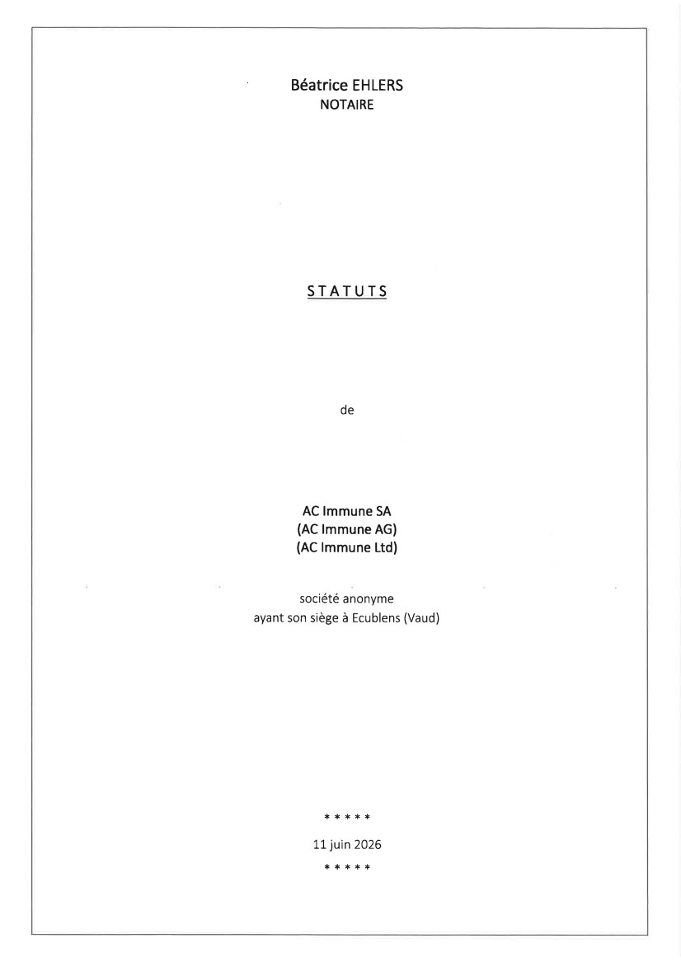 | Béatrice EHLERS NOTAIRE STATUTS de AC lmmune SA (AC lmmune AG) (AC lmmune Ltd) société anonyme ayant son siège à Ecublens (Vaud) ***** Lt )uin 2026 *****
 | 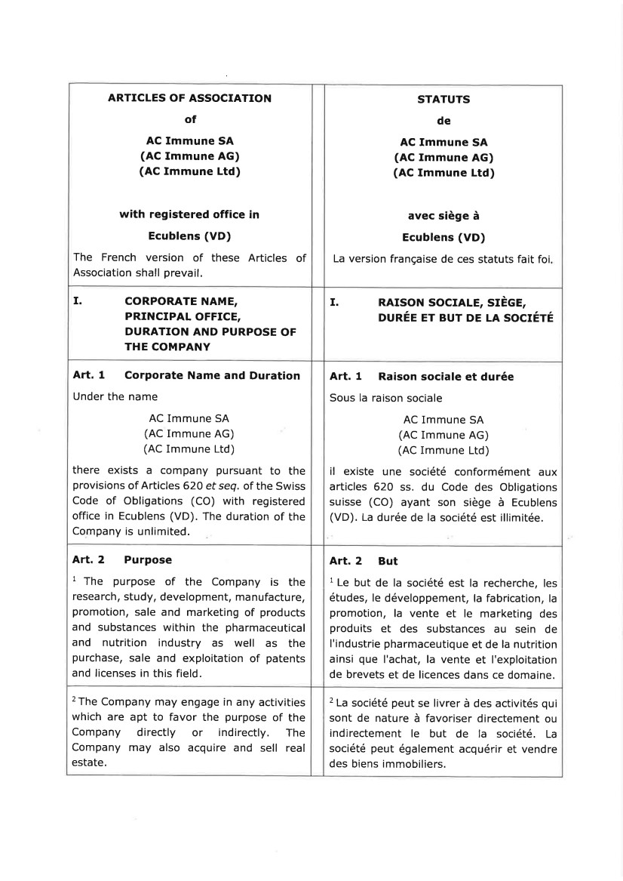 | ARTICLES OF ASSOCIATION of AC Immune SA (AC Immune AG) (AC Immune Ltd) with registered office in Ecublens (VD) The French version of these Articles of Association shall prevail. STATUTS de AC Immune SA (AC Immune AG) (AC Immune Ltd) avec siège à Ecublens (VD) La version française de ces statuts fait foi I. coRPoRATE NAME, PRINCIPAL OFFICE, DURATION AND PURPOSE OF THE COMPANY I. RATSON SOCTALE, SrÈcE, DURÉE ET BUT DE LA soclÉTÉ Art. 1 Corporate Name and Duration Under the name AC Immune SA (AC Immune AG) (AC Immune Ltd) there exists a company pursuant to the provisions of Articles 620 et seq. of the Swiss Code of Obligations (CO) with registered office in Ecublens (VD). The duration of the Company is unlimited. Art. 1 Raison sociale et durée Sous la raison sociale AC Immune SA (AC Immune AG) (AC Immune Ltd) il existe une société conformément aux articles 620 ss. du Code des Obligations suisse (CO) ayant son siège à Ecublens (VD). La durée de la société est illimitée. Art. 2 Purpose 1 The purpose of the Company is the research, study, development, manufacture, promotion, sale and marketing of products and substances within the pharmaceutical and nutrition industry as well as the purchase, sale and exploitation of patents and licenses in this field. Art. 2 But 1 Le but de la société est la recherche, les études, le développement, la fabrication, la promotion, la vente et le marketing des produits et des substances au sein de I'industrie pharmaceutique et de la nutrition ainsi que I'achat, la vente et I'exploitation de brevets et de licences dans ce domaine. 2The Company may engage in any activities which are apt to favor the purpose of the Company directly or indirectly. The Company may also acquire and sell real estate. 2 La société peut se livrer à des activités qui sont de nature à favoriser directement ou indirectement le but de la société. La société peut également acquérir et vendre des biens immobiliers.
 | 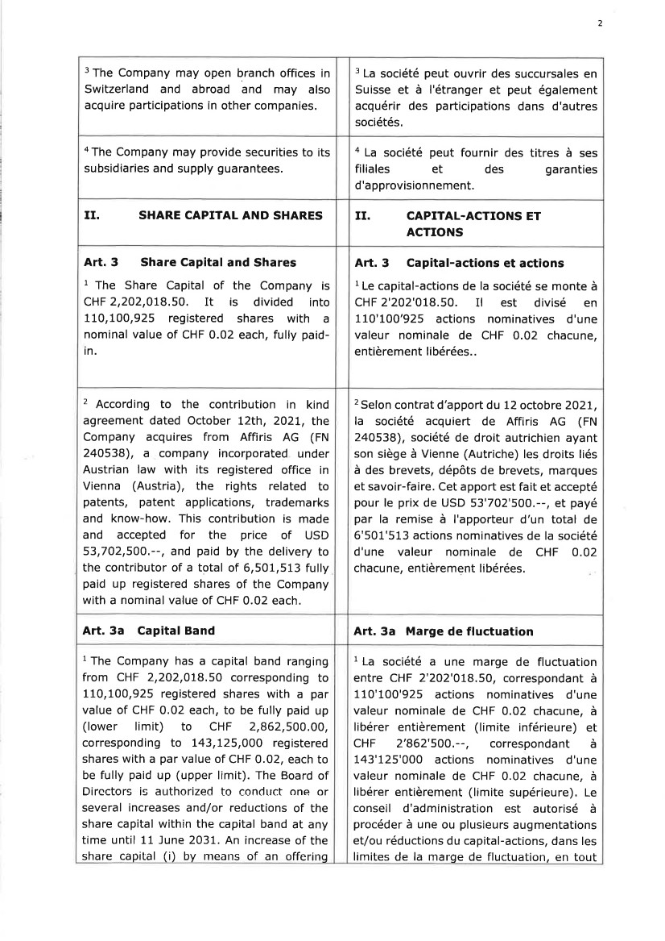 | 2 3 The Company may open branch offices in Switzerland and abroad and may also acquire participations in other companies. 3 La société peut ouvrir des succursales en Suisse et à l'étranger et peut également acquérir des participations dans d'autres sociétés. aThe Company may provide securities to its subsidiaries and supply guarantees. a La société peut fournir des titres à ses filiales et des garanties d'approvisionnement. II. SHARE CAPITAT AND SHARES II. CAPITAL.ACTIONS ET ACTIONS Art. 3 Share Capital and Shares 1 The Share Capital of the Company is CHF 2,202,018.50. It is divided into 110,100,925 registered shares with a nominal value of CHF 0.02 each, fully paid-in. Art. 3 Capital-actions et actions I Le capital-actions de la société se monte à CHF 2'202'018.50. Il est divisé en 110'100'925 actions nominatives d'une valeur nominale de CHF 0.02 chacune, entièrement libérées.. 2 According to the contribution in kind agreement dated October 12th, 2021, the Company acquires from Affiris AG (FN 240538), a company incorporated under Austrian law with its registered office in Vienna (Austria), the rights related to patents, patent applications, trademarks and know-how. This contribution is made and accepted for the price of USD 53,702,500.--, and paid by the delivery to the contributor of a total of 6,501,513 fully paid up registered shares of the Company with a nominal value of CHF 0.02 each. 2 Selon contrat d'apport du 12 octobre 2021, la société acquiert de Affiris AG (FN 240538), société de droit autrichien ayant son siège à Vienne (Autriche) les droits liés à des brevets, dépôts de brevets, marques et savoir-faire. Cet apport est fait et accepté pour le prix de USD 53'702'500.--, et payé par la remise à I'apporteur d'un total de 6'501'513 actions nominatives de la société d'une valeur nominale de CHF 0.02 chacune, entièrement libérées. Art. 3a Capital Band Art. 3a Marge de fluctuation 1 The Company has a capital band ranging from CHF 2,202,018.50 corresponding to 110,100,925 registered shares with a par value of CHF 0.02 each, to be fully paid up (lower limit) to CHF 2,862,500.00, corresponding to t43,I25,O0O registered shares with a par value of CHF 0.02, each to be fully paid up (upper limit). The Board of Directors is authorized to conduct one or several increases and/or reductions of the share capital within the capital band at any time until 11 June 2031. An increase of the share capital (i) by means of an offerirrg 1 La société a une marge de fluctuation entre CHF 2'202'018.50, correspondant à 110'100'925 actions nominatives d'u ne valeur nominale de CHF 0.02 chacune, à libérer entièrement (limite inférieure) et CHF 2'862'500.--, correspondant à 143'125'O0O actions nominatives d'une valeur nominale de CHF 0.02 chacune, à libérer entièrement (limite supérieure). Le conseil d'administration est autorisé à procéder à une ou plusieurs augmentations et/ou réductions du capital-actions, dans les limites de la marge de fluctuation, en tout
 | 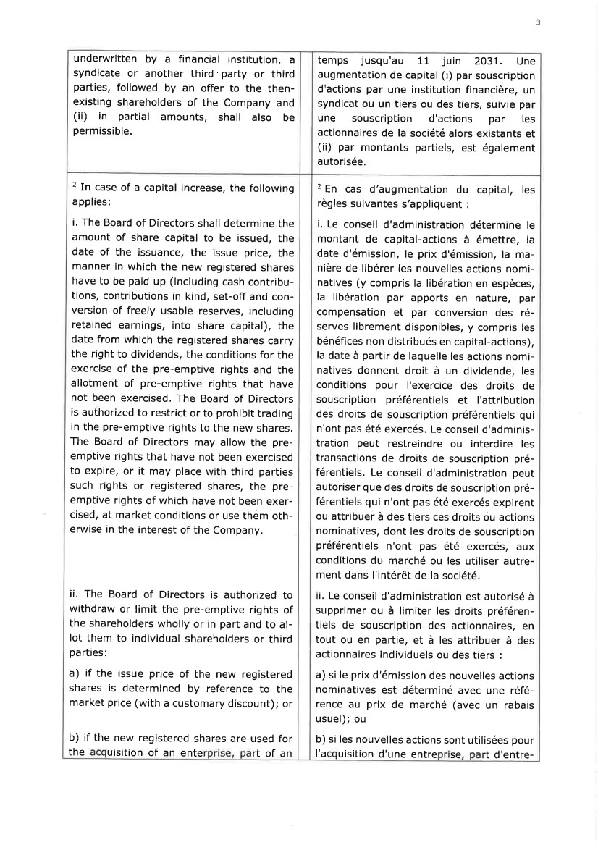 | ? underwritten by a financial institution, a syndicate or another third party or third parties, followed by an offer to the then-existing shareholders of the Company and (ii) in partial amounts, shall also be permissible. temps jusqu'au 11 juin 2031. Une augmentation de capital (i) par souscription d'actions par une institution financière, un syndicat ou un tiers ou des tiers, suivie par une souscription d'actions par les actionnaires de la société alors existants et (ii) par montants partiels, est également autorisée, 2 In case of a capital increase, the following applies: i. The Board of Directors shall determine the amount of share capital to be issued, the date of the issuance, the issue price, the manner in which the new registered shares have to be paid up (including cash contribu-tions, contributions in kind, set-off and con-version of freely usable reserves, including retained earnings, into share capital), the date from which the registered shares carry the right to dividends, the conditions for the exercise of the pre-emptive rights and the allotment of pre-emptive rights that have not been exercised. The Board of Directors is authorized to restrict or to prohibit trading in the pre-emptive rights to the new shares. The Board of Directors may allow the pre-emptive rights that have not been exercised to expire, or it may place with third parties such rights or registered shares, the pre-emptive rights of which have not been exer-cised, at market conditions or use them oth-erwise in the interest of the Company. ii. The Board of Directors is authorized to withdraw or limit the pre-emptive rights of the shareholders wholly or in part and to al-lot them to individual shareholders or third parties: a) if the issue price of the new registered shares is determined by reference to the market price (with a customary discount); or b) if the new registered shares are used for the uisition of an ente rt of an 2 En cas d'augmentation du capital, les règles suivantes s'appliquent : i. Le conseil d'administration détermine le montant de capital-actions à émettre, la date d'émission, le prix d'émission, la ma-nière de libérer les nouvelles actions nomi-natives (y compris la libération en espèces, la libération par apports en nature, par compensation et par conversion des ré-serves librement disponibles, y compris les bénéfices non distribués en capital-actions), la date à partir de laquelle les actions nomi-natives donnent droit à un dividende, les conditions pou r l'exercice des droits de souscription préférentiels et I'attribution des droits de souscription préférentiels qui n'ont pas été exercés. Le conseil d'adminis-tration peut restreindre ou interdire les transactions de droits de souscription pré-férentiels. Le conseil d'administration peut autoriser que des droits de souscription pré-férentiels qui n'ont pas été exercés expirent ou attribuer à des tiers ces droits ou actions nominatives, dont les droits de souscription préférentiels n'ont pas été exercés, aux conditions du marché ou les utiliser autre-ment dans I'intérêt de la société. ii. Le conseil d'administration est autorisé à supprimer ou à limiter les droits préféren-tiels de souscription des actionnaires, en tout ou en partie, et à les attribuer à des actionnaires individuels ou des tiers : a) si le prix d'émission des nouvelles actions nominatives est déterminé avec une réfé-rence au prix de marché (avec un rabais usuel); ou b) si les nouvelles actions sont utilisées pour I'a uisition d'une entre se rt d'entre-
 | 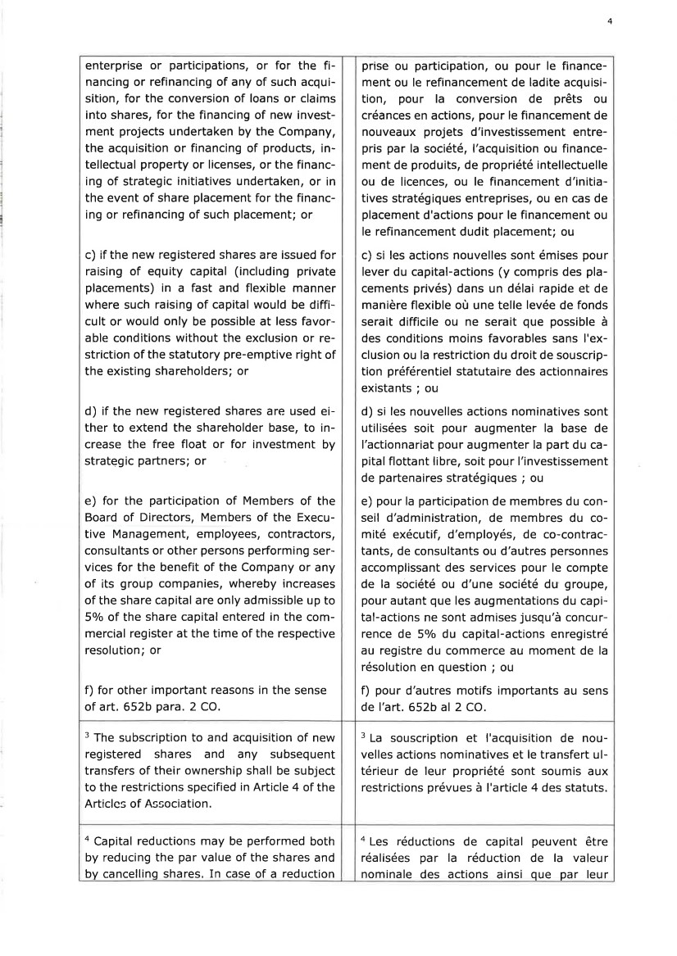 | 4 enterprise or participations, or for the fi-nancing or refinancing of any of such acqui-sition, for the conversion of loans or claims into shares, for the financing of new invest-ment projects undertaken by the Company, the acquisition or financing of products, in-tellectual property or licenses, or the financ-ing of strategic initiatives undertaken, or in the event of share placement for the financ-ing or refinancing of such placement; or c) if the new registered shares are issued for raising of equity capital (including private placements) in a fast and flexible manner where such raising of capital would be diffi-cult or would only be possible at less favor-able conditions without the exclusion or re-striction of the statutory pre-emptive right of the existing shareholders; or d) if the new registered shares are used ei-ther to extend the shareholder base, to in-crease the free float or for investment by strategic partners; or e) for the participation of Members of the Board of Directors, Members of the Execu-tive Management, employees, contractors, consultants or other persons performing ser-vices for the benefit of the Company or any of its group companies, whereby increases of the share capital are only admissible up to 5o/o of the share capital entered in the com-mercial register at the time of the respective resolution; or f) for other important reasons in the sense of art, 652b para. 2 CO. prise ou participation, ou pour le finance-ment ou le refinancement de ladite acquisi-tion, pour la conversion de prêts ou créances en actions, pour le financement de nouveaux projets d'investissement entre-pris par la société, l'acquisition ou finance-ment de produits, de propriété intellectuelle ou de licences, ou le financement d'initia-tives stratégiques entreprises, ou en cas de placement d'actions pour le financement ou le refinancement dudit placement; ou c) si les actions nouvelles sont émises pour lever du capital-actions (y compris des pla-cements privés) dans un délai rapide et de manière flexible où une telle levée de fonds serait difficile ou ne serait que possible à des conditions moins favorables sans I'ex-clusion ou la restriction du droit de souscrip-tion préférentiel statutaire des actionnaires existants ; ou d) si les nouvelles actions nominatives sont utilisées soit pour augmenter la base de l'actionnariat pour augmenter la part du ca-pital flottant libre, soit pour l'investissement de partenaires stratégiques ; ou e) pour la participation de membres du con-seil d'administration, de membres du co-mité exécutif, d'employés, de co-contrac-tants, de consultants ou d'autres personnes accomplissant des services pour le compte de la société ou d'une société du groupe, pour autant que les augmentations du capi-tal-actions ne sont admises jusqu'à concur-rence de 5olo du capital-actions enregistré au registre du commerce au moment de la résolution en question ; ou f) pour d'autres motifs importants au sens de I'art. 652b al 2 CO. 3 The subscription to and acquisition of new registered shares and any subsequent transfers of their ownership shall be subject to the restrictions specified in Article 4 of the Articlcs of Association. 3 La souscription et I'acquisition de nou-velles actions nominatives et le transfert ul-térieur de leur propriété sont soumis aux restrictions prévues à I'article 4 des statuts. a Capital reductions may be performed both by reducing the par value of the shares and by cancelling shares. In case of a reduction a Les réductions de capital peuvent être réalisées par la réduction de la valeur nominale des actions ainsi que par leur
 | 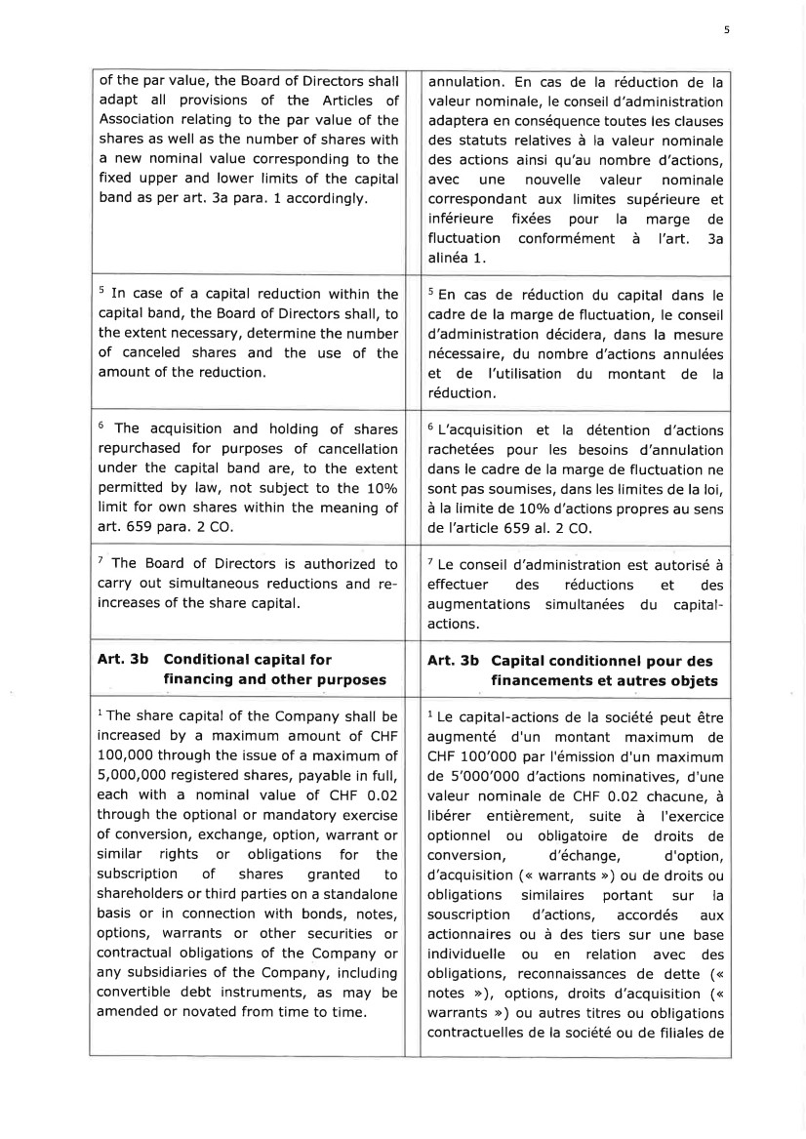 | 5 of the par value, the Board of Directors shall adapt all provisions of the Articles of Association relating to the par value of the shares as well as the number of shares with a new nominal value corresponding to the fixed upper and lower limits of the capital band as per art. 3a para. 1 accordingly. annulation. En cas de la réduction de la valeur nominale, le conseil d'administration adaptera en conséquence toutes les clauses des statuts relatives à la valeur nominale des actions ainsi qu'au nombre d'actions, avec une nouvelle valeur nominale correspondant aux limites supérieure et inférieure fixées pour la marge de fluctuation conformément à l'art. 3a alinéa 1. 5 In case of a capital reduction within the capital band, the Board of Directors shall, to the extent necessary, determine the number of canceled shares and the use of the amount of the reduction. s En cas de réduction du capital dans le cadre de la marge de fluctuation, le conseil d'administration décidera, dans la mesure nécessaire, du nombre d'actions annulées et de l'utilisation du montant de la réduction. 6 The acquisition and holding of shares repurchased for purposes of cancellation under the capital band are, to the extent permitted by law, not subject to the 10olo limit for own shares within the meaning of art. 659 para. 2 CO. 6 L'acquisition et la détention d'actions rachetées pour les besoins d'annulation dans le cadre de la marge de fluctuation ne sont pas soumises, dans les limites de la loi, à la limite de 10olo d'actions propres au sens de l'article 659 al. 2 CO. 7 The Board of Directors is authorized to carry out simultaneous reductions and re-increases of the share capital. 7 Le conseil d'administration est autorisé à effectuer des réductions et des augmentations simultanées du capital-actions. Art. 3b Conditional capital for financing and other purposes Art, 3b Capital conditionnel pour des financements et autres objets l The share capital of the Company shall be increased by a maximum amount of CHF 100,000 through the issue of a maximum of 5,000,000 registered shares, payable in full, each with a nominal value of CHF 0.02 through the optional or mandatory exercise of conversion, exchange, option, warrant or similar rights or obligations for the subscription of shares granted to shareholders or third parties on a standalone basis or in connection with bonds, notes, options, warrants or other securities or contractual obligations of the Company or any subsidiaries of the Company, including convertible debt instruments, as may be amended or novated from time to time. 1 Le capital-actions de la société peut être augmenté d'un montant maximum de CHF 100'000 par l'émission d'un maximum de 5'000'000 d'actions nominatives, d'une valeur nominale de CHF 0.02 chacune, à libérer entièrement, suite à I'exercice optionnel ou obligatoire de droits de conversion , d'échange, d'option, d'acquisition (<< warrants ,>) ou de droits ou obligations similaires portant sur la souscription d'actions, accordés aux actionnaires ou à des tiers sur une base individuelle ou en relation avec des obligations, reconnaissances de dette (u notes >>), options, droits d'acquisition (< warrants n) ou autres titres ou obligations contractuelles de la société ou de filiales de
 | 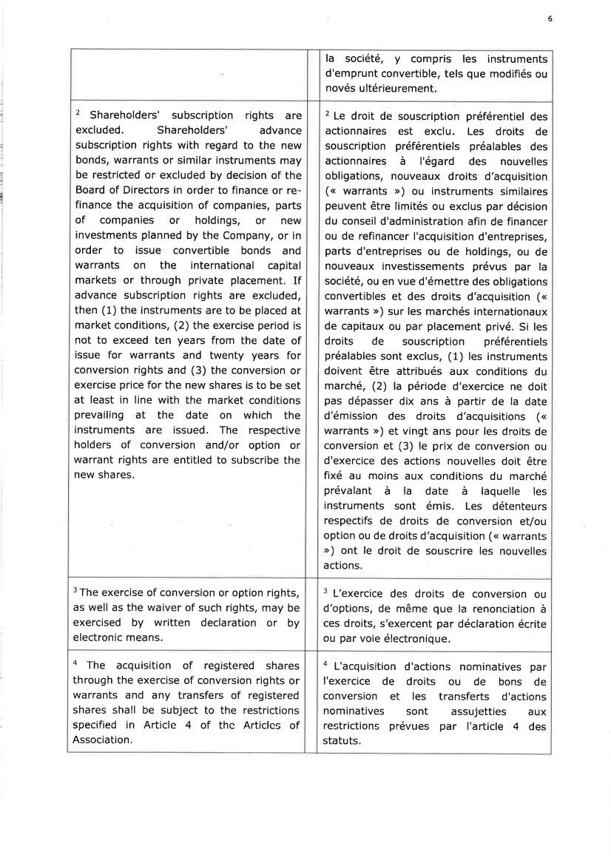 | 6 la société, y compris les instruments d'emprunt convertible, tels que modifiés ou novés ultérieurement. 2 Shareholders' subscription rights are excluded. Shareholders' advance subscription rights with regard to the new bonds, warrants or similar instruments may be restricted or excluded by decision of the Board of Directors in order to finance or re-finance the acquisition of companies, parts of companies or holdings, or new investments planned by the Company, or in order to issue convertible bonds and warrants on the international capital markets or through private placement. If advance subscription rights are excluded, then (1) the instruments are to be placed at market conditions, (2) the exercise period is not to exceed ten years from the date of issue for warrants and twenty years for conversion rights and (3) the conversion or exercise price for the new shares is to be set at least in line with the market conditions prevailing at the date on which the instruments are issued. The respective holders of conversion and/or option or warrant rights are entitled to subscribe the new shares. 2 Le droit de souscription préférentiel des actionnaires est exclu. Les droits de souscription préférentiels préalables des actionnaires à l'égard des nouvelles obligations, nouveaux droits d'acquisition (<< warrants >>) ou instruments similaires peuvent être limités ou exclus par décision du conseil d'administration afin de financer ou de refinancer I'acquisition d'entreprises, parts d'entreprises ou de holdings, ou de nouveaux investissements prévus par la société, ou en vue d'émettre des obligations convertibles et des droits d'acquisition (< warrants >) sur les marchés internationaux de capitaux ou par placement privé. Si les droits de souscription préférentiels préalables sont exclus, (1) les instruments doivent être attribués aux conditions du marché, (2) la période d'exercice ne doit pas dépasser dix ans à partir de la date d'émission des droits d'acquisitions (u warrants >) et vingt ans pour les droits de conversion et (3) le prix de conversion ou d'exercice des actions nouvelles doit être fixé au moins aux conditions du marché prévalant à la date à laquelle les instruments sont émis. Les détenteurs respectifs de droits de conversion et/ou option ou de droits d'acquisition (<< warrants >>) ont le droit de souscrire les nouvelles actions. 3The exercise of conversion or option rights, as well as the waiver of such rights, may be exercised by written declaration or by electronic means. 3 L'exercice des droits de conversion ou d'options, de même que la renonciation à ces droits, s'exercent par déclaration écrite ou par voie électronique. a The acquisition of registered shares through the exercise of conversion rights or warrants and any transfers of registered shares shall be subject to the restrictions specified in Article 4 of thc Articlcs of Association. a L'acquisition d'actions nominatives par I'exercice de droits ou de bons de conversion et les transferts d'actions nominatives sont assujetties aux restrictions prévues par I'article 4 des statuts.
 | 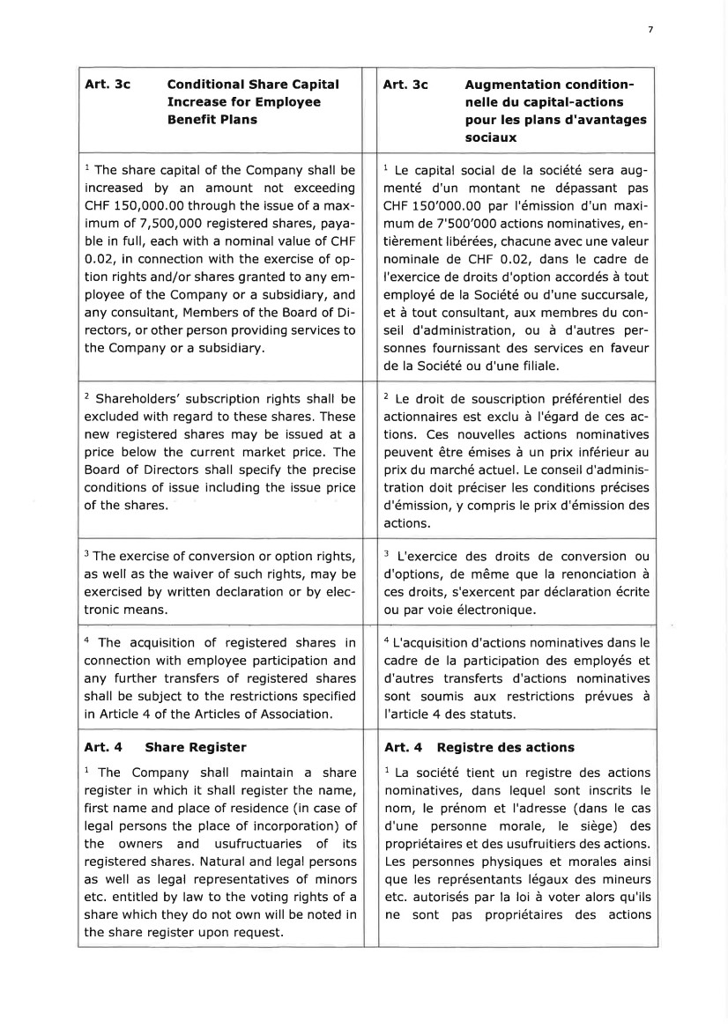 | 7 Art. 3c Conditional Share Capital Increase for Employee Benefit Plans Art, 3c Augmentation condition-nelle du capital-actions pour les plans d'avantages sociaux 1 The share capital of the Company shall be increased by an amount not exceeding CHF 150,000.00 through the issue of a max-imum of 7,500,000 registered shares, paya-ble in full, each with a nominal value of CHF 0.02, in connection with the exercise of op-tion rights and/or shares granted to any em-ployee of the Company or a subsidiary, and any consultant, Members of the Board of Di-rectors, or other person providing services to the Company or a subsidiary. 1 Le capital social de la société sera aug-menté d'un montant ne dépassant pas CHF 150'000.00 par l'émission d'un maxi-mum de 7'500'000 actions nominatives, en-tièrement libérées, chacune avec une valeur nominale de CHF 0,02, dans le cadre de I'exercice de droits d'option accordés à tout employé de la Société ou d'une succursale, et à tout consultant, aux membres du con-seil d'administration, ou à d'autres per-sonnes fournissant des services en faveur de la Société ou d'une filiale. 2 Shareholders' subscription rights shall be excluded with regard to these shares, These new registered shares may be issued at a price below the current market price. The Board of Directors shall specify the precise conditions of issue including the issue price of the shares. 2 Le droit de souscription préférentiel des actionnaires est exclu à l'égard de ces ac-tions. Ces nouvelles actions nominatives peuvent être émises à un prix inférieur au prix du marché actuel. Le conseil d'adminis-tration doit préciser les conditions précises d'émission, y compris le prix d'émission des actions. 3 The exercise of conversion or option rights, as well as the waiver of such rights, may be exercised by written declaration or by elec-tronic means, 3 L'exercice des droits de conversion ou d'options, de même que la renonciation à ces droits, s'exercent par déclaration écrite ou par voie électronique. 4 The acquisition of registered shares in connection with employee participation and any further transfers of registered shares shall be subject to the restrictions specified in Article 4 of the Articles of Association. a L'acquisition d'actions nominatives dans le cadre de la participation des employés et d'autres transferts d'actions nominatives sont soumis aux restrictions prévues à I'article 4 des statuts. Art. 4 Share Register 1 The Company shall maintain a share register in which it shall register the name, first name and place of residence (in case of legal persons the place of incorporation) of the owners and usufructuaries of its registered shares. Natural and legal persons as well as legal representatives of minors etc. entitled by law to the voting rights of a share which they do not own will be noted in the share register upon request. Art. 4 Registre des actions 1 La société tient un registre des actions nominatives, dans lequel sont inscrits le nom, le prénom et I'adresse (dans le cas d'une personne morale, le siège) des propriétaires et des usufruitiers des actions. Les personnes physiques et morales ainsi que les représentants légaux des mineurs etc. autorisés par la loi à voter alors qu'ils ne sont pas propriétaires des actions
 | 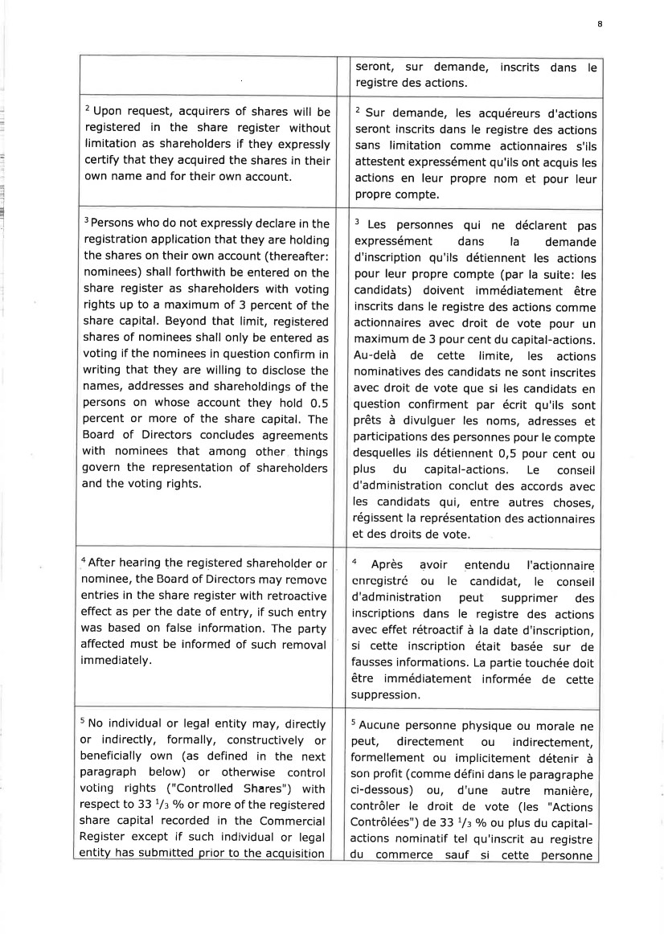 | I : - i l q I-l seront, sur demande, inscrits dans le registre des actions. 2 Upon request, acquirers of shares will be registered in the share register without limitation as shareholders if they expressly certify that they acquired the shares in their own name and for their own account. 2 Sur demande, les acquéreurs d'actions seront inscrits dans le registre des actions sans limitation comme actionnaires s'ils attestent expressément qu'ils ont acquis les actions en leur propre nom et pour leur propre compte, 3 Persons who do not expressly declare in the registration application that they are holding the shares on their own account (thereafter: nominees) shall forthwith be entered on the share register as shareholders with voting rights up to a maximum of 3 percent of the share capital. Beyond that limit, registered shares of nominees shall only be entered as voting if the nominees in question confirm in writing that they are willing to disclose the names, addresses and shareholdings of the persons on whose account they hold 0.5 percent or more of the share capital. The Board of Directors concludes agreements with nominees that among other things govern the representation of shareholders and the voting rights. 3 Les personnes qui ne déclarent pas expressément dans la demande d'inscription qu'ils détiennent les actions pour leur propre compte (par la suite: les candidats) doivent immédiatement être inscrits dans le registre des actions comme actionnaires avec droit de vote pour un maximum de 3 pour cent du capital-actions. Au-delà de cette limite, les actions nominatives des candidats ne sont inscrites avec droit de vote que si les candidats en question confirment par écrit qu'ils sont prêts à divulguer les noms, adresses et participations des personnes pour le compte desquelles ils détiennent 0,5 pour cent ou plus du capital-actions. Le conseil d'administration conclut des accords avec les candidats gui, entre autres choses, régissent la représentation des actionnaires et des droits de vote. 4After hearing the registered shareholder or nominee, the Board of Directors may removc entries in the share register with retroactive effect as per the date of entry, if such entry was based on false information. The party affected must be informed of such removal immediately. a Après avoir entendu I'actionnaire enrcgistré ou le candidat, le conseil d'administration peut supprimer des inscriptions dans le registre des actions avec effet rétroactif à la date d'inscription, si cette inscription était basée sur de fausses informations, La partie touchée doit être immédiatement informée de cette suppression. s No individual or legal entity may, direcily or indirectly, formally, constructively or beneficially own (as defined in the next paragraph below) or otherwise control voting riglrts ("Controlled Shares") with respect to 33 1/: o/o or ITtorê of the registered share capital recorded in the Commercial Register except if such individual or legal entity has submitted prior to the acquisition s Aucune personne physique ou morale ne peut, directement ou indirectement, formellement ou implicitement détenir à son profit (comme défini dans le paragraphe ci-dessous) ou, d'une autre manière, contrôler le droit de vote (les "Actions Contrôlées") de 33 t/z o/o ou plus du capital-actions nominatif tel qu'inscrit au registre du commerce sauf si cette ersonne
 | 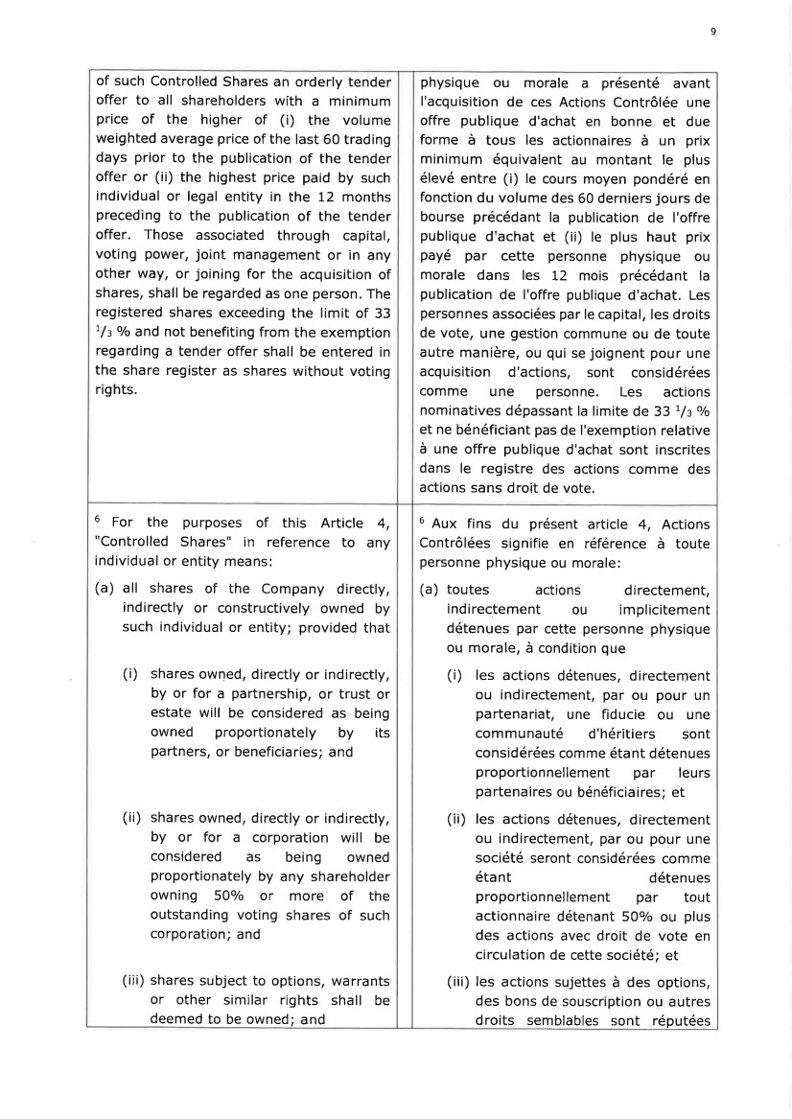 | 9 of such Controlled Shares an orderly tender offer to all shareholders with a minimum price of the higher of (i) the volume weighted average price of the last 60 trading days prior to the publication of the tender offer or (ii) the highest price paid by such individual or legal entity in the 12 months preceding to the publication of the tender offer. Those associated through capital, voting power, joint management or in any other way, or joining for the acquisition of shares, shall be regarded as one person. The registered shares exceeding the limit of 33 1/z o/o and not benefiting from the exemption regarding a tender offer shall be entered in the share register as shares without voting rights. physique ou morale a présenté avant I'acquisition de ces Actions Contrôlée une offre publique d'achat en bonne et due forme à tous les actionnaires à un prix minimum équivalent au montant le plus élevé entre (i) le cours moyen pondéré en fonction du volume des 60 derniers jours de bourse précédant la publication de I'offre publique d'achat et (ii) le plus haut prix payé par cette personne physique ou morale dans les 72 mois précédant la publication de I'offre publique d'achat. Les personnes associées par le capital, les droits de vote, une gestion commune ou de toute autre manière, ou qui se joignent pour une acquisition d'actions, sont considérées comme une personne. Les actions nominatives dépassant la limite de 33 t/z o/o et ne bénéficiant pas de I'exemption relative à une offre publique d'achat sont inscrites dans le registre des actions comme des actions sans droit de vote. 6 For the purposes of this Article 4, "Controlled Shares" in reference to any individual or entity means: (a) all shares of the Company directly, indirectly or constructively owned by such individual or entity; provided that (i) shares owned, directly or indirectlv, by or for a partnership, or trust or estate will be considered as being owned proportionately by its partners, or beneficiaries; and (ii) shares owned, directly or indirectly, by or for a corporation will be considered as being owned proportionately by any shareholder owning 50o/o or more of the outstanding voting shares of such corporation; and (iii) shares subject to options, warrants or other similar rights shall be deemed to be owned; and 6 Aux fins du présent article 4, Actions Contrôlées signifie en référence à toute personne physique ou morale: (a) toutes actions directement, indirectement ou implicitement détenues par cette personne physique ou morale, à condition que (i) les actions détenues, directement ou indirectement, par ou pour un partenariat, une fiducie ou une communauté d'héritiers sont considérées comme étant détenues proportionnellement par leurs partenaires ou bénéficiaires; et (ii) les actions détenues, directement ou indirectement, par ou pour une société seront considérées comme étant détenues proportionnellement par tout actionnaire détenant 50o/o ou plus des actions avec droit de vote en circulation de cette société; et (iii) les actions sujettes à des options, des bons de souscription ou autres droits semblables sont réputées
 | 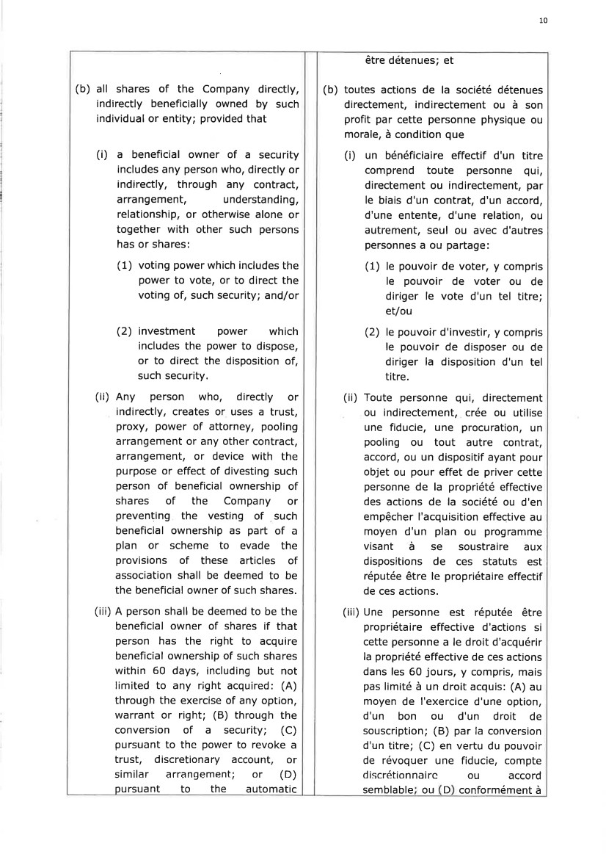 | 10 (b) all shares of the Company directly, indirectly beneficially owned by such individual or entity; provided that (i) a beneficial owner of a security includes any person who, directly or indirectly, through any contract, arrangement, understanding, relationship, or otherwise alone or together with other sueh persons has or shares: (1) voting power which includes the power to vote, or to direct the voting of, such security; and/or (2) investment power which includes the power to dispose, or to direct the disposition of, such security. (ii) Any person who, directly or indirectly, creates or uses a trust, proxy, power of attorney, pooling arrangement or any other contract, arrangement, or device with the purpose or effect of divesting such person of beneficial ownership of shares of the Company or preventing the vesting of suçh beneficial ownership as part of a plan or scheme to evade the provisions of these articles of association shall be deemed to be the beneficial owner of such shares. (iii) A person shall be deemed to be the beneficial owner of shares if that person has the right to acquire beneficial ownership of such shares within 60 days, including but not limited to any right acquired: (A) through the exercise of any option, warrant or right; (B) through the conversion of a security; (C) pursuant to the power to revoke a trust, discretionary account, or similar arrangement; or (D) pu rsua nt to the a utomatic être détenues; et (b) toutes actions de la société détenues directement, indirectement ou à son profit par cette personne physique ou morale, à condition que (i) un bénéficiaire effectif d'un titre comprend toute personne gui, directement ou indirectement, par le biais d'un contrat, d'un accord, d'une entente, d'une relation, ou autrement, seul ou avec d'autres personnes a ou partage: (1) le pouvoir de voter, y compris le pouvoir de voter ou de diriger le vote d'un tel titre; et/ou (2) le pouvoir d'investir, y compris le pouvoir de disposer ou de diriger la disposition d'un tel titre. (ii) Toute personne Qui, directement ou indirectement, crée ou utilise une fiducie, une procuration, un pooling ou tout autre contrat, accord, ou un dispositif ayant pour objet ou pour effet de priver cette personne de la propriété effective des actions de la société ou d'en empêcher I'acquisition effective au moyen d'un plan ou programme visant à se soustraire aux dispositions de ces statuts est réputée être le propriétaire effectif de ces actions. (iii) Une personne est réputée être propriétaire effective d'actions si cette personne a le droit d'acquérir la propriété effective de ces actions dans les 60 jours, y compris, mais pas limité à un droit acquis: (A) au moyen de I'exercice d'une option, d'un bon ou d'un droit de souscription; (B) par la conversion d'un titre; (C) en vertu du pouvoir de révoquer une fiducie, compte discrétionnairc ou accord semblable ou D conformément à
 | 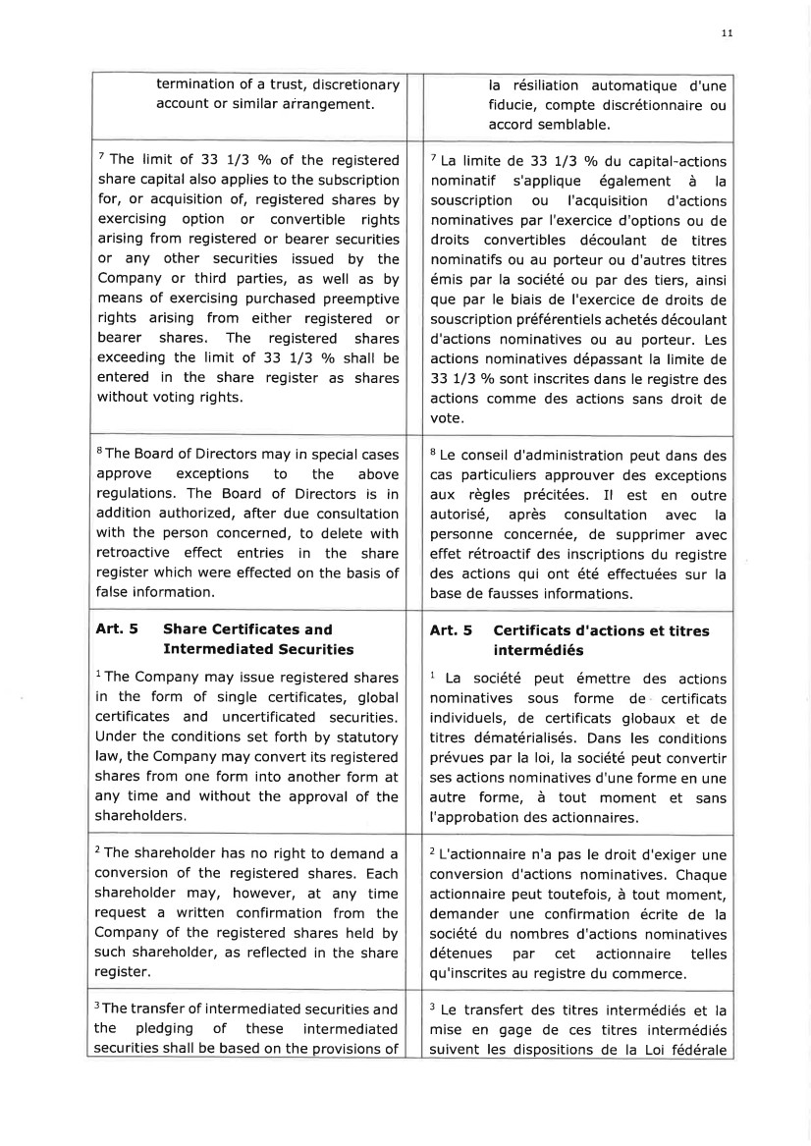 | 11 termination of a trust, discretionary account or similar arrangement. la résiliation automatique d'une fiducie, compte discrétionnaire ou accord semblable. 7 The limit of 33 l/3 o/o of the registered share capital also applies to the subscription for, or acquisition of, registered shares by exercising option or convertible rights arising from registered or bearer securities or any other securities issued by the Company or third parties, as well as by means of exercising purchased preemptive rights arising from either registered or bearer shares. The registered shares exceeding the limit of 33 1/3 o/o shall be entered in the share register as shares without voting rights. 7 La limite de 33 t/3 o/o du capital-actions nominatif s'applique également à la souscription ou I'acquisition d'actions nominatives par I'exercice d'options ou de droits convertibles découlant de titres nominatifs ou au porteur ou d'autres titres émis par la société ou par des tiers, ainsi que par le biais de I'exercice de droits de souscri ption préférentiels achetés décou la nt d'actions nominatives ou au porteur. Les actions nominatives dépassant la limite de 33 t/3 o/o soflt inscrites dans le registre des actions comme des actions sans droit de vote. sThe Board of Directors may in special cases approve exceptions to the above regulations. The Board of Directors is in addition authorized, after due consultation with the person concerned, to delete with retroactive effect entries in the share register which were effected on the basis of false information. I Le conseil d'administration peut dans des cas particuliers approuver des exceptions aux règles précitées. Il est en outre autorisé, après consultation avec la personne concernée, de supprimer avec effet rétroactif des inscriptions du registre des actions qui ont été effectuées sur la base de fausses informations. Art. 5 Share Certificates and Intermed iated Securities lThe Company may issue registered shares in the form of single certificates, global certificates and uncertificated securities. Under the conditions set forth by statutory law, the Company may convert its registered shares from one form into another form at any time and without the approval of the shareholders. Art. 5 Certificats d'actions et titres intermédiés 1 La société peut émettre des actions nominatives sous forme de certificats individuels, de certificats globaux et de titres dématérialisés. Dans les conditions prévues par la loi, la société peut convertir ses actions nominatives d'une forme en une autre forme, à tout moment et sans I'approbation des actionnaires. 2 The shareholder has no right to demand a conversion of the registered shares. Each shareholder may, however, at any time request a written confirmation from the Company of the registered shares held by such shareholder, as reflected in the share register. 2 L'actionnaire n'a pas le droit d'exiger une conversion d'actions nominatives, Chaque actionnaire peut toutefois, à tout moment, demander une confirmation écrite de la société du nombres d'actions nominatives détenues par cet actionnaire telles qu'inscrites au registre du commerce. 3The transfer of intermediated securities and the pledging of these intermediated securities shall be based on the provisions of 3 Le transfert des titres intermédiés et la mise en gage de ces titres intermédiés suivent les dispositions de la Loi fédérale
 | 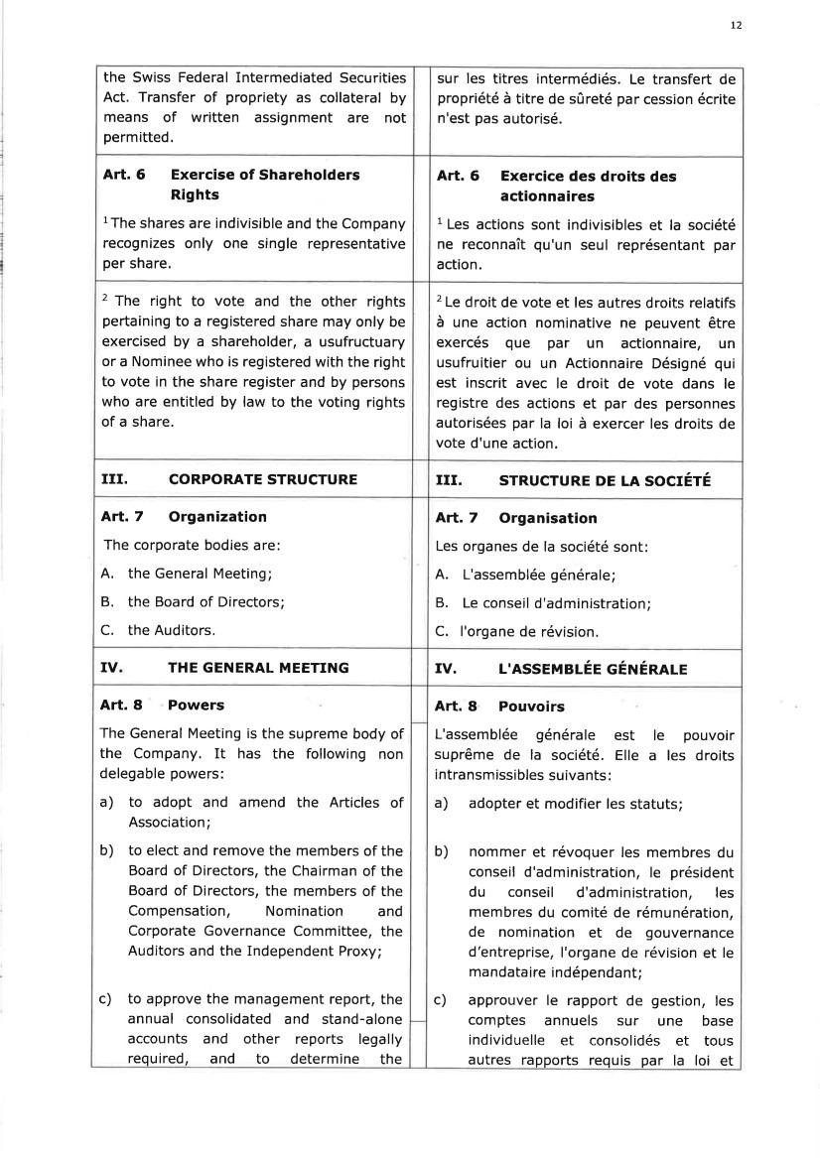 | 12 the Swiss Federal Intermediated Securities Act, Transfer of propriety as collateral by means of written assignment are not permitted. sur les titres intermédiés. Le transfert de propriété à titre de sûreté par cession écrite n'est pas autorisé. Art. 6 Exercise of Shareholders Rights lThe shares are indivisible and the Company recognizes only one single representative per share. Art. 6 Exercice des droits des actionnaires 1 Les actions sont indivisibles et la société ne reconnaît qu'un seul représentant par action. 2 The right to vote and the other rights pertaining to a registered share may only be exercised by a shareholder, a usufructuary or a Nominee who is registered with the right to vote in the share register and by persons who are entitled by law to the voting rights of a share. 2 Le droit de vote et les autres droits relatifs à une action nominative ne peuvent être exercés que par un actionnaire, utr usufruitier ou un Actionnaire Désigné qui est inscrit avec le droit de vote dans le registre des actions et par des personnes autorisées par la loi à exercer les droits de vote d'une action. III. CORPORATE STRUCTURE III. STRUCTURE DE LA SOCIÉTÉ Art. 7 Organization The corporate bodies are: A. the General Meeting; B. the Board of Directors; C. the Auditors. Art. 7 Organisation Les organes de la société sont: A. L'assemblée générale; B. Le conseil d'administration; C. I'organe de révision. IV THE GENERAT MEETING IV. L'ASSEMBIÉE EÉrVÉRAIE Aft.8 Powers The General Meeting is the supreme body of the Company. It has the following non delegable powers: a) to adopt and amend the Articles of Association; b) to elect and remove the members of the Board of Directors, the Chairman of the Board of Directors, the members of the Compensation, Nomination and Corporate Governance Committee, the Auditors and the Independent Proxy; c) to approve the management report, the annual consolidated and stand-alone accounts and other reports legally required, and to determine the Art. I Pouvoirs L'assemblée générale est le pouvoir suprême de la société. Elle a les droits intransmissibles suivants : a) adopter et modifier les statuts; b) nommer et révoquer les membres du conseil d'administration, le président du conseil d'administration, les membres du comité de rémunération, de nomination et de gouvernance d'entreprise, I'organe de révision et le mandataire indépendant; c) approuver le rapport de gestion, les comptes annuels sur une base individuelle et consolidés et tous autres rapports requis par la loi et
 | 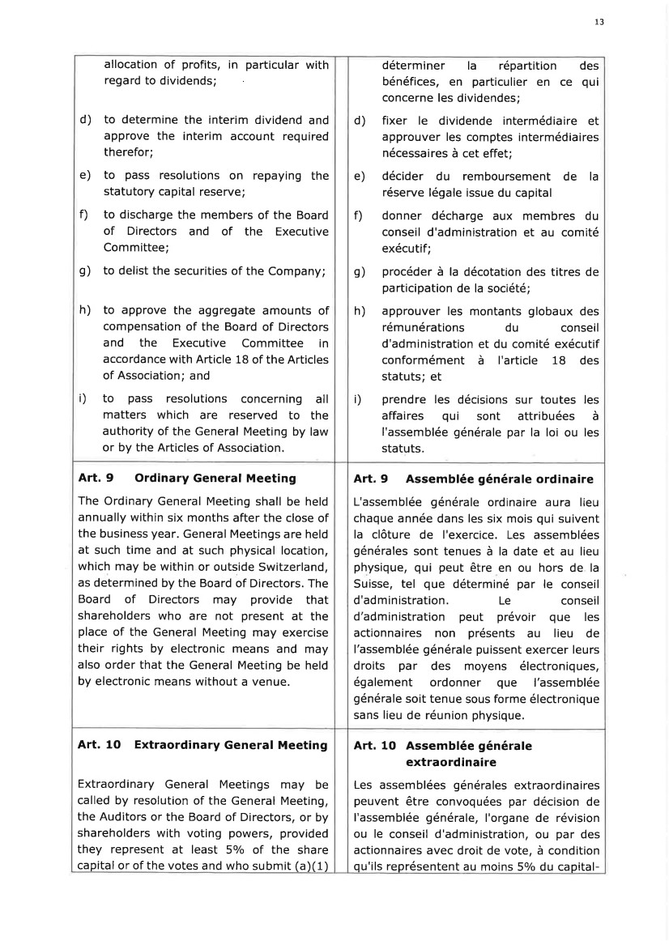 | 13 allocation of profits, in particular with regard to dividends; d) to determine the interim dividend and approve the interim account required therefor; e) to pass resolutions on repaying the statutory capital reserve; f) to discharge the members of the Board of Directors and of the Executive Committee; g) to delist the securities of the Company; h) to approve the aggregate amounts of compensation of the Board of Directors and the Executive Committee in accordance with Article 1B of the Articles of Association; and i) to pass resolutions concerning all matters which are reserved to the authority of the General Meeting by law or by the Articles of Association. déterminer la répartition des bénéfices, en particulier en ce qui concerne les dividendes; d) fixer le dividende intermédiaire et approuver les comptes intermédiaires nécessaires à cet effet; e) décider du remboursement de la réserve légale issue du capital f) donner décharge aux membres du conseil d'administration et au comité exécutif; g) procéder à la décotation des titres de participation de la société; h) approuver les montants globaux des rémunérations du conseil d'administration et du comité exécutif conformément à I'article 1B des statuts; et i) prendre les décisions sur toutes les affaires qui sont attribuées à I'assemblée générale par la loi ou les statuts. Art. 9 Ordinary General Meeting The Ordinary General Meeting shall be held annually within six months after the close of the business year. General Meetings are held at such time and at such physical location, which may be within or outside Switzerland, as determined by the Board of Directors. The Board of Directors may provide that shareholders who are not present at the place of the General Meeting may exercise their rights by electronic means and may also order that the General Meeting be held by electronic means without a venue. Art, 9 Assemblée générale ordinaire L'assemblée générale ordinaire aura lieu chaque année dans les six mois qui suivent la clôture de I'exercice. Les assemblées générales sont tenues à la date et au lieu physique, qui peut être en ou hors de la Suisse, tel que déterminé par le conseil d'administration. Le conseil d'administration peut prévoir que les actionnaires non présents au lieu de l'assemblée générale puissent exercer leurs droits par des moyens électroniques, également ordonner que l'assemblée générale soit tenue sous forme électronique sans lieu de réunion physique. Art. 1O Extraordinary General Meeting Extraordinary General Meetings may be called by resolution of the General Meeting, the Auditors or the Board of Directors, or by shareholders with voting powers, provided they represent at least 5olo of the share capital or of the votes and who submit (a)(1) Art. 10 Assemblée générale extraordinaire Les assemblées générales extraordinaires peuvent être convoquées par décision de I'assemblée générale, I'organe de révision ou le conseil d'administration, ou par des actionnaires avec droit de vote, à condition qu'ils représentent au moins 5olo du capital-
 | 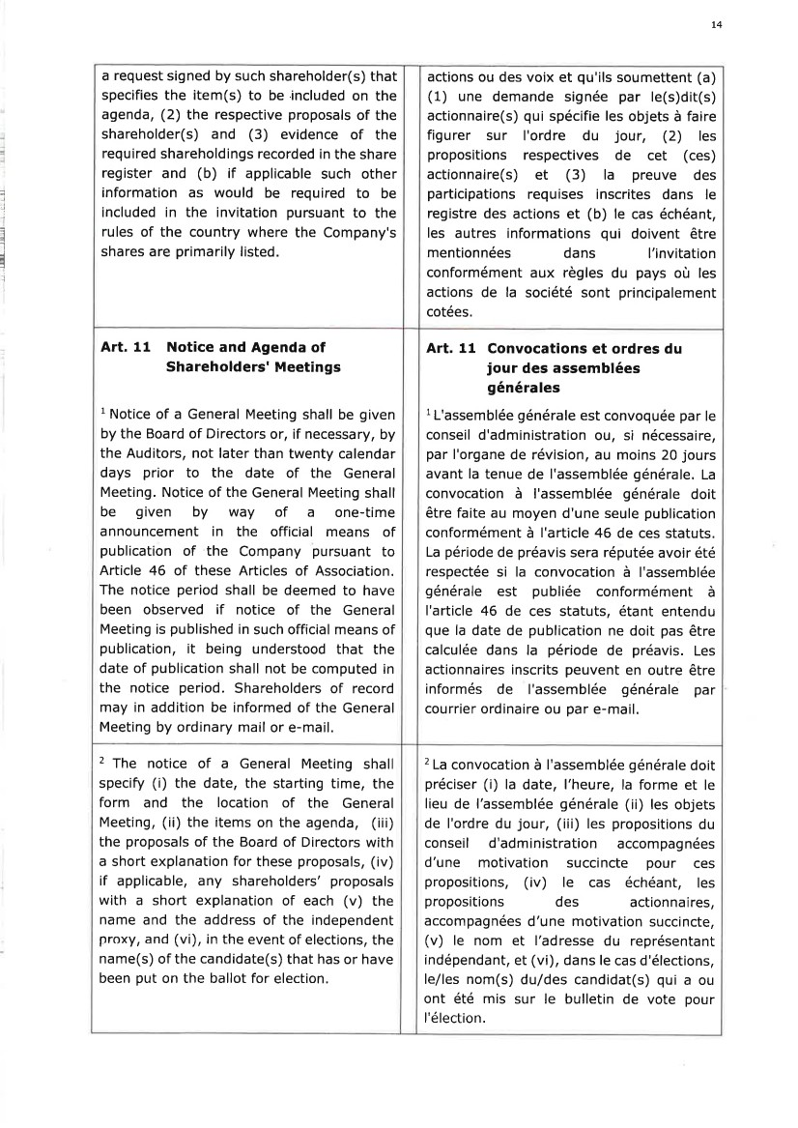 | 14 =l I 1 i I I 5 l : a request signed by such shareholder(s) that specifies the item(s) to be included on the agenda, (2) the respective proposals of the shareholder(s) and (3) evidence of the required shareholdings recorded in the share register and (b) if applicable such other information as would be required to be included in the invitation pursuant to the rules of the country where the Company's shares are primarily listed. actions ou des voix et qu'ils soumettent (a) (1) une demande signée par le(s)dit(s) actionnaire(s) qui spécifie les objets à faire fig u rer su r I'ord re d u jou r, (2) les propositions respectives de cet (ces) actionnaire(s) et (3) la preuve des participations requises inscrites dans le registre des actions et (b) le cas échéant, les autres informations qui doivent être mentionnées dans l'invitation conformément aux règles du pays où les actions de la société sont principalement cotées. Art, 11 Notice and Agenda of Shareholders' Meetings 1 Notice of a General Meeting shall be given by the Board of Directors or, if necessary, by the Auditors, not later than twenty calendar days prior to the date of the General Meeting. Notice of the General Meeting shall be given by way of a one-time announcement in the official means of publication of the Company pursuant to Article 46 of these Articles of Association. The notice period shall be deemed to have been observed if notice of the General Meeting is published in such official means of publication, it being understood that the date of publication shall not be computed in the notice period. Shareholders of record may in addition be informed of the General Meeting by ordinary mail or e-mail. Art. 11 Convocations et ordres du jour des assemblées générales 1L'assemblée générale est convoquée par le conseil d'administration ou, si nécessaire, par I'organe de révision, au moins 20 jours avant la tenue de l'assemblée générale. La convocation à I'assemblée générale doit être faite au moyen d'une seule publication conformément à l'article 46 de ces statuts. La période de préavis sera réputée avoir été respectée si la convocation à I'assemblée générale est publiée conformément à I'article 46 de ces statuts, étant entendu que la date de publication ne doit pas être calculée dans la période de préavis. Les actionnaires inscrits peuvent en outre être informés de I'assemblée générale par courrier ordinaire ou par e-mail. 2 The notice of a General Meeting shall specify (i) the date, the starting time, the form and the location of the General Meeting, (ii) the items on the agenda, (iii) the proposals of the Board of Directors with a short explanation for these proposals, (iv) if applicable, any shareholders' proposals with a short explanation of each (v) the name and the address of the independent proxy, and (vi), in the event of elections, the name(s) of the candidate(s) that has or have been put on the ballot for election, 2 La convocation à I'assemblée générale doit préciser (i) la date, l'heure, la forme et le lieu de l'assemblée générale (ii) les objets de I'ordre du jour, (iii) Ies propositions du conseil d'administration accompagnées d'une motivation succincte pour ces propositions, (iv) le cas échéant, les propositions des actionnaires, accompagnées d'une motivation succincte, (v) Ie nom et l'adresse du représentant indépendant, et (vi), dans le cas d'élections, le/les nom(s) duldes candidat(s) qui a ou ont été mis sur le bulletin de vote pour l'élection.
 | 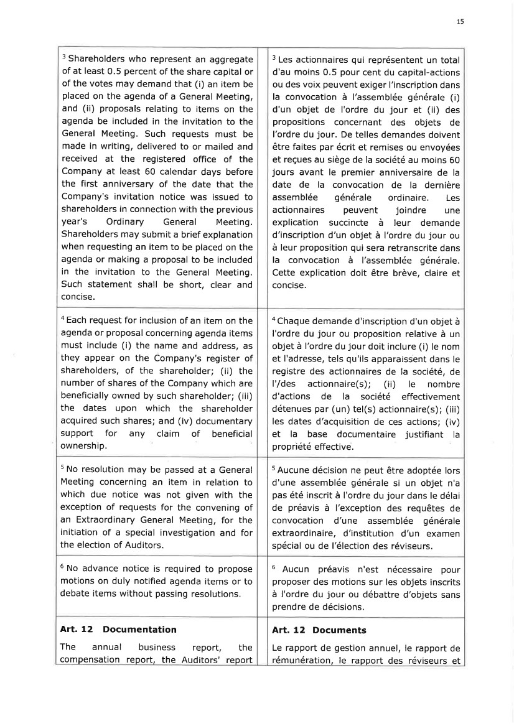 | 15 3 Shareholders who represent an aggregate of at least 0,5 percent of the share capital or of the votes may demand that (i) an item be placed on the agenda of a General Meeting, and (ii) proposals relating to items on the agenda be included in the invitation to the General Meeting. Such requests must be made in writing, delivered to or mailed and received at the registered office of the Company at least 60 calendar days before the first anniversary of the date that the Company's invitation notice was issued to shareholders in connection with the previous year's Ordinary General Meeting, Shareholders may submit a brief explanation when requesting an item to be placed on the agenda or making a proposal to be included in the invitation to the General Meeting. Such statement shall be short, clear and concise. 3 Les actionnaires qui représentent un total d'au moins 0.5 pour cent du capital-actions ou des voix peuvent exiger l'inscription dans la convocation à I'assemblée générale (i) d'un objet de I'ordre du jour et (ii) des propositions concernant des objets de I'ordre du jour. De telles demandes doivent être faites par écrit et remises ou envoyées et reçues au siège de la société au moins 60 jours avant le premier anniversaire de la date de la convocation de la dernière assemblée générale ordinaire. Les actionnaires peuvent joindre une explication succincte à leur demande d'inscription d'un objet à l'ordre du jour ou à leur proposition qui sera retranscrite dans la convocation à l'assemblée générale. Cette explication doit être brève, claire et concise. a Each request for inclusion of an item on the agenda or proposal concerning agenda items must include (i) the name and address, as they appear on the Company's register of shareholders, of the shareholder; (ii) the number of shares of the Company which are beneficially owned by such shareholder; (iii) the dates upon which the shareholder acquired such shares; and (iv) documentary support for any claim of beneficial ownership. aChaque demande d'inscription d'un objet à I'ordre du jour ou proposition relative à un objet à l'ordre du jour doit inclure (i) le nom et I'adresse, tels qu'ils apparaissent dans le registre des actionnaires de la société, de l'ldes actionnaire(s); (ii) le nombre d'actions de la société effectivement détenues par (un) tel(s) actionnaire(s); (iii) les dates d'acquisition de ces actions; (iv) et la base documentaire justifiant la propriété effective. 5 No resolution may be passed at a General Meeting concerning an item in relation to which due notice was not given with the exception of requests for the convening of an Extraordinary General Meeting, for the initiation of a special investigation and for the election of Auditors. s Aucune décision ne peut être adoptée lors d'une assemblée générale si un objet n'a pas été inscrit à I'ordre du jour dans le délai de préavis à I'exception des requêtes de convocation d'une assemblée générale extraordinaire, d'institution d'un examen spécial ou de l'élection des réviseurs. 6 No advance notice is required to propose motions on duly notified agenda items or to debate items without passing resolutions. 6 Aucun préavis n'est nécessaire pour proposer des motions sur les objets inscrits à I'ordre du jour ou débattre d'objets sans prendre de décisions. Art. 12 Documentation The annual business report, the com pensation report, the Auditors' report Art. 12 Documents Le rapport de gestion annuel, le rapport de rémunération, le rapport des réviseurs et
 | 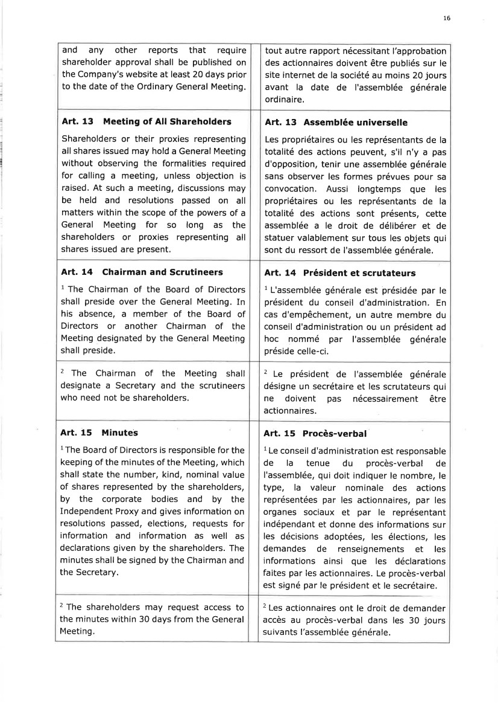 | 16 and any other reports that require shareholder approval shall be published on the Company's website at least 20 days prior to the date of the Ordinary General Meeting. tout autre rapport nécessitant I'approbation des actionnaires doivent être publiés sur le site internet de la société au moins 20 jours avant la date de I'assemblée générale ordinaire. Art. 13 Meeting of All Shareholders Shareholders or their proxies representing allshares issued may hold a General Meeting without observing the formalities required for calling a meeting, unless objection is raised. At such a meeting, discussions may be held and resolutions passed on all matters within the scope of the powers of a General Meeting for so long as the shareholders or proxies representing all shares issued are present. Art. 13 Assemblée universelle Les propriétaires ou les représentants de la totalité des actions peuvent, s'il n'y a pas d'opposition, tenir une assemblée générale sans observer les formes prévues pour sa convocation. Aussi longternps que les propriétaires ou les représentants de la totalité des actions sont présents, cette assemblée a le droit de délibérer et de statuer valablement sur tous les objets qui sont du ressort de I'assemblée générale. Art. 14 Chairman and Scrutineers 1 The Chairman of the Board of Directors shall preside over the General Meeting. In his absence, a member of the Board of Directors or another Chairman of the Meeting designated by the General Meeting shall preside. Art. 14 Président et scrutateurs 1 L'assemblée générale est présidée par le président du conseil d'administration. En cas d'empêchement, un autre membre du conseil d'administration ou un président ad hoc nommé par I'assemblée générale préside celle-ci. 2 The Chairman of the Meeting shall designate a Secretary and the scrutineers who need not be shareholders. 2 Le président de I'assemblée générale désigne un secrétaire et les scrutateurs qui ne doivent pas nécessairement être actionnaires. Art. 15 Minutes lThe Board of Directors is responsible for the keeping of the minutes of the Meeting, which shall state the number, kind, nominal value of shares represented by the shareholders, by the corporate bodies and by the Independent Proxy and gives information on resolutions passed, elections, requests for information and information as well as declarations given by the shareholders. The minutes shall be signed by the Chairman and the Secretary. Art. 15 Procès-verbal 1Le conseil d'administration est responsable de la tenue du procès-verbal de l'assemblée, qui doit indiquer le nombre, le type, la valeur nominale des actions représentées par les actionnaires, par les organes sociaux et par le représentant indépendant et donne des informations sur les décisions adoptées, les élections, les demandes de renseignements et les informations ainsi que les déclarations faites par les actionnaires. Le procès-verbal est signé par le président et le secrétaire. 2 Les actionnaires ont le droit de demander accès au procès-verbal dans les 30 jours su ivants l'assemblée générale. 2 The shareholders may request access to the minutes within 30 days from the General Meeting.
 | 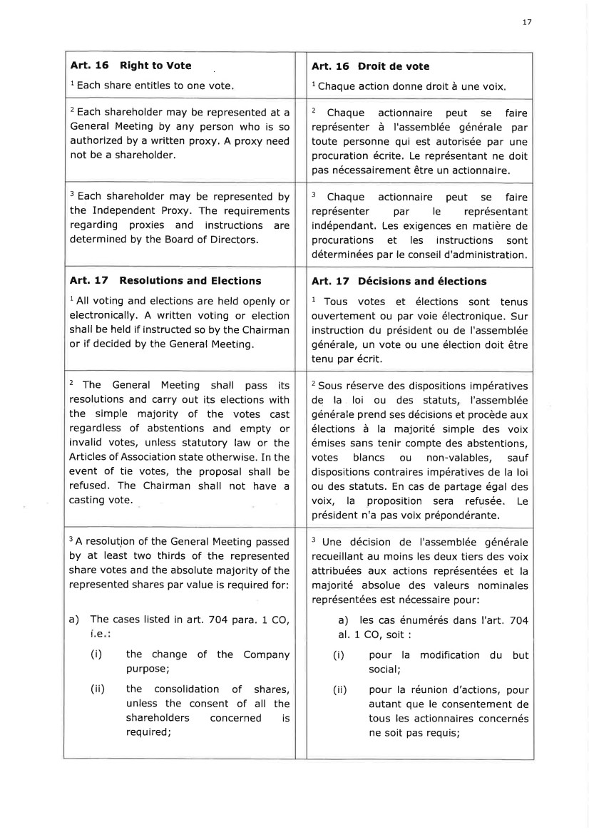 | 17 Art. 16 Right to Vote 1 Each share entitles to one vote Art. 16 Droit de vote l Chaque action donne droit à une voix 2 Each shareholder may be represented at a General Meeting by any person who is so authorized by a written proxy. A proxy need not be a shareholder. 2 Chaque actionnaire peut se faire représenter à l'assemblée générale par toute personne qui est autorisée par une procuration écrite, Le représentant ne doit pas nécessairement être un actionnaire. 3 Each shareholder may be represented by the Independent Proxy. The requirements regarding proxies and instructions are determined by the Board of Directors. 3 Chaque actionnaire peut se faire représenter pa r le représenta nt indépendant, Les exigences en matière de procu rations et les instructions sont déterminées par le conseil d'administration. Art. 17 Resolutions and Elections l All voting and elections are held openly or electronically. A written voting or election shall be held if instructed so by the Chairman or if decided by the General Meeting. Art. 17 Décisions and élections I Tous votes et élections sont tenus ouvertement ou par voie électronique. Sur instruction du président ou de I'assemblée générale, un vote ou une élection doit être tenu par écrit. 2 The General Meeting shall pass its resolutions and carry out its elections with the simple majority of the votes cast regardless of abstentions and empty or invalid votes, unless statutory law or the Articles of Association state otherwise. In the event of tie votes, the proposal shall be refused. The Chairman shall not have a casting vote. 2 Sous réserve des dispositions impératives de la loi ou des statuts, I'assemblée générale prend ses décisions et procède aux élections à la majorité simple des voix émises sans tenir compte des abstentions, votes blancs ou non-valables, sauf dispositions contraires impératives de la loi ou des statuts. En cas de partage égal des voix, la proposition sera refusée. Le président n'a pas voix prépondérante. 3 A resolutjon of the General Meeting passed by at least two thirds of the represented share votes and the absolute majority of the represented shares par value is required for: a) The cases listed in art. 7O4 para. 1 CO, i.e (i) the change of the Company purpose; the consolidation of shares, unless the consent of all the shareholders concerned is requ ired; (ii) 3 Une décision de I'assemblée générale recueillant au moins les deux tiers des voix attribuées aux actions représentées et la majorité absolue des valeurs nominales représentées est nécessaire pour: a) les cas énumérés dans I'art. 704 al. 1 CO, soit : (i) pour la modification du but social; (ii) pour la réunion d'actions, pour autant que le consentement de tous les actionnaires concernés ne soit pas requis;
 | 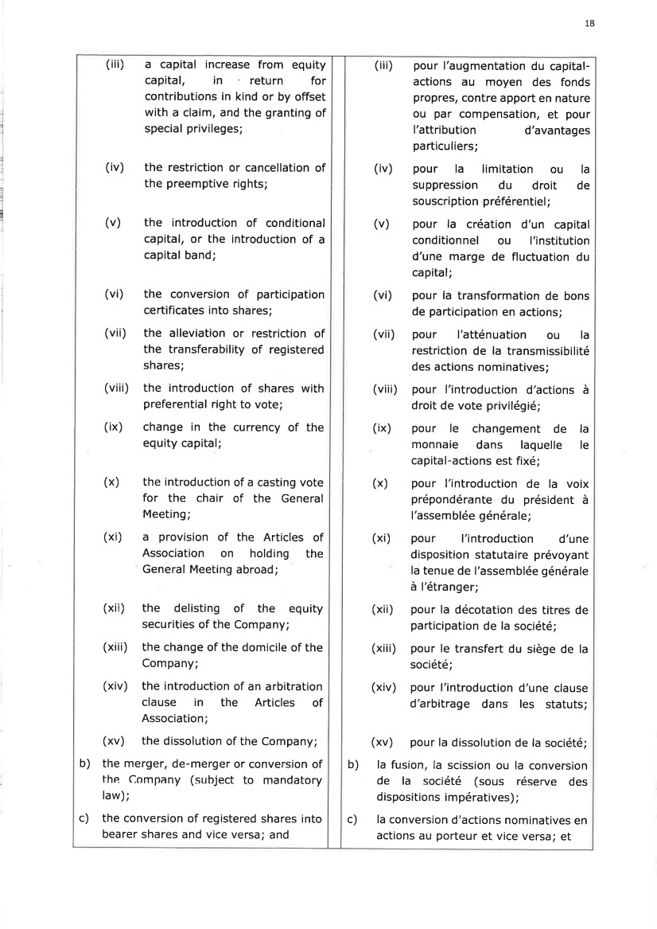 | 18 (vi) (vii) (viii) (ix) (iii) a capital increase from equity capital, in return for contributions in kind or by offset with a claim, and the granting of special privileges; (iv) the restriction or cancellation of the preemptive rights; (v) the introduction of conditional capital, or the introduction of a capital band; the conversion of participation certificates into shares; the alleviation or restriction of the transferability of registered shares; the introduction of shares with preferential right to vote; change in the currency of the equity capital; (x) the introduction of a casting vote for the chair of the General Meeting; (xi) a provision of the Articles of Association on holding the General Meeting abroad; (xii) the delisting of the equity securities of the Company; (xiii) the change of the domicile of the Company; (xiv) the introduction of an arbitration clause in the Articles of Association; (xv) the dissolution of the Company; b) the merger, de-merger or conversion of the Company (subject to mandatory law); c) the conversion of registered shares into bearer shares and vice versa; and pour l'augmentation du capital-actions au moyen des fonds propres, contre apport en nature ou par compensation, et pour I'attribution d'avantages particuliers; pour la limitation ou la suppression du droit de souscription préférentiel ; pour la création d'un capital conditionnel ou l'institution d'une marge de fluctuation du capital; pour la transformation de bons de participation en actions; pour l'atténuation ou la restriction de la transmissibilité des actions nominatives; pour l'introduction d'actions à droit de vote privilégié; pour le changement de la monnaie dans laquelle le capital-actions est fixé; pour l'introduction de la voix prépondérante du président à l'assemblée générale; pour l'introduction d'une disposition statutaire prévoyant la tenue de l'assemblée générale à l'étranger; pour la décotation des titres de participation de la société; pour le transfert du siège de la société; pour I'introduction d'une clause d'arbitrage dans les statuts; (iii) (iv) (v) (vi) (vii) (viii) (ix) (x) (xi) (xii) (xiii) (xiv) (xv) pour la dissolution de la société; b) la fusion, la scission ou la conversion de la société (sous réserve des dispositions impératives) ; c) la conversion d'actions nominatives en actions au porteur et vice versa; et
 | 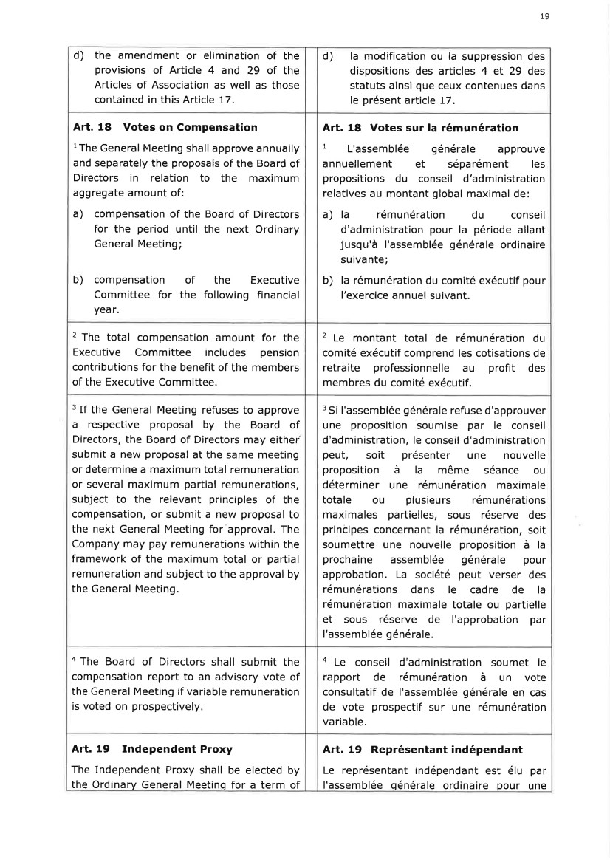 | 19 d) the amendment or elimination of the provisions of Article 4 and 29 of the Articles of Association as well as those contained in this Article 17. d) la modification ou la suppression des dispositions des articles 4 et 29 des statuts ainsi que ceux contenues dans le présent article 17. b) compensation of Committee for the yea r. the Executive following financial Art. 18 Votes on Compensation lThe General Meeting shall approve annually and separately the proposals of the Board of Directors in relation to the maximum aggregate amount of: a) compensation of the Board of Directors for the period until the next Ordinary General Meeting; Art. 18 Votes sur la rémunération 1 L'assemblée générale approuve annuellement et séparément les propositions du conseil d'administration relatives au montant global maximal de: a) la rémunération du conseil d'administration pour la période allant jusqu'à l'assemblée générale ordinaire suivante; b) la rémunération du comité exécutif pour l'exercice annuel suivant. 2 The total compensation amount for the Executive Committee includes pension contributions for the benefit of the members of the Executive Committee. 2 Le montant total de rémunération du comité exécutif comprend les cotisations de retraite professionnelle au profit des membres du comité exécutif. 3 If the General Meeting refuses to approve a respective proposal by the Board of Directors, the Board of Directors may either submit a new proposal at the same meeting or determine a maximum total remuneration or several maximum partial remunerations, subject to the relevant principles of the compensation, or submit a new proposal to the next General Meeting for approval. The Company may pay remunerations within the framework of the maximum total or partial remuneration and subject to the approval by the General Meeting. 3 Si I'assemblée générale refuse d'approuver une proposition soumise par le conseil d'ad mi nistration, le conseil d'ad ministration peut, soit présenter une nouvelle proposition à la même séance ou déterminer une rémunération maximale totale ou plusieurs rémunérations maximales partielles, sous réserve des principes concernant la rémunération, soit soumettre une nouvelle proposition à la prochaine assemblée générale pour approbation. La société peut verser des rémunérations dans le cadre de la rémunération maximale totale ou partielle et sous réserve de I'approbation par I'assemblée générale. a The Board of Directors shall submit the compensation report to an advisory vote of the General Meeting if variable remuneration is voted on prospectively. a Le conseil d'administration soumet le rapport de rémunération à un vote consultatif de I'assemblée générale en cas de vote prospectif sur une rémunération variable. Art. 19 Independent Proxy The Independent Proxy shall be elected by the Ordinary General Meeting for a term of Art. 19 Représentant indépendant Le représentant indépendant est élu par l'assemblée générale ordinaire pour une
 | 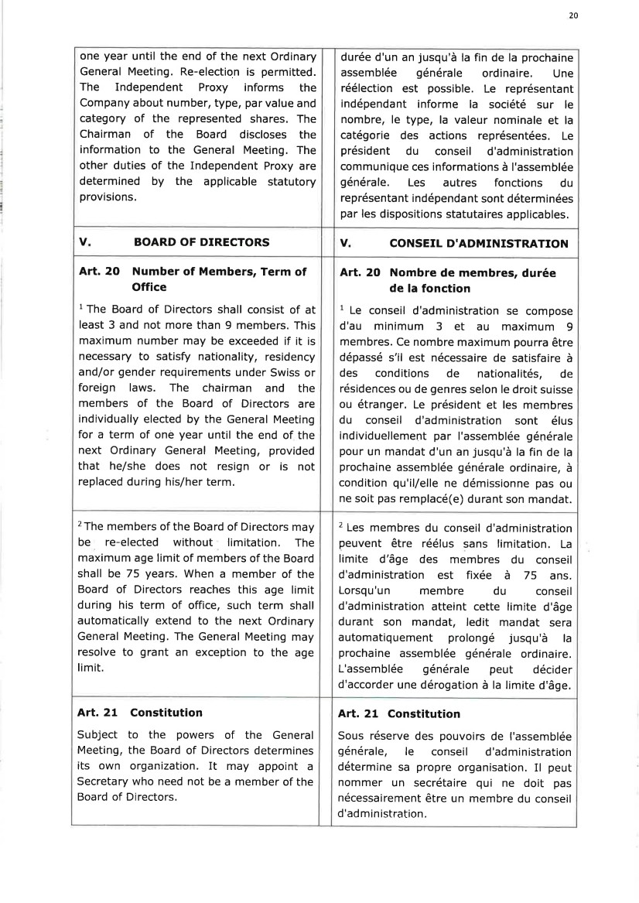 | 20 one year until the end of the next Ordinary General Meeting. Re-election is permitted. The Independent Proxy informs the Company about number, type, par value and category of the represented shares. The Chairman of the Board discloses the information to the General Meeting. The other duties of the Independent Proxy are determined by the applicable statutory provisions. durée d'un an jusqu'à la fin de la prochaine assemblée générale ordinaire. Une réélection est possible. Le représentant indépendant informe la société sur le nombre, le type, la valeur nominale et la catégorie des actions représentées. Le président du conseil d'administration communique ces informations à I'assemblée générale. Les autres fonctions du représentant indépendant sont déterminées par les dispositions statutaires applicables. v BOARD OF DIRECTORS v CONSEIL D'ADMINISTRATION Art. 2O Number of Members, Term of Office 1 The Board of Directors shall consist of at least 3 and not more than 9 members. This maximum number may be exceeded if it is necessary to satisfy nationality, residency and/or gender requirements under Swiss or foreign laws. The chairman and the members of the Board of Directors are individually elected by the General Meeting for a term of one year until the end of the next Ordinary General Meeting, provided that he/she does not resign or is not replaced during his/her term. Art. 20 Nombre de membres, durée de la fonction 1 Le conseil d'administration se compose d'au minimum 3 et au maximum 9 membres. Ce nombre maximum pourra être dépassé s'il est nécessaire de satisfaire à des conditions de nationalités, de résidences ou de genres selon le droit suisse ou étranger. Le président et les membres du conseil d'administration sont élus individuellement par I'assemblée générale pour un mandat d'un an jusqu'à la fin de la prochaine assemblée générale ordinaire, à condition qu'il/elle ne démissionne pas ou ne soit pas remplacé(e) durant son mandat. 2The members of the Board of Directors may be re-elected without limitation. The maximum age limit of members of the Board shall be 75 years. When a member of the Board of Directors reaches this age limit during his term of office, such term shall automatically extend to the next Ordinary General Meeting. The General Meeting may resolve to grant an exception to the age limit. 2 Les membres du conseil d'administration peuvent être réélus sans limitation, La limite d'âge des membres du conseil d'administration est fixée à 75 ans. Lorsqu'un membre du conseil d'administration atteint cette limite d'âge durant son mandat, ledit mandat sera automatiquement prolongé jusqu'à la prochaine assemblée générale ordinaire. L'assemblée générale peut décider d'accorder une dérogation à la limite d'âge, Art. 21 Constitution Subject to the powers of the General Meeting, the Board of Directors determines its own organization. It may appoint a Secretary who need not be a member of the Board of Directors. Art. 21 Constitution Sous réserve des pouvoirs de I'assemblée générale, le conseil d'administration détermine sa propre organisation. Il peut nommer un secrétaire qui ne doit pas nécessairement être un membre du conseil d'ad min istration,
 | 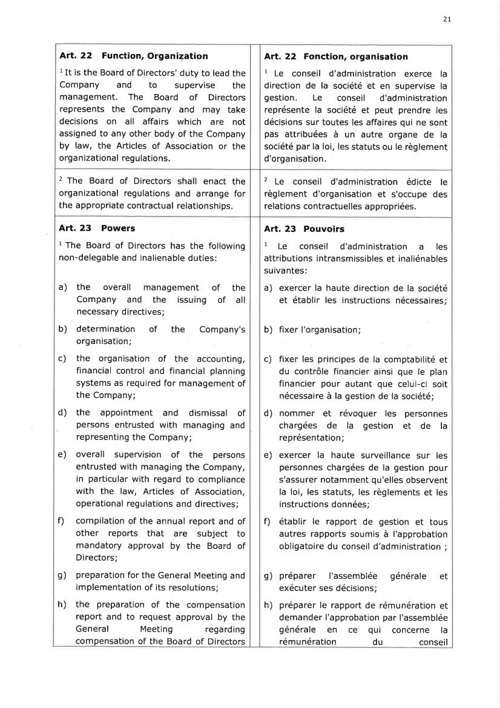 | 2l Art. 22 Function, Organization 1It is the Board of Directors' duty to lead the Company and to supervise the management. The Board of Directors represents the Company and may take decisions on all affairs which are not assigned to any other body of the Company by law, the Articles of Association or the orga nizational regulations. Art. 22 Fonction, organisation 1 Le conseil d'administration exerce la direction de la société et en supervise la gestion. Le conseil d'administration représente la société et peut prendre les décisions sur toutes les affaires qui ne sont pas attribuées à un autre organe de la société par la loi, les statuts ou le règlement d'organisation. 2 The Board of Directors shall enact the organizational regulations and arrange for the appropriate contractual relationships. 2 Le conseil d'administration édicte le règlement d'organisation et s'occupe des relations contractuelles appropriées. Art. 23 Powers 1 The Board of Directors has the following non-delegable and inalienable duties: a) the overall management of the Company and the issuing of all necessary directives; b) determination of the Company's organisation; c) the organisation of the accounting, financial control and financial planning systems as required for management of the Company; d) the appointment and dismissal of persons entrusted with managing and representing the Company; e) overall supervision of the persons entrusted with managing the Company, in particular with regard to compliance with the law, Articles of Association, operational regulations and directives; f) compilation of the annual report and of other reports that are subject to mandatory approval by the Board of Directors; g) preparation for the General Meeting and implementation of its resolutions; h) the preparation of the compensation report and to request approval by the General Meeting regarding compensation of the Board of Directors Art. 23 Pouvoirs 1 Le conseil d'administration a les attributions intransmissibles et inaliénables suivantes: a) exercer la haute direction de la société et établir les instructions nécessaires; b) fixer I'organisation; c) fixer les principes de la comptabilité et du contrôle financier ainsi que le plan financier pour autant que celui-ci soit nécessaire à la gestion de la société; d) nommer et révoquer les personnes chargées de la gestion et de la représentation; e) exercer la haute surveillance sur les personnes chargées de la gestion pour s'assurer notamment qu'elles observent la loi, les statuts, les règlements et les instructions données; f) établir le rapport de gestion et tous autres rapports soumis à l'approbation obligatoire du conseil d'administration ; g) préparer I'assemblée générale et exécuter ses décisions; h) préparer le rapport de rémunération et demander I'approbation par I'assemblée générale en ce qui concerne la rémunération du conseil
 | 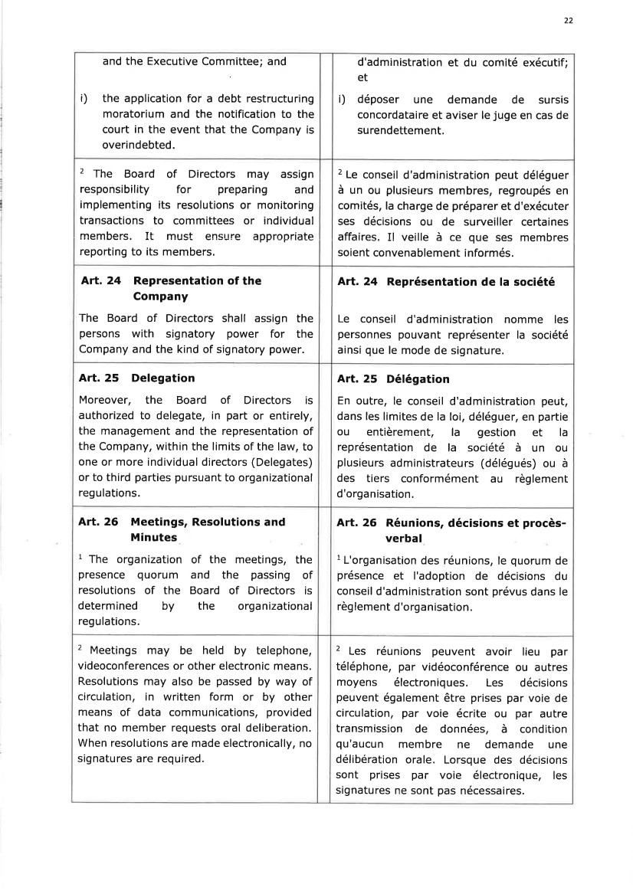 | 22 and the Executive Committee; and i) the application for a debt restructuring moratorium and the notification to the court in the event that the Company is overindebted. d'administration et du comité exécutif; et i) déposer une demande de sursis concordataire et aviser le juge en cas de surendettement. 2 The Board of Directors may assign responsibility for preparing and implementing its resolutions or monitoring transactions to committees or individual members, It must ensure appropriate reporting to its members. 2 Le conseil d'administration peut déléguer à un ou plusieurs membres, regroupés en comités, la charge de préparer et d'exécuter ses décisions ou de surveiller certaines affaires. Il veille à ce que ses membres soient convenablement informés, Att. 24 Representation of the Company The Board of Directors shall assign the persons with signatory power for the Company and the kind of signatory power. Art. 24 Représentation de la société Le conseil d'administration nomme les personnes pouvant représenter la société ainsi que le mode de signature. Art. 25 Delegation Moreover, the Board of Directors is authorized to delegate, in part or entirely, the management and the representation of the Company, within the limits of the law, to one or more individual directors (Delegates) or to third parties pursuant to organizational regulations. Art. 25 Délégation En outre, le conseil d'administration peut, dans les limites de la loi, déléguer, en partie ou entièrement, la gestion et la représentation de la société à un ou plusieurs administrateurs (délégués) ou à des tiers conformément au règlement d'organ isation. Art. 26 Meetings, Resolutions and Minutes 1 The organization presence quorum resolutions of the determined by regulations. of the meetings, the and the passing of Board of Directors is the organizational Art. 26 Réunions, décisions et procès-verbal 1L'organisation des réunions, le quorum de présence et I'adoption de décisions du conseil d'administration sont prévus dans le règlement d'organisation. 2 Meetings may be held by telephone, videoconferences or other electronic means. Resolutions may also be passed by way of circulation, in written form or by other means of data communications, provided that no member requests oral deliberation. When resolutions are made electronically, no signatures are required. 2 Les réunions peuvent avoir lieu par téléphone, par vidéoconférence ou autres moyens électroniques, Les décisions peuvent également être prises par voie de circulation, par voie écrite ou par autre transmission de données, à condition qu'aucun membre ne demande une délibération orale. Lorsque des décisions sont prises par voie électronique, les signatures ne sont pas nécessaires.
 | 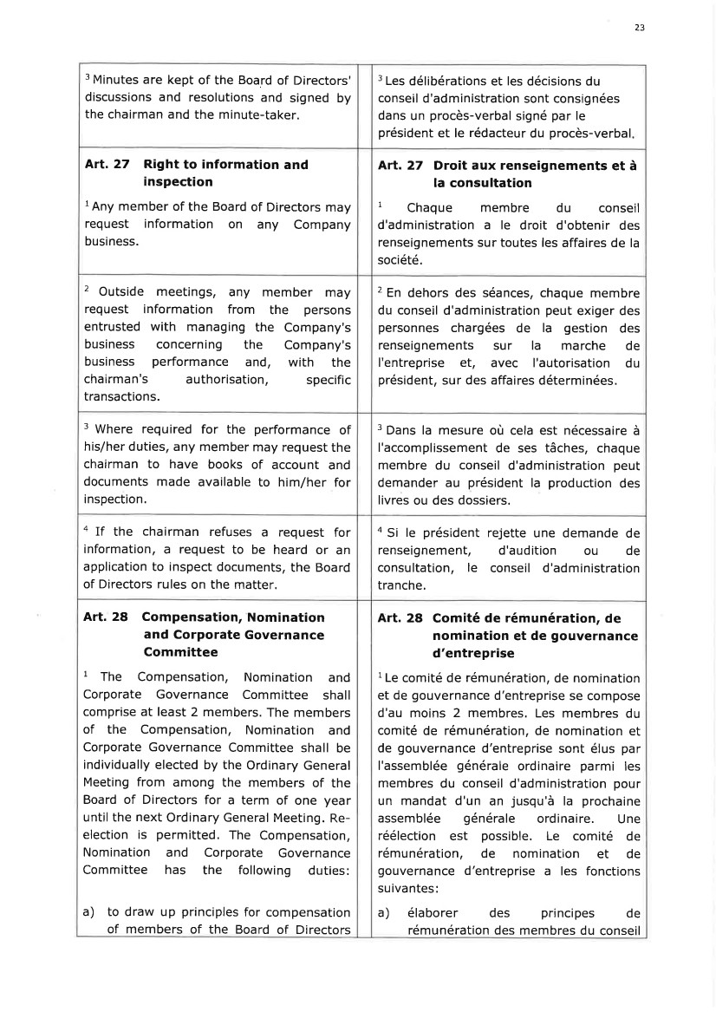 | 23 3 Minutes are kept of the Board of Directors' discussions and resolutions and signed by the chairman and the minute-taker. 3 Les délibérations et les décisions du conseil d'administration sont consignées dans un procès-verbal signé par le président et le rédacteur du procès-verbal Art.27 Right to information and inspection l Any member of the Board of Directors may request information on any Company business. Art.27 Droit aux renseignements et à la consultation 1 Chaque membre du conseil d'administration a le droit d'obtenir des renseignements sur toutes les affaires de la société. 2 Outside meetings, any member may request information from the persons entrusted with managing the Company's business concerning the Company's business performance and, with the chairman's authorisation, specific transactions. 2 En dehors des séances, chaque membre du conseil d'administration peut exiger des personnes chargées de la gestion des renseignements sur la marche de I'entreprise €t, avec I'autorisation du président, sur des affaires déterminées. 3 Where required for the performance of his/her duties, any member may request the chairman to have books of account and documents made available to him/her for inspection. 3 Dans la mesure où cela est nécessaire à l'accomplissement de ses tâches, chaque membre du conseil d'administration peut demander au président la production des livres ou des dossiers. a If the chairman refuses a request for information, a request to be heard or an application to inspect documents, the Board of Directors rules on the matter. a Si le président rejette une demande de renseignement, d'audition ou de consultation, le conseil d'administration tranche, Art. 28 Compensation, Nomination and Corporate Governance Committee I The Compensation, Nomination and Corporate Governance Committee shall comprise at least 2 members. The members of the Compensation, Nomination and Corporate Governance Committee shall be individually elected by the Ordinary General Meeting from among the members of the Board of Directors for a term of one year until the next Ordinary General Meeting. Re-election is permitted. The Compensation, Nomination and Corporate Governance Committee has the following duties: a) to draw up principles for compensation of members of the Board of Directors Art. 28 Comité de rémunération, de nomination et de gouvernance d'entreprise 1Le comité de rémunération, de nomination et de gouvernance d'entreprise se compose d'au moins 2 membres. Les membres du comité de rémunération, de nomination et de gouvernance d'entreprise sont élus par l'assemblée générale ordinaire parmi les membres du conseil d'administration pour un mandat d'un an jusqu'à la prochaine assemblée générale ordinaire. Une réélection est possible. Le comité de rémunération, de nomination et de gouvernance d'entreprise a les fonctions su iva ntes : a ) éla bore r des principes d e rémunération des membres du conseil
 | 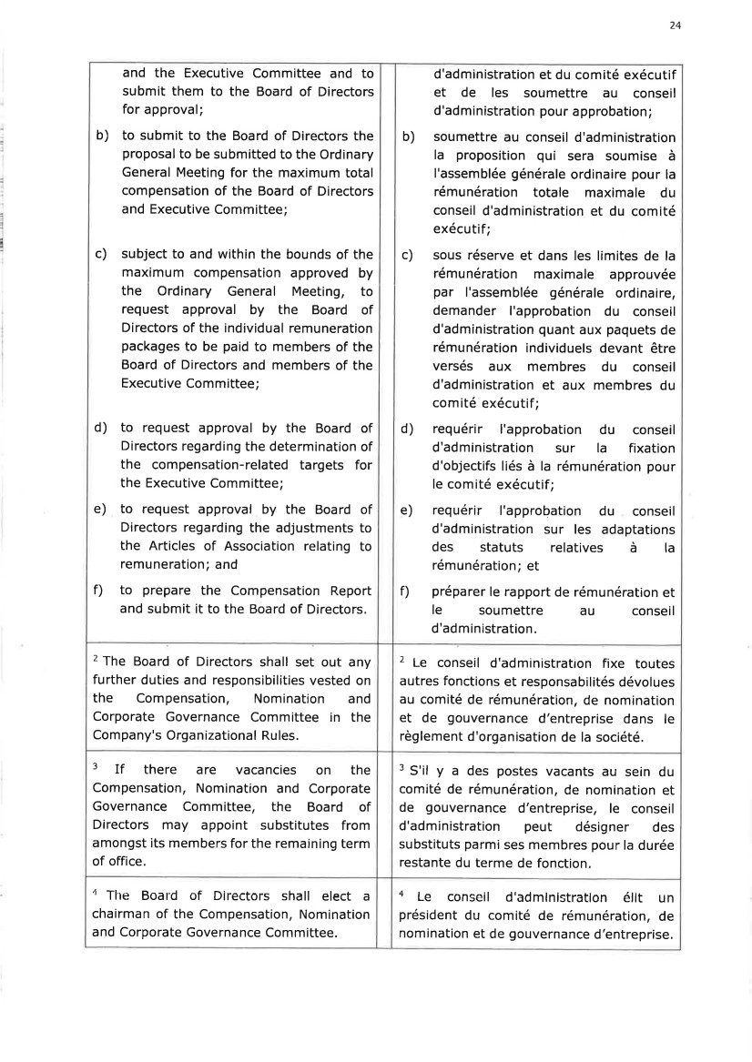 | 24 and the Executive Committee and to submit them to the Board of Directors for approval; b) to submit to the Board of Directors the proposal to be submitted to the Ordinary General Meeting for the maximum total compensation of the Board of Directors and Executive Committee; c) subject to and within the bounds of the maximum compensation approved by the Ordinary General Meeting, to request approval by the Board of Directors of the individual remuneration packages to be paid to members of the Board of Directors and members of the Executive Committee; d) to request approval by the Board of Directors regarding the determination of the compensation-related targets for the Executive Committee; e) to request approval by the Board of Directors regarding the adjustments to the Articles of Association relating to remuneration; and f) to prepare the Compensation Report and submit it to the Board of Directors. d'administration et du comité exécutif et de les soumettre au conseil d'administration pour a pprobation ; b) soumettre au conseil d'administration la proposition qui sera soumise à I'assemblée générale ordinaire pour la rémunération totale maximale du conseil d'administration et du comité exécutif ; c) sous réserve et dans les limites de la rémunération maximale approuvée par l'assemblée générale ordinaire, demander I'approbation du conseil d'administration quant aux paquets de rémunération individuels devant être versés aux membres du conseil d'administration et aux membres du comité exécutif; d) requérir I'approbation du conseil d'administration sur la fixation d'objectifs liés à la rémunération pour le comité exécutif; e) requérir l'approbation du conseil d'administration sur les adaptations des statuts relatives à la rémunération; et 0 préparer le rapport de rémunération et le soumettre au conseil d'administration. 2 The Board of Directors shall set out any further duties and responsibilities vested on the Compensation, Nomination and Corporate Governance Committee in the Company's Organizational Rules. 2 Le conseil d'administration fixe toutes autres fonctions et responsabilités dévolues au comité de rémunération, de nomination et de gouvernance d'entreprise dans le règlement d'organisation de la société. 3 If there are vacancies on the Compensation, Nomination and Corporate Governance Committee, the Board of Directors may appoint substitutes from amongst its members for the remaining term of office. 3 S'il y a des postes vacants au sein du comité de rémunération, de nomination et de gouvernance d'entreprise, le conseil d'administration peut désigner des substituts parmi ses membres pour la durée restante du terme de fonction. a The Board of Directors shall elect a chairman of the Compensation, Nomination and Corporate Governance Committee. + Le conseil d'admlnlstratlon éllt un président du comité de rémunération, de nomination et de gouvernance d'entreprise.
 | 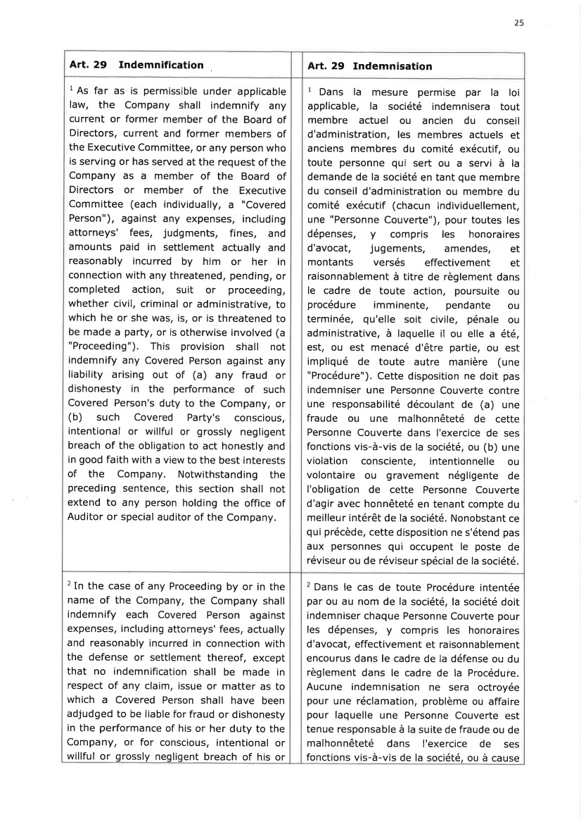 | 25 Art.29 Indemnification Art. 29 Indemnisation 1 As far as is permissible under applicable law, the Company shall indemnify any current or former member of the Board of Director5, current and former members of the Executive Committee, or any person who is serving or has served at the request of the Company as a member of the Board of Directors or member of the Executive Committee (each individually, a "Covered Person"), against any expenses, including attorneys' fees, judgments, fines, and amounts paid in settlement actually and reasonably incurred by him or her in connection with any threatened, pending, or completed action, suit or proceeding, whether civil, criminal or administrative, to which he or she was, is, or is threatened to be made a party, or is otherwise involved (a "Proceeding"). This provision shall not indemnify any Covered Person against any liability arising out of (a) any fraud or dishonesty in the performance of such Covered Person's duty to the Company, or (b) such Covered Party's conscious, intentional or willful or grossly negligent breach of the obligation to act honestly and in good faith with a view to the best interests of the Company. Notwithstanding the preceding sentence, this section shall not extend to any person holding the office of Auditor or special auditor of the Company. 1 Dans la mesure permise par la loi applicable, la société indemnisera tout membre actuel ou ancien du conseil d'administration, les membres actuels et anciens membres du comité exécutif, ou toute personne qui sert ou a servi à la demande de la société en tant que membre du conseil d'administration ou membre du comité exécutif (chacun individuellement, une "Personne Couverte"), pour toutes les dépenses, y compris les honoraires d'avocat, jugements, amendes, et montants versés effectivement et raisonnablement à titre de règlement dans le cadre de toute action, poursuite ou procédure imminente, pendante ou terminée, qu'elle soit civile, pénale ou administrative, à laquelle il ou elle a été, est, ou est menacé d'être partie, ou est impliqué de toute autre manière (une "Procédure"). Cette disposition ne doit pas indemniser une Personne Couverte contre une responsabilité découlant de (a) une fraude ou une malhonnêteté de cette Personne Couverte dans I'exercice de ses fonctions vis-à-vis de la société, ou (b) une violation consciente, intentionnelle ou volontaire ou gravement négligente de I'obligation de cette Personne Couverte d'agir avec honnêteté en tenant compte du meilleur intérêt de la société. Nonobstant ce qui précède, cette disposition ne s'étend pas aux personnes qui occupent le poste de réviseur ou de réviseur spécial de la société. 2In the case of any Proceeding by or in the name of the Company, the Company shall indemnify each Covered Person against expenses, including attorneys' fees, actually and reasonably incurred in connection with the defense or settlement thereof, except that no indemnification shall be made in respect of any claim, issue or matter as to which a Covered Person shall have been adjudged to be liable for fraud or dishonesty in the performance of his or her duty to the Company, or for conscious, intentional or willful or grossly negligent breach of his or 2 Dans le cas de toute Procédure intentée par ou au nom de la société, la société doit indemniser chaque Personne Couverte pour les dépenses, y compris les honoraires d'avocat, effectivement et raisonnablement encourus dans le cadre de la défense ou du règlement dans le cadre de la Procéduie. Aucune indemnisation ne sera octroyée pour une réclamation, problème ou affaire pour laquelle une Personne Couverte est tenue responsable à la suite de fraude ou de malhonnêteté dans l'exercice de ses fonctions vis-à-vis de la société, ou à cause
 | 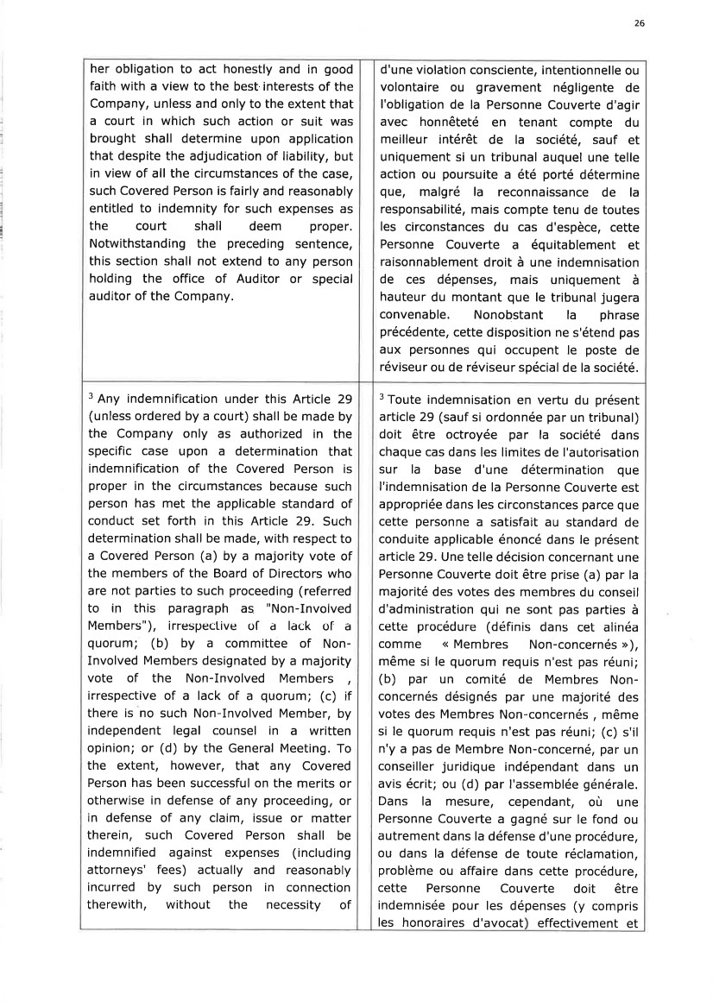 | 26 her obligation to act honestly and in good faith with a view to the best interests of the Company, unless and only to the extent that a court in which such action or suit was brought shall determine upon application that despite the adjudication of liability, but in view of all the circumstances of the case, such Covered Person is fairly and reasonably entitled to indemnity for such expenses as the court shall deem proper. Notwithstanding the preceding sentence, this section shall not extend to any person holding the office of Auditor or special auditor of the Company, d'une violation consciente, intentionnelle ou volontaire ou gravement négligente de I'obligation de la Personne Couverte d'agir avec honnêteté en tenant compte du meilleur intérêt de la société, sauf et uniquement si un tribunal auquel une telle action ou poursuite a été porté détermine gu€, malgré la reconnaissance de la responsabilité, mais compte tenu de toutes les circonstances du cas d'espèce, cette Personne Couverte a équitablement et raisonnablement droit à une indemnisation de ces dépenses, mais uniquement à hauteur du montant que le tribunal jugera convenable. Nonobstant la phrase précédente, cette disposition ne s'étend pas aux personnes qui occupent le poste de réviseur ou de réviseur spécial de la société. 'Any indemnification under this Article 29 (unless ordered by a court) shall be made by the Company only as authorized in the specific case upon a determination that indemnification of the Covered Person is proper in the circumstances because such person has met the applicable standard of conduct set forth in this Article 29. Such determination shall be made, with respect to a Covered Person (a) by a majority vote of the members of the Board of Directors who are not parties to such proceeding (referred to in this paragraph as "Non-Involved Members"), irrespective of a lack of a quorum; (b) by a committee of Non-Involved Members designated by a majority vote of the Non-Involved Members t irrespective of a lack of a quorum; (c) if there is no such Non-Involved Member, by independent legal counsel in a written opinion; or (d) by the General Meeting. To the extent, however, that any Covered Person has been successful on the merits or otherwise in defense of any proceeding, or in defense of any claim, issue or matter therein, such Covered Person shall be indemnified against expenses (including attorneys' fees) actually and reasonably incurred by such person in connection therewith, without the necessity of 3 Toute indemnisation en vertu du présent article 29 (sauf si ordonnée par un tribunal) doit être octroyée par la société dans chaque cas dans les limites de I'autorisation sur la base d'une détermination que I'indemnisation de la Personne Couverte est appropriée dans les circonstances parce que cette personne a satisfait au standard de conduite applicable énoncé dans le présent article 29. Une telle décision concernant une Personne Couverte doit être prise (a) par la majorité des votes des membres du conseil d'administration qui ne sont pas parties à cette procédure (définis dans cet alinéa comme << Membres Non-concernés ,r), même si le quorum requis n'est pas réuni; (b) par un comité de Membres Non-concernés désignés par une majorité des votes des Membres Non-concernés , même si le quorum requis n'est pas réuni; (c) s'il n'y a pas de Membre Non-concerné, par un conseiller juridique indépendant dans un avis écrit; ou (d) par I'assemblée générale. Dans la mesure, cependant, où une Personne Couverte a gagné sur le fond ou autrement dans la défense d'une procédure, ou dans la défense de toute réclamation, problème ou affaire dans cette procédure, cette Personne Couverte doit être indemnisée pour les dépenses (y compris les honoraires d'avocat effectivement et
 | 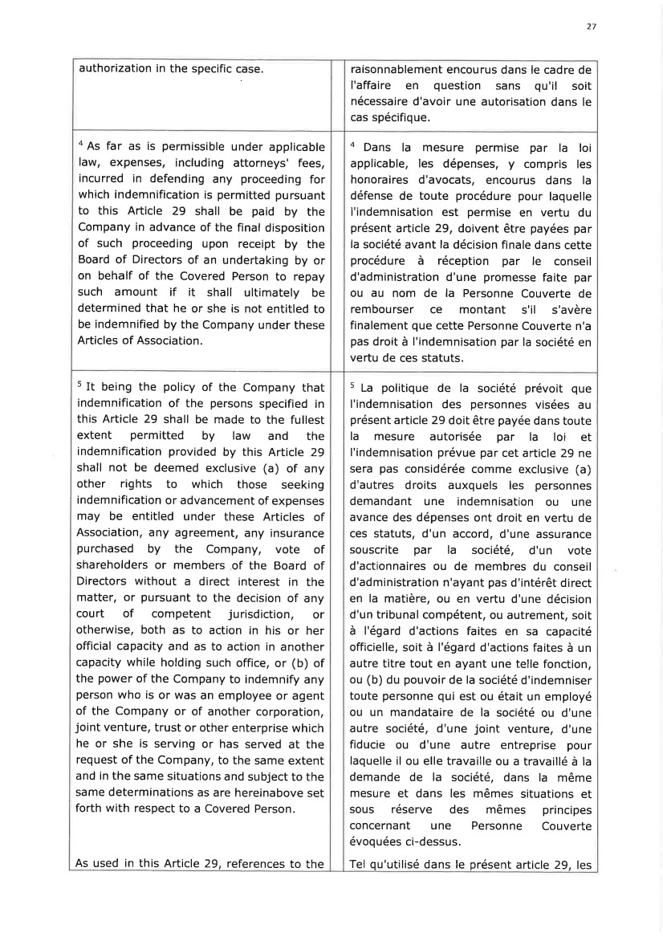 | 27 authorization in the specific case. raisonnablement encourus dans le cadre de l'affaire en question sans qu'il soit nécessaire d'avoir une autorisation dans le cas spécifique. 4 As far as is permissible under applicable law, expenses, including attorneys' fees, incurred in defending any proceeding for which indemnification is permitted pursuant to this Article 29 shall be paid by the Company in advance of the final disposition of such proceeding upon receipt by the Board of Directors of an undertaking by or on behalf of the Covered Person to repay such amount if it shall ultimately be determined that he or she is not entitled to be indemnified by the Company under these Articles of Association. 4 Dans la mesure permise par la loi applicable, les dépenses, y compris les honoraires d'avocats, encourus dans la défense de toute procédure pour laquelle I'indemnisation est permise en vertu du présent article 29, doivent être payées par la société avant la décision finale dans cette procédure à réception par le conseil d'administration d'une promesse faite par ou au nom de la Personne Couverte de rembourser ce montant s'il s'avère finalement que cette Personne Couverte n'a pas droit à l'indemnisation par la société en vertu de ces statuts. s It being the policy of the Company that indemnification of the persons specified in this Article 29 shall be made to the fullest extent permitted by law and the indemnification provided by this Article 29 shall not be deemed exclusive (a) of any other rights to which those seeking indemnification or advancement of expenses may be entitled under these Articles of Association, â[y agreement, âfy insurance purchased by the Company, vote of shareholders or members of the Board of Directors without a direct interest in the matter, or pursuant to the decision of any court of competent jurisdiction, or otherwise, both as to action in his or her official capacity and as to action in another capacity while holding such office, or (b) of the power of the Company to indemnify any person who is or was an employee or agent of the Company or of another corporation, joint venture, trust or other enterprise which he or she is serving or has served at the request of the Company, to the same extent and in the same situations and subject to the same determinations as are hereinabove set forth with respect to a Covered Person. As used in this Article 29, references to the s La politique de la société prévoit que I'indemnisation des personnes visées au présent article 29 doit être payée dans toute la mesure autorisée par la loi et I'indemnisation prévue par cet article 29 ne sera pas considérée comme exclusive (a) d'autres droits auxquels les personnes demandant une indemnisation ou une avance des dépenses ont droit en vertu de ces statuts, d'un accord, d'une assurance souscrite pa r la société, d'u n vote d'actionnaires ou de membres du conseil d'administration n'ayant pas d'intérêt direct en la matière, ou en vertu d'une décision d'un tribunal compétent, ou autrement, soit à l'égard d'actions faites en sa capacité officielle, soit à l'égard d'actions faites à un autre titre tout en ayant une telle fonction, ou (b) du pouvoir de la société d'indemniser toute personne qui est ou était un employé ou un mandataire de la société ou d'une autre société, d'une joint venture, d'une fiducie ou d'une autre entreprise pour laquelle il ou elle travaille ou a travaillé à la demande de la société, dans la même mesure et dans les mêmes situations et sous réserve des mêmes principes concernant une Personne Couverte évoquées ci-dessus. Tel qu'utilisé dans le présent article 29, les
 | 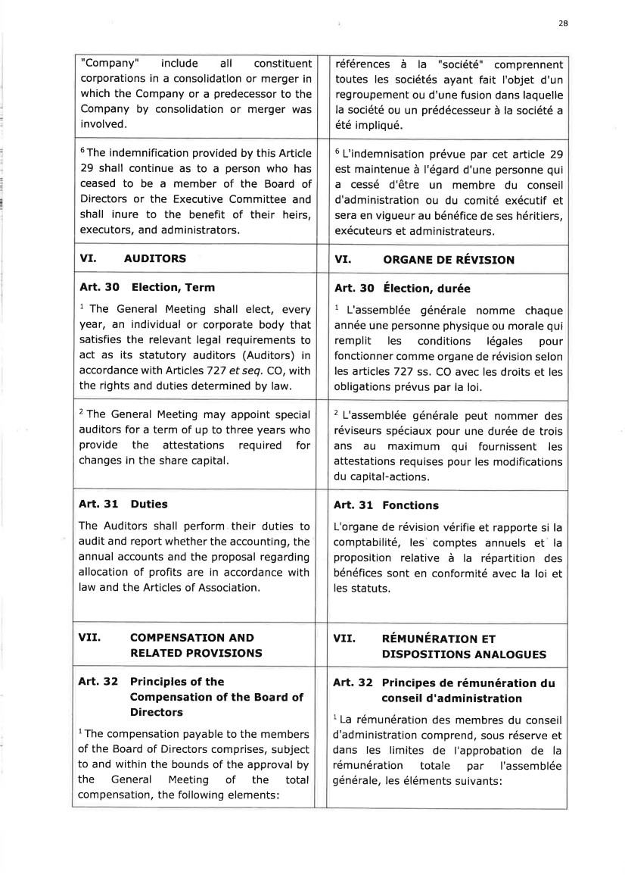 | 28 "Company" include all constituent corporations in a consolidation or merger in which the Company or a predecessor to the Company by consolidation or merger was involved. références à la "société" comprennent toutes les sociétés ayant fait I'objet d'un regroupement ou d'une fusion dans laquelle la société ou un prédécesseur à la société a été impliqué. 6The indemnification provided by this Article 29 shall continue as to a person who has ceased to be a member of the Board of Directors or the Executive Committee and shall inure to the benefit of their heirs, executors, and administrators. 6 L'indemnisation prévue par cet article 29 est maintenue à l'égard d'une personne qui a cessé d'être un membre du conseil d'administration ou du comité exécutif et sera en vigueur au bénéfice de ses héritiers, exécuteurs et administrateurs. VI. AUDITORS VI. ORGANE DE REVISION Art. 3O Election, Term 1 The General Meeting shall elect, every year, an individual or corporate body that satisfies the relevant legal requirements to act as its statutory auditors (Auditors) in accordance with ArticlesT2T et seq. CO, with the rights and duties determined by law. Art. 3O Election, durée 1 L'assemblée générale nomme chaque année une personne physique ou morale qui remplit les conditions légales pour fonctionner comme organe de révision selon les articles 727 ss. CO avec les droits et les obligations prévus par la loi. 2 The General Meeting may appoint special auditors for a term of up to three years who provide the attestations required for changes in the share capital. 2 L'assemblée générale peut nommer des réviseurs spéciaux pour une durée de trois ans au maximum qui fournissent les attestations requises pour les modifications du capital-actions. Art. 31 Duties The Auditors shall perform their duties to audit and report whether the accounting, the annual accounts and the proposal regarding allocation of profits are in accordance with law and the Articles of Association, Art. 31 Fonctions L'organe de révision vérifie et rapporte si la comptabilité, les comptes annuels et la proposition relative à la répartition des bénéfices sont en conformité avec la loi et les statuts. VII. COMPENSATION AND RELATED PROVISIONS VII. REMUNERATION ET DISPOSITIONS ANALOGU ES Art. 32 Principles of the Compensation of the Board of Directors lThe compensation payable to the members of the Board of Directors comprises, subject to and within the bounds of the approval by the General Meeting of the total compensation, the following elements: Art. 32 Principes de rémunération du conseil d'administration 1 La rémunération des membres du conseil d'administration comprend, sous réserve et dans les limites de I'approbation de la rémunération totale par I'assemblée générale, les éléments suivants:
 | 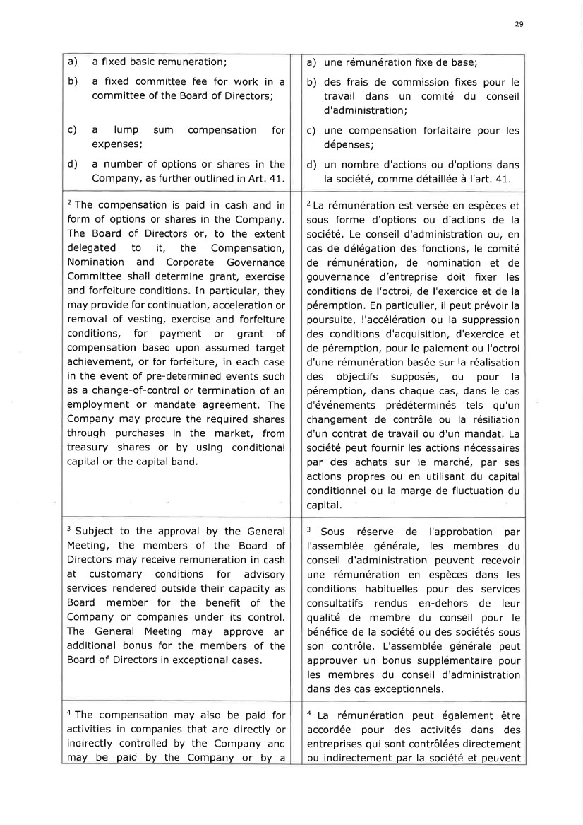 | 29 a) a fixed basic remuneration; b) a fixed committee fee for work in a committee of the Board of Directors; c) a lump sum compensation for expenses; d) a number of options or shares in the Company, as further outlined in Art. 41. a) une rémunération fixe de base; b) des frais de commission fixes pour le travail dans un comité du conseil d'administration; c) une compensation forfaitaire pour les dépenses; d) un nombre d'actions ou d'options dans la société, comme détaillée à I'art. 41. 2 The compensation is paid in cash and in form of options or shares in the Company. The Board of Directors or, to the extent delegated to it, the Compensation, Nomination and Corporate Governance Committee shall determine grant, exercise and forfeiture conditions. In particular, they may provide for continuation, acceleration or removal of vesting, exercise and forfeiture conditions, for payment or grant of compensation based upon assumed target achievement, or for forfeiture, in each case in the event of pre-determined events such as a change-of-control or termination of an employment or mandate agreement. The Company may procure the required shares through purchases in the market, from treasury shares or by using conditional capital or the capital band. 2 La rémunération est versée en espèces et sous forme d'options ou d'actions de la société, Le conseil d'administration ou, en cas de délégation des fonctions, le comité de rémunération, de nomination et de gouvernance d'entreprise doit fixer les conditions de I'octroi, de I'exercice et de la péremption. En particulier, il peut prévoir la poursuite, I'accélération ou la suppression des conditions d'acquisition, d'exercice et de péremption, pour le paiement ou I'octroi d'une rémunération basée sur la réalisation des objectifs supposés, ou pour la péremption, dans chaque cas, dans le cas d'événements prédéterminés tels qu'un changement de contrôle ou la résiliation d'un contrat de travail ou d'un mandat. La société peut fournir les actions nécessaires par des achats sur le marché, par ses actions propres ou en utilisant du capital conditionnel ou la marge de fluctuation du capital. 3 Subject to the approval by the General Meeting, the members of the Board of Directors may receive remuneration in cash at customary conditions for advisory services rendered outside their capacity as Board member for the benefit of the Company or companies under its control. The General Meeting may approve an additional bonus for the members of the Board of Directors in exceptional cases. 3 Sous réserve de I'approbation par I'assemblée générale, les membres du conseil d'administration peuvent recevoir une rémunération en espèces dans les conditions habituelles pour des services consu ltatifs rend us en-dehors d e leu r qualité de membre du conseil pour le bénéfice de la société ou des sociétés sous son contrôle. L'assemblée générale peut approuver un bonus supplémentaire pour les membres du conseil d'administration dans des cas exceptionnels. a The compensation may also be paid for activities in companies that are directly or indirectly controlled by the Company and may be paid by the Company or by a a La rémunération peut également être accordée pour des activités dans des entreprises qui sont contrôlées directement ou indirectement par la société et peuvent
 | 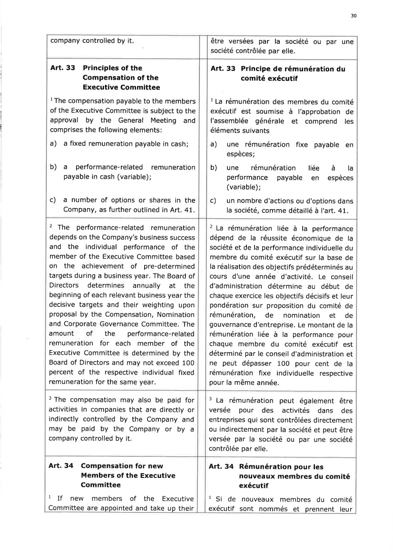 | 30 company controlled by it être versées par la société ou par une société contrôlée par elle. Art. 33 Principles of the Compensation of the Executive Committee lThe compensation payable to the members of the Executive Committee is subject to the approval by the General Meeting and comprises the following elements: a) a fixed remuneration payable in cash; b) a performance-related remuneration payable in cash (variable); c) a number of options or shares in the Company, as further outlined in Art. 41. Art. 33 Principe de rémunération du comité exécutif 1 La rémunération des membres du comité exécutif est soumise à I'approbation de I'assemblée générale et comprend les éléments suivants a) une rémunération fixe espèces; b) une rémunération performance payable (variable); payable en liée en àla espèces c) un nombre d'actions ou d'options dans la société, comme détaillé à l'art. 41. 2 The performance-related remuneration depends on the Company's business success and the individual performance of the member of the Executive Committee based on the achievement of pre-determined targets during a business year. The Board of Directors determines annually at the beginning of each relevant business year the decisive targets and their weighting upon proposal by the Compensation, Nomination and Corporate Governance Committee. The amount of the performance-related remuneration for each member of the Executive Committee is determined by the Board of Directors and may not exceed 100 percent of the respective individual fixed remuneration for the same year. 2 La rémunération liée à la performance dépend de la réussite économique de la société et de la performance individuelle du membre du comité exécutif sur la base de la réalisation des objectifs prédéterminés au cours d'une année d'activité. Le conseil d'administration détermine au début de chaque exercice les objectifs décisifs et leur pondération sur proposition du comité de rémunération, de nomination et de gouvernance d'entreprise. Le montant de la rémunération liée à la performance pour chaque merbre du comité exécutif est déterminé par le conseil d'administration et ne peut dépasser 100 pour cent de la rémunération fixe individuelle respective pour la même année. 3 The compensation may also be paid for activities in companies that are directly or indirectly controlled by the Company and may be paid by the Company or by a company controlled by it. 3 La rémunération peut également être versée pour des activités dans des entreprises qui sont contrôlées directement ou indirectement par la société et peut être versée par la société ou par une société contrôlée par elle. Art. 34 Compensation for new Members of the Executive Committee 1 If new members of the Executive Committee are a ppointed and take up their Art. 34 Rémunération pour les nouveaux membres du comité exécutif lSide exécutif nouveaux membres du comité sont nommés et prennent leur
 | 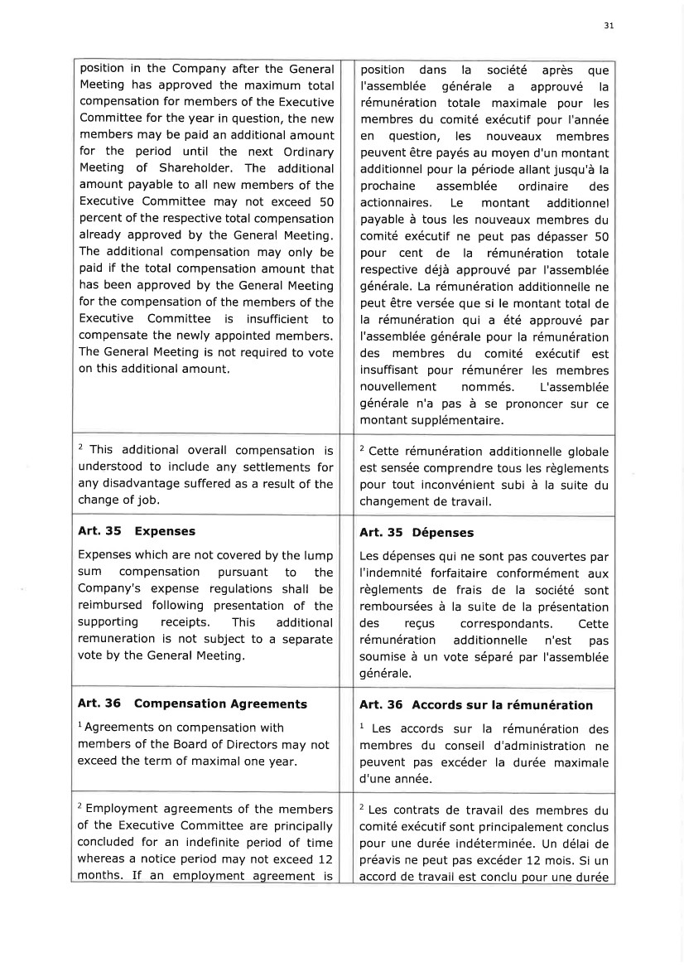 | 31 position in the Company after the General Meeting has approved the maximum total compensation for members of the Executive Committee for the year in question, the new members may be paid an additional amount for the period until the next Ordinary Meeting of Shareholder. The additional amount payable to all new members of the Executive Committee may not exceed 50 percent of the respective total compensation already approved by the General Meeting. The additional compensation may only be paid if the total compensation amount that has been approved by the General Meeting for the compensation of the members of the Executive Committee is insufficient to compensate the newly appointed members. The General Meeting is not required to vote on this additional amount, position dans la société après que l'assemblée générale a approuvé la rémunération totale maximale pour les membres du comité exécutif pour I'année en question, les nouveaux membres peuvent être payés au moyen d'un montant additionnel pour la période allant jusqu'à la prochaine assemblée ordinaire des actionnaires. Le montant additionnel payable à tous les nouveaux membres du comité exécutif ne peut pas dépasser 50 pour cent de la rémunération totale respective déjà approuvé par I'assemblée générale. La rémunération additionnelle ne peut être versée que si le montant total de la rémunération qui a été approuvé par l'assemblée générale pour la rémunération des membres du comité exécutif est insuffisant pour rémunérer les membres nouvellement nommés. L'assemblée générale n'a pas à se prononcer sur ce montant su pplémentaire. 2 This additional overall compensation is understood to include any settlements for any disadvantage suffered as a result of the change of job. 2 Cette rémunération additionnelle globale est sensée comprendre tous les règlements pour tout inconvénient subi à la suite du changement de travail. Art. 35 Expenses Expenses which are not covered by the lump sum compensation pursuant to the Company's expense regulations shall be reimbursed following presentation of the supporting receipts. This additional remuneration is not subject to a separate vote by the General Meeting, Art. 35 Dépenses Les dépenses qui ne sont pas couvertes par I'indemnité forfaitaire conformément aux règlements de frais de la société sont remboursées à la suite de la présentation des reçus correspondants. Cette rémunération additionnelle n'est pas soumise à un vote séparé par l'assemblée générale. Art. 36 Compensation Agreements lAgreements on compensation with members of the Board of Directors may not exceed the term of maximal one year. Art. 36 Accords sur la rémunération l Les accords sur la rémunération des membres du conseil d'administration ne peuvent pas excéder la durée maximale d'une année. 2 Employment agreements of the members of the Executive Committee are principally concluded for an indefinite period of time whereas a notice period may not exceed 12 months. If an employment agreement is 2 Les contrats de travail des membres du comité exécutif sont principalement conclus pour une durée indéterminée. Un délai de préavis ne peut pas excéder 12 mois. Si un accord de travail est conclu pour une durée
 | 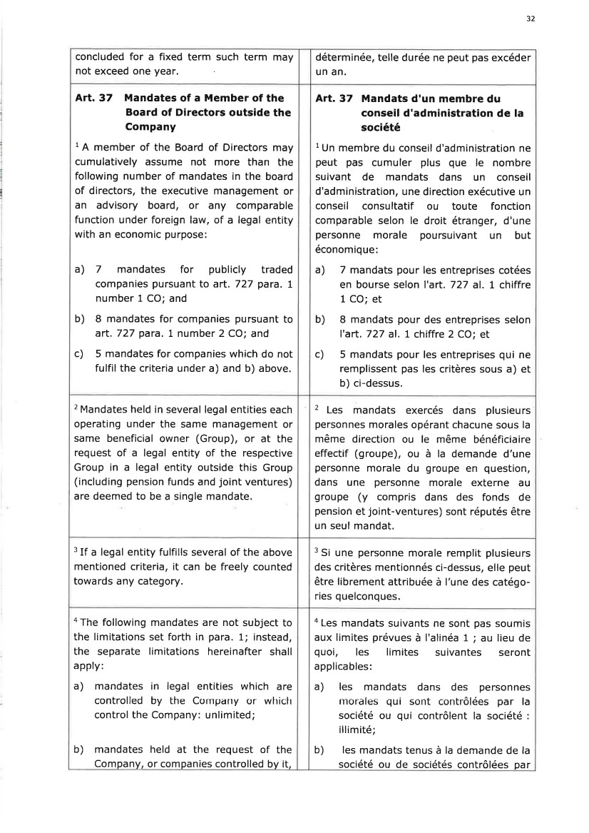 | 32 concluded for a fixed term such term may not exceed one year. déterminée, telle durée ne peut pas excéder un an, Art. 37 Mandates of a Member of the Board of Directors outside the Company 1 A member of the Board of Directors may cumulatively assume not more than the following number of mandates in the board of directors, the executive management or an advisory board, or any comparable function under foreign iaw, of a legal entity with an economic purposel a) 7 mandates for publicly traded companies pursuant to art. 727 para. t number 1 CO; and b) B mandates for companies pursuant to art.727 para. 1 number 2 CO; and c) 5 mandates for companies which do not fulfil the criteria under a) and b) above. Art. 37 Mandats d'un membre du conseil d'administration de la société 1Un membre du conseil d'administration ne peut pas cumuler plus que le nombre suivant de mandats dans un conseil d'administration, une direction exécutive un conseil consultatif ou toute fonction comparable selon le droit étranger, d'une personne morale poursuivant un but économique: a) 7 mandats pour les entreprises cotées en bourse selon I'art. 727 al. 1 chiffre 1 CO; et b) B mandats pour des entreprises selon l'arl.727 al. 1 chiffre 2 CO; et c) 5 mandats pour les entreprises qui ne remplissent pas les critères sous a) et b) ci-dessus. 2 Mandates held in several legal entities each operating under the same management or same beneficial owner (Group), or at the request of a legal entity of the respective Group in a legal entity outside this Group (including pension funds and joint ventures) are deemed to be a single mandate. 2 Les mandats exercés dans plusieurs personnes morales opérant chacune sous la même direction ou le même bénéficiaire effectif (groupe), ou à la demande d'une personne morale du groupe en question, dans une personne morale externe au groupe (y compris dans des fonds de pension et joint-ventures) sont réputés être un seul mandat. 3 If a legal entity fulfills several of the above mentioned criteria, it can be freely counted towards any category. 3 Si une personne morale remplit plusieurs des critères mentionnés ci-dessus, elle peut être librement attribuée à l'une des catégo-ries quelconques. 4 The following mandates are not subject to the limitations set forth in para. 1; instead, the separate limitations hereinafter shall apply: a) mandates in legal entities which are controlled by the Conrparry or whiclr control the Company: unlimited; b) mandates held at the request of the Company, or companies controlled by it, a Les mandats suivants ne sont pas soumis aux limites prévues à I'alinéa 1 ; au lieu de quoi, les limites suivantes seront applicables: a) les mandats dans des personnes nrorales qui sont corrtrôlées par la société ou qui contrôlent la société : illimité; b) les mandats tenus à la demande de la société ou de sociétés contrôlées par
 | 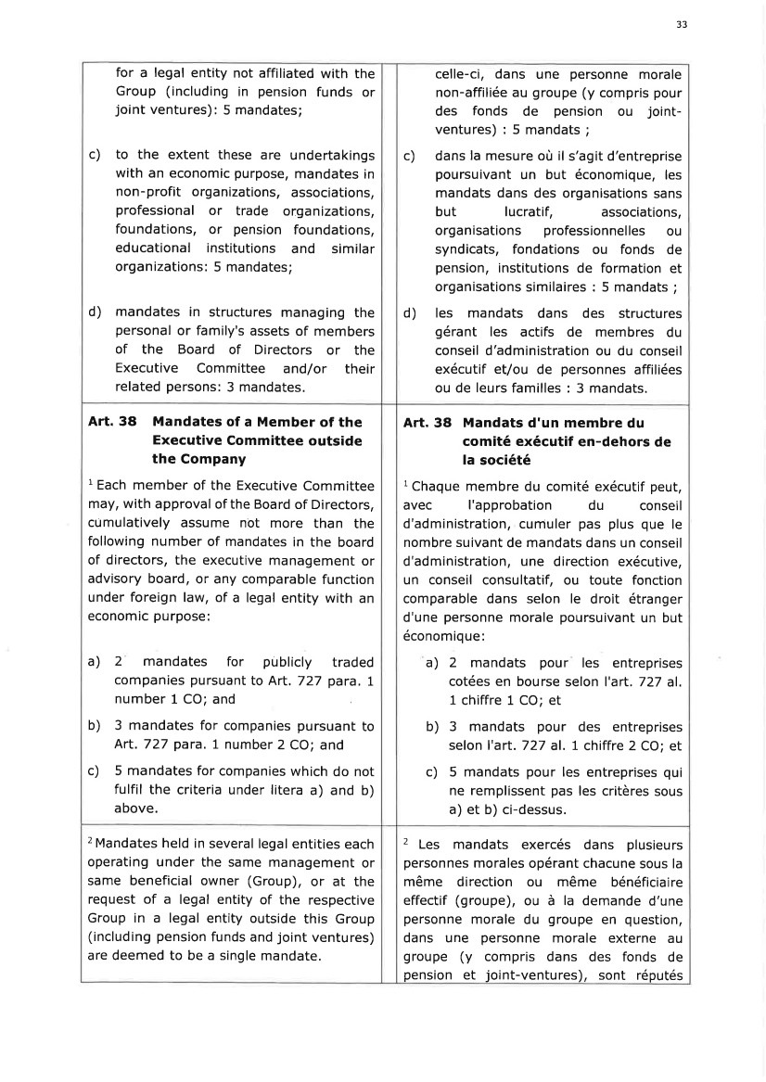 | 33 for a legal entity not affiliated with the Group (including in pension funds or joint ventures): 5 mandates; c) to the extent these are undertakings with an economic purpose, mandates in non-profit organizations, associations, professional or trade organizations, foundations, or pension foundations, educational institutions and similar organizations: 5 mandates; d) mandates in structures managing the personal or family's assets of members of the Board of Directors or the Executive Committee and/or their related persons: 3 mandates. celle-ci, dans une personne morale non-affiliée au groupe (y compris pour des fonds de pension ou joint-ventures):5mandats; c) dans la mesure où il s'agit d'entreprise poursuivant un but économique, les mandats dans des organisations sans but lucratif, associations, organisations professionnelles ou syndicats, fondations ou fonds de pension, institutions de formation et organisations similaires : 5 mandats ; d) les mandats dans des structures gérant les actifs de membres du conseil d'administration ou du conseil exécutif et/ou de personnes affiliées ou de leurs familles : 3 mandats. Art. 38 Mandates of a Member of the Executive Committee outside the Company l Each member of the Executive Committee may, with approval of the Board of Directors, cumulatively assurne nôt more than the following number of mandates in the board of directors, the executive management or advisory board, or any comparable function under foreign law, of a legal entity with an economic purpose: a) 2 mandates for publicly traded companies pursuant to Art. 727 para. I number 1 CO; and b) 3 mandates for companies pursuant to Art.727 para. 1 number 2 CO; and c) 5 mandates for companies which do not fulfil the criteria under litera a) and b) above. Art. 38 Mandats d'un membre du comité exécutif en-dehors de la société 1 Chaque membre du comité exécutif peut, avec I'approbation du conseil d'administration, cumuler pas plus que le nombre suivant de mandats dans un conseil d'administration, une direction exécutive, un conseil consultatif, ou toute fonction comparable dans selon le droit étranger d'une personne morale poursuivant un but économique: a) 2 mandats pour les entreprises cotées en bourse selon I'art. 727 al. 1 chiffre 1 CO; et b) 3 mandats pour des entreprises selon I'art. 727 al. 1 chiffre 2 CO; et c) 5 mandats pour les entreprises qui ne remplissent pas les critères sous a) et b) ci-dessus. 2 Mandates held in several legal entities each operating under the same management or same beneficial owner (Group), or at the request of a legal entity of the respective Group in a legal entity outside this Group (including pension funds and joint ventures) are deemed to be a single mandate. 2 Les mandats exercés dans plusieurs personnes morales opérant chacune sous la même direction ou même bénéficiaire effectif (groupe), ou à la demande d'une personne morale du groupe en question, dans une personne morale externe au groupe (y compris dans des fonds de pension et joint-ventures), sont réputés
 | 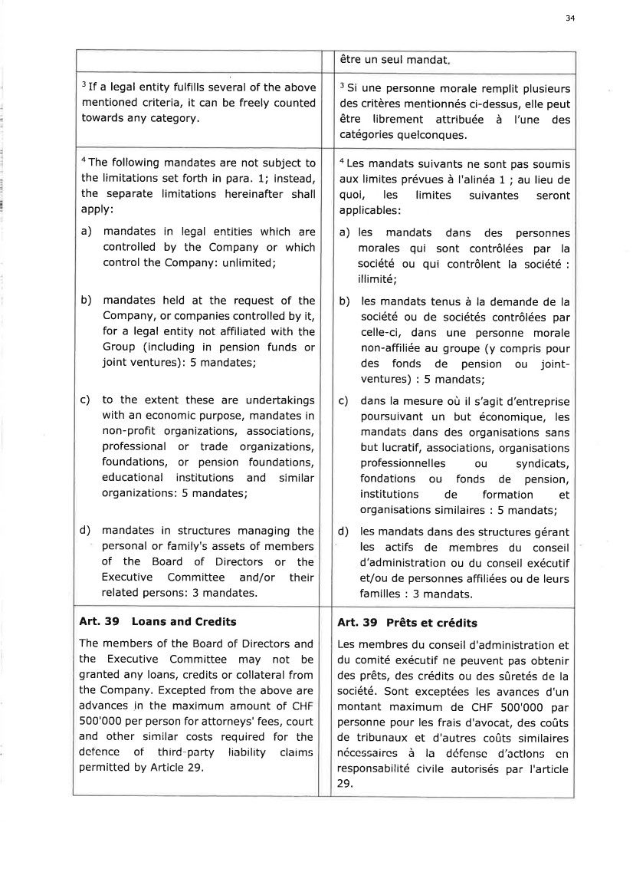 | 34 être un seul mandat 3 If a legal entity fulfills several of the above mentioned criteria, it can be freely counted towards any category. 3 Si une personne morale remplit plusieurs des critères mentionnés ci-dessus, elle peut être librement attribuée à l'une des catégories quelconques. aThe following mandates are not subject to the limitations set forth in para. 1; instead, the separate limitations hereinafter shall apply: a) mandates in legal entities which are controlled by the Company or which control the Company: unlimited; b) mandates held at the request of the Company, or companies controlled by it, for a legal entity not affiliated with the Group (including in pension funds or joint ventures): 5 mandates; c) to the extent these are undertakings with an economic purpose/ mandates in non-profit grganizations, associations, professional or trade organizations, foundations, or pension foundations, educational institutions and similar organizations: 5 mandates; d) mandates in structures managing the personal or family's assets of members of the Board of Directors or the Executive Committee and/or their related persons: 3 mandates. a Les mandats suivants ne sont pas soumis aux limites prévues à I'alinéa 1 ; au lieu de quoi, les limites suivantes seront applicables: a) les mandats dans des personnes morales qui sont contrôlées par la société ou qui contrôlent la société : illimité; b) les mandats tenus à la demande de la société ou de sociétés contrôlées par celle-ci, dans une personne morale non-affiliée au groupe (y compris pour des fonds de pension ou joint-ventures) : 5 mandats; c) dans la mesure où il s'agit d'entreprise poursuivant un but économique, les mandats dans des organisations sans but lucratif, associations, organisations professionnelles ou syndicats, fondations ou fonds de pension, institutions de formation et organisations similaires : 5 mandats; d) les mandats dans des structures gérant les actifs de membres du conseil d'administration ou du conseil exécutif et/ou de personnes affiliées ou de leurs familles : 3 mandats. Art. 39 Loans and Credits The members of the Board of Directors and the Executive Committee may not be granted any loans, credits or collateral from the Company. Excepted from the above are advances in the maximum amount of CHF 500'000 per person for attorneys' fees, court and other similar costs required for the defence of third-party liability claims permitted by Article 29. Art. 39 Prêts et crédits Les membres du conseil d'administration et du comité exécutif ne peuvent pas obtenir des prêts, des crédits ou des sûretés de la société. Sont exceptées les avances d'un montant maximum de CHF 500'000 par personne pour les frais d'avocat, des coûts de tribunaux et d'autres coûts similaires néccssaircs à la défenso d'acflons en responsabilité civile autorisés par I'article 29.
 | 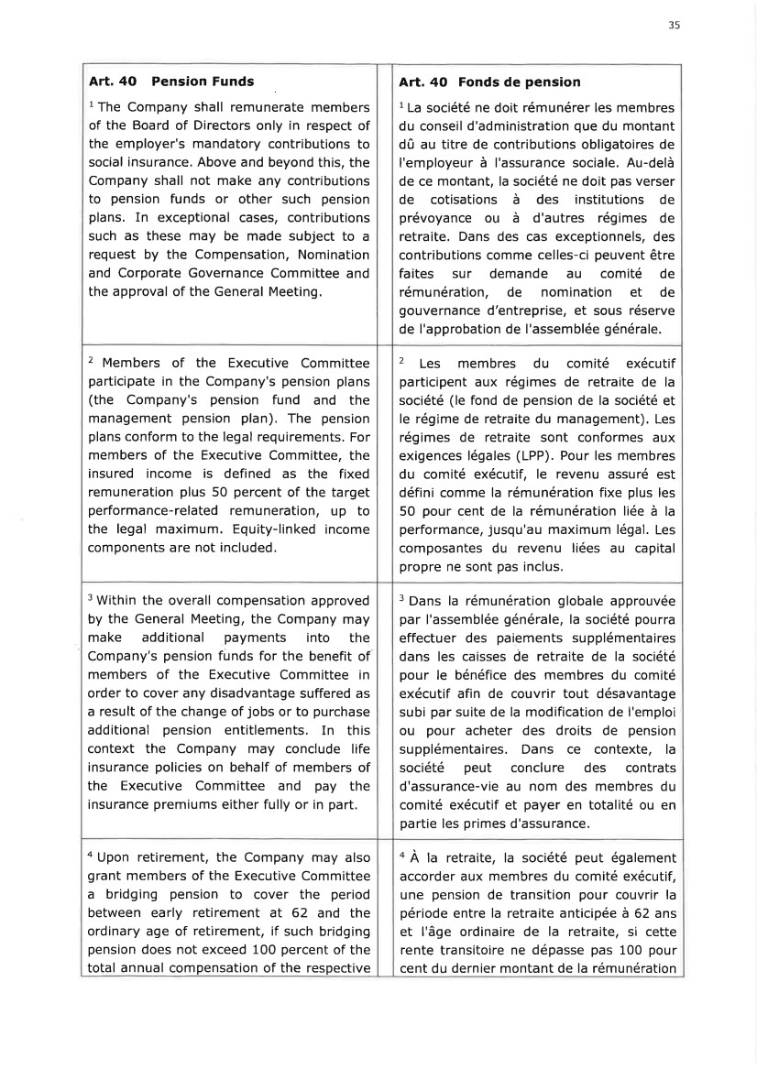 | 35 Art. 4O Pension Funds l The Company shall remunerate members of the Board of Directors only in respect of the employer's mandatory contributions to social insurance. Above and beyond this, the Company shall not make any contributions to pension funds or other such pension plans. In exceptional cases, contributions such as these may be made subject to a request by the Compensation, Nomination and Corporate Governance Committee and the approval of the General Meeting. Art. 4O Fonds de pension 1 La société ne doit rémunérer les membres du conseil d'administration que du montant dû au titre de contributions obligatoires de I'employeur à l'assurance sociale. Au-delà de ce montant, la société ne doit pas verser de cotisations à des institutions de prévoyance ou à d'autres régimes de retraite. Dans des cas exceptionnels, des contributions comme celles-ci peuvent être faites sur demande au comité de rémunération, de nomination et de gouvernance d'entreprise, et sous réserve de I'approbation de l'assemblée générale. 2 Members of the Executive Committee participate in the Company's pension plans (the Company's pension fund and the management pension plan). The pension plans conform to the legal requirements. For members of the Executive Committee, the insured income is defined as the fixed remuneration plus 50 percent of the target performance-related remuneration, up to the legal maximum. Equity-linked income components are not included. 2 Les membres du comité exécutif participent aux régimes de retraite de la société (le fond de pension de la société et le régime de retraite du management). Les régimes de retraite sont conformes aux exigences légales (LPP). Pour les membres du comité exécutif, le revenu assuré est défini comme la rémunération fixe plus les 50 pour cent de la rémunération liée à la performance, jusqu'au maximum légal. Les composantes du revenu liées au capital propre ne sont pas inclus. 3 Within the overall compensation approved by the General Meeting, the Company may make additional payments into the Company's pension funds for the benefit of members of the Executive Committee in order to cover any disadvantage suffered as a result of the change of jobs or to purchase additional pension entitlements. In this context the Company may conclude life insurance policies on behalf of members of the Executive Committee and pay the insurance premiums either fully or in part. 3 Dans la rémunération globale approuvée par l'assemblée générale, la société pourra effectuer des paiements supplémentaires dans les caisses de retraite de la société pour le bénéfice des membres du comité exécutif afin de couvrir tout désavantage subi par suite de la modification de I'emploi ou pour acheter des droits de pension supplémentaires. Dans ce contexte, la société peut conclu re des contrats d'assurance-vie au nom des membres du comité exécutif et payer en totalité ou en partie les primes d'assurance. a Upon retirement, the Company may also grant members of the Executive Committee a bridging pension to cover the period between early retirement at 62 and the ordinary age of retirement, if such bridging pension does not exceed 100 percent of the total annual compensation of the respective o À la retraite, la société peut également accorder aux membres du comité exécutif, une pension de transition pour couvrir la période entre la retraite anticipée à 62 ans et l'âge ordinaire de la retraite, si cette rente transitoire ne dépasse pas 100 pour cent du dernier montant de la rémunération
 | 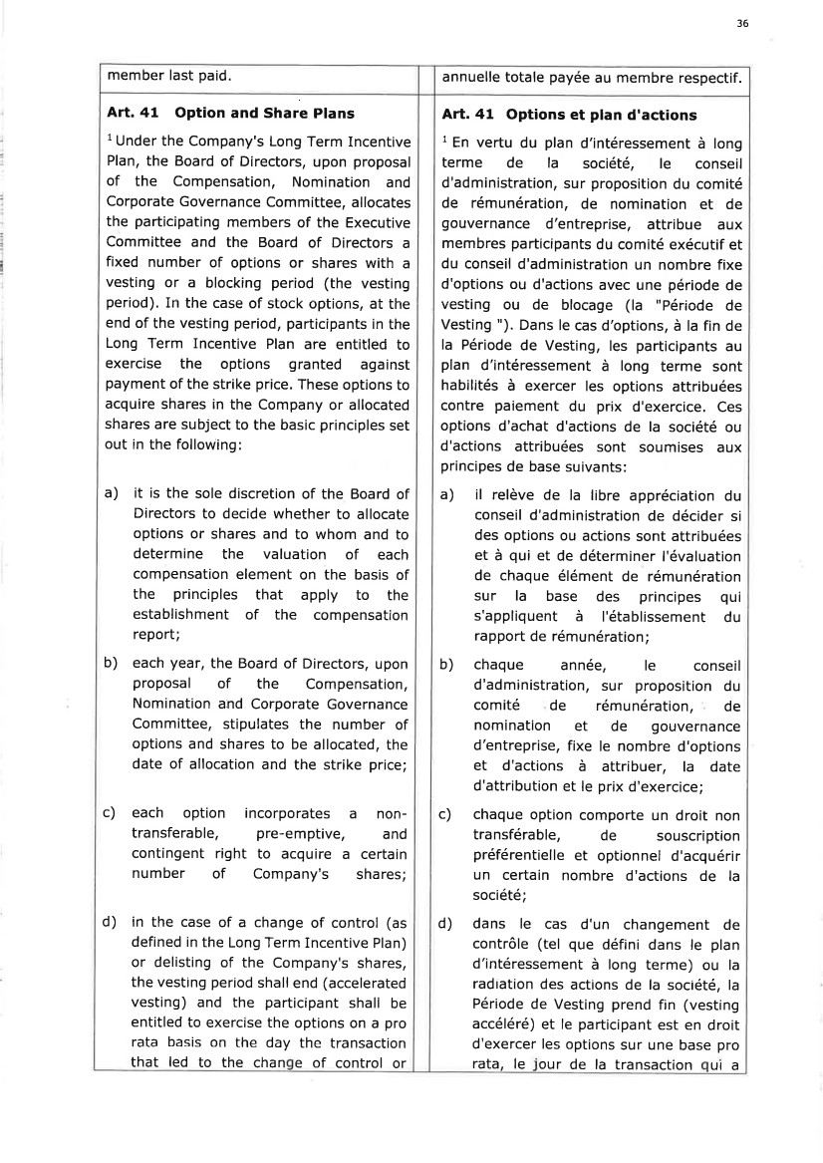 | 36 member last paid. annuelle totale payée au membre respectif. Art. 41 Option and Share Plans l Under the Company's Long Term Incentive Plan, the Board of Directors, upon proposal of the Compensation, Nomination and Corporate Governance Committee, allocates the participating members of the Executive Committee and the Board of Directors a fixed number of options or shares with a vesting or a blocking period (the vesting period). In the case of stock options, at the end of the vesting period, participants in the Long Term Incentive Plan are entitled to exercise the options granted against payment of the strike price. These options to acquire shares in the Company or allocated shares are subject to the basic principles set out in the following: a) it is the sole discretion of the Board of Directors to decide whether to allocate options or shares and to whom and to determine the valuation of each compensation element on the basis of the principles that apply to the establishment of the compensation report; b) each year, the Board of Directors, upon proposal of the Compensation, Nomination and Corporate Governance Committee, stipulates the number of options and shares to be allocated, the date of allocation and the strike price; c) each option incorporates a non-transferable, pre-emptive, and contingent right to acquire a certain number of Company's shares; d) in the case of a change of control (as defined in the Long Term Incentive Plan) or delisting of the Company's shares, the vesting period shall end (accelerated vesting) and the participant shall be entitled to exercise the options on a pro rata basis on the day the transaction that led to the chan e of control or Art. 41 Options et plan d'actions 1 En vertu du plan d'intéressement à long terme de la société, le conseil d'administration, sur proposition du comité de rémunération, de nomination et de gouvernance d'entreprise, attribue aux membres participants du comité exécutif et du conseil d'administration un nombre fixe d'options ou d'actions avec une période de vesting ou de blocage (la "Période de Vesting "). Dans le cas d'options, à la fin de la Période de Vesting, les participants au plan d'intéressement à long terme sont habilités à exercer les options attribuées contre paiement du prix d'exercice, Ces options d'achat d'actions de la société ou d'actions attribuées sont soumises aux principes de base suivants: a) il relève de la libre appréciation du conseil d'administration de décider si des options ou actions sont attribuées et à qui et de déterminer l'évaluation de chaque élément de rémunération sur la base des principes qui s'appliquent à l'établissement du rapport de rémunération ; b) chaque année, le conseil d'administration, sur proposition du comité de rémunération, de nomination et de gouvernance d'entreprise, fixe le nombre d'options et d'actions à attribuer, la date d'attribution et le prix d'exercice; c) chaque option comporte un droit non transférable, de souscription préférentielle et optionnel d'acquérir un certain nombre d'actions de la société; d) dans le cas d'un changement de contrôle (tel que défini dans le plan d'intéressement à long terme) ou la radiation des actions de la société, la Période de Vesting prend fin (vesting accéléré) et le participant est en droit d'exercer les options sur une base pro rata, le our de la transaction ui a
 | 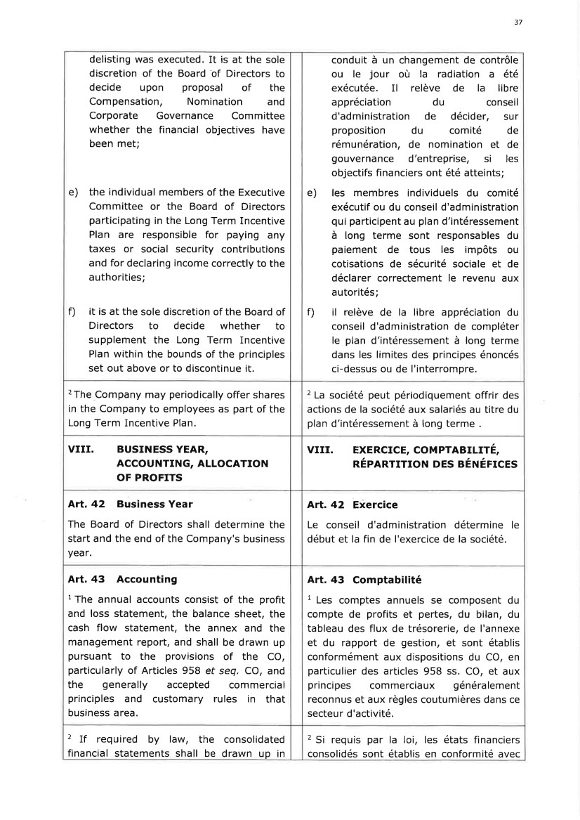 | 37 delisting was executed. It is at the sole discretion of the Board of Directors to decide upon proposal of the Compensation, Nomination and Corporate Governance Committee whether the financial objectives have been met; e) the individual members of the Executive Committee or the Board of Directors participating in the Long Term Incentive Plan are responsible for paying any taxes or social security contributions and for declaring income correctly to the authorities; f) it is at the sole discretion of the Board of Directors to decide whether to supplement the Long Term Incentive Plan within the bounds of the principles set out above or to discontinue it. conduit à un changement de contrôle ou le jour où la radiation a été exécutée. Il relève de la libre appréciation du conseil d'administration de décider, sur proposition du comité de rémunération, de nomination et de gouvernance d'entreprise, si les objectifs financiers ont été atteints; e) les membres individuels du comité exécutif ou du conseil d'administration qui participent au plan d'intéressement à long terme sont responsables du paiement de tous les impôts ou cotisations de sécurité sociale et de déclarer correctement le revenu aux autorités; f) il relève de la libre appréciation du conseil d'administration de compléter le plan d'intéressement à long terme dans les limites des principes énoncés ci-dessus ou de I'interrompre. 2The Company may periodically offer shares in the Company to employees as part of the Long Term Incentive Plan. 2 La société peut périodiquement offrir des actions de la société aux salariés au titre du plan d'intéressement à long terme . VIII. BUSTNESS YEAR, ACCOU NTING, ALLOCATION OF PROFITS VIII. EXE RCTCE, COM PTABTLTTÉ, nÉpnRrrrroN DEs eÉNÉrrces Art. 42 Business Year The Board of Directors shall determine the start and the end of the Company's business year. Art. 42 Exercice Le conseil d'administration détermine le début et la fin de I'exercice de la société. Art. 43 Accounting l The annual accounts consist of the profit and loss statement, the balance sheet, the cash flow statement, the annex and the management report, and shall be drawn up pursuant to the provisions of the CO, particularly of Articles 958 ef seq. CO, and the generally accepted commercial principles and customary rules in that business area. Art.43 Comptabilité 1 Les comptes annuels se composent du compte de profits et pertes, du bilan, du tableau des flux de trésorerie, de I'annexe et du rapport de gestion, et sont établis conformément aux dispositions du CO, en particulier des articles 958 ss. CO, et aux principes commerciaux généralement reconnus et aux règles coutumières dans ce secteur d'activité. 2 If required by law, the consolidated financial statements shall be drawn up in z Si requis par la loi, les états financiers consolidés sont établis en conformité avec
 | 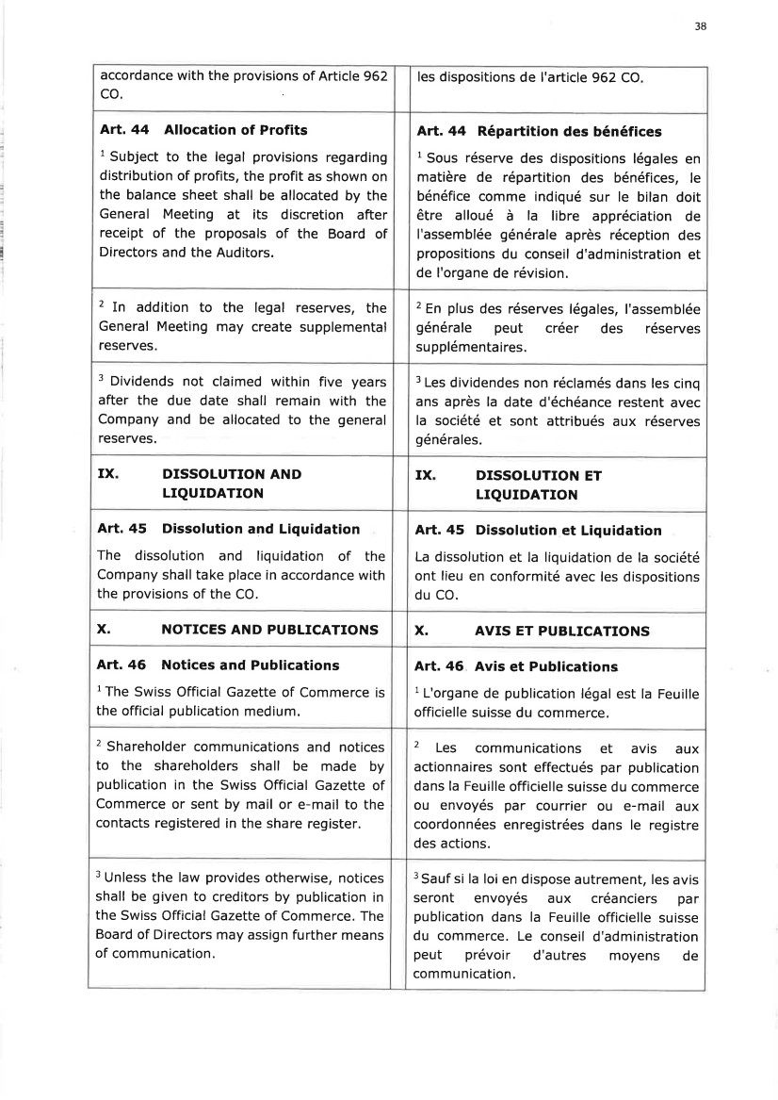 | 38 accordance with the provisions of Article 962 co. les dispositions de I'article 962 CO Art.44 Allocation of Profits 1 Subject to the legal provisions regarding distribution of profits, the profit as shown on the balance sheet shall be allocated by the General Meeting at its discretion after receipt of the proposals of the Board of Directors and the Auditors. Art.44 Répartition des bénéfices I Sous réserve des dispositions légales en matière de répartition des bénéfices, le bénéfice comme indiqué sur le bilan doit être alloué à la libre appréciation de I'assemblée générale après réception des propositions du conseil d'administration et de I'organe de révision. 2 In addition to the legal reserves, the General Meeting may create supplemental reseryes. 2 En plus des réserves légales, I'assemblée générale peut créer des réserves supplémentaires. 3 Dividends not claimed within five years after the due date shall remain with the Company and be allocated to the general reserves. 3 Les dividendes non réclamés dans les cinq ans après la date d'échéance restent avec la société et sont attribués aux réserves générales. IX DISSOTUTION AND LIQUIDATION IX DISSOLUTION ET LIQUIDATION Art. 45 Dissolution and Liquidation The dissolution and liquidation of the Company shall take place in accordance with the provisions of the CO. Art. 45 Dissolution et Liquidation La dissolution et la liquidation de la société ont lieu en conformité avec les dispositions du CO. x. NOTICES AND PUBLICATIONS x. AVIS ET PUBLICATIONS Art. 46 Notices and Publications l The Swiss Official Gazette of Commerce is the official publication medium. Art. 46. Avis et Publications 1 L'organe de publication légal est la Feuille officielle suisse du commerce. 2 Shareholder communications and notices to the shareholders shall be made by publication in the Swiss Official Gazette of Commerce or sent by mail or e-mail to the contacts registered in the share register. 2 Les communications et avis aux actionnaires sont effectués par publication dans la Feuille officielle suisse du commerce ou envoyés par courrier ou e-mail aux coordonnées enregistrées dans le registre des actions. 3 Unless the law provides otherwise, notices shall be given to creditors by publication in the Swiss Official Gazette of Commerce. The Board of Directors may assign further means of communication. 3 Sauf si la loi en dispose autrement, les avis seront envoyés aux créanciers par publication dans la Feuille officielle suisse du commerce. Le conseil d'administration peut prévoir d'autres moyens de communication.
 |  | 39 STATUTS modifiés lors de I'assemblée générale ordinaire du 11 juin 2026, I'atteste ffor

