UNITED STATES
SECURITIES AND EXCHANGE COMMISSION
Washington, D.C. 20549

FORM 6-K

REPORT OF FOREIGN PRIVATE ISSUER PURSUANT TO RULE 13a-16
OR
15d-16 UNDER THE SECURITIES EXCHANGE ACT OF 1934

For the month of September, 2026

Commission file number: 001-37891

AC IMMUNE SA
(Exact Name of Registrant as Specified in Its Charter)

EPFL Innovation Park
Building B
1015 Lausanne, Switzerland
(Address of Principal Executive Offices)

Indicate by check mark whether the registrant files or will file annual reports under cover of Form 20-F or Form 40-F.

Form 20-F | ☒ | Form 40-F | ☐

INFORMATION CONTAINED IN THIS REPORT ON FORM 6-K

Extraordinary General Meeting

On September 2, 2026, AC Immune SA (the “Company”) published its Extraordinary General Meeting (“EGM”) Invitation and General Meeting Proxy Cards for the EGM to be held on October 2, 2026. A copy of the EGM Invitation and General Meeting Proxy Cards are attached as Exhibits 99.1, 99.2 and 99.3 to this Report on Form 6-K.

Proposed New Board Member

At the EGM, the Company will propose Tom Graney for election as a member of the Board of Directors (“Board”) for a term of office until the end of the Annual General Meeting in 2027. Subject to his election, the Board intends to appoint Mr. Graney as a member of the Audit and Finance Committee.

Mr. Graney is an experienced health-care executive with a strong background in company management, financing and business development. He has over 25 years’ diverse experience in biopharma. His industry experience comprises time spent as CFO at Vertex Pharmaceuticals, Ironwood Pharmaceuticals and Generation Bio after a long career at Johnson & Johnson, which included four years as worldwide Vice President of Finance and CFO of Ethicon. In addition, Mr. Graney is already familiar with the Company thanks to his prior mandate as Board member from 2016 until 2023. Most recently, Mr. Graney has been appointed CFO, then CEO of Oxurion, a clinical-stage biopharmaceutical company developing next-generation ophthalmic therapies. To date, he has contributed towards the raising of more than USD 500 million on both private and public capital markets. A Chartered Financial Analyst, Certified Financial Manager and Management Accountant, Mr. Graney holds a BS in accounting from the University of Delaware and an MBA in Marketing, Finance and International Business from the Leonard N. Stern School of Business at New York University.

Board Member Not Standing for Re-election

Carl June has decided to step down from the Board and the Audit and Finance Committee, effective as of the EGM. His decision was not because of a disagreement with the Company on any matter relating to the Company’s operations, policies, or practices. The Company thanks him sincerely for his contributions to the Board and wishes him well in his future endeavors.

EXHIBIT INDEX

Exhibit  Number |  | Description
99.1 |  | Invitation to Extraordinary General Shareholders’ Meeting
99.2 |  | 2026 Extraordinary General Meeting Proxy Card (Common Share Record Holders)
99.3 |  | 2026 Extraordinary General Meeting Proxy Card (Brokers)

SIGNATURE

Pursuant to the requirements of the Securities Exchange Act of 1934, the registrant has duly caused this report to be signed on its behalf by the undersigned, thereunto duly authorized.

 | AC IMMUNE SA
 | By: | /s/ Martin Zügel
 |  | Name: Martin Zügel
 |  | Title: Interim Chief Executive Officer
 | By: | /s/ Christopher Roberts
 |  | Name: Christopher Roberts
 |  | Title: Chief Financial Officer
Date: September 3, 2026

Exhibit 99.1


INVITATION TO EXTRAORDINARY GENERAL MEETING 2026 to the Shareholders of AC Immune SA Friday, 2 October 2026 1:30 pm CEST 7:30 am EST

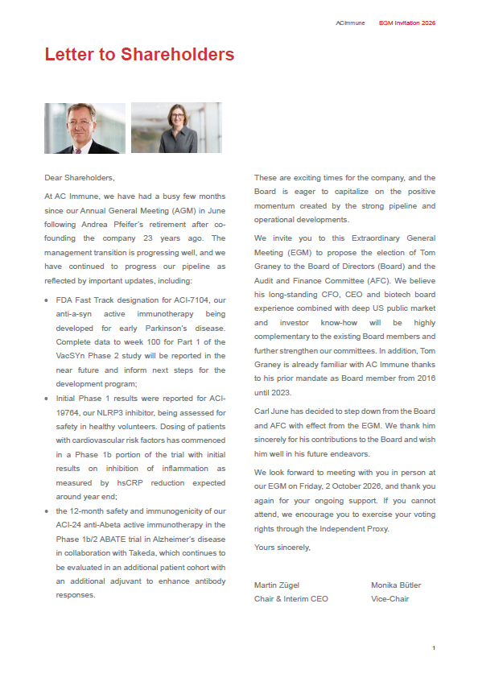
ACImmune EGM Invitation 2026 Letter to Shareholders Dear Shareholders, At AC Immune, we have had a busy few months since our Annual General Meeting (AGM) in June following Andrea Pfeifer’s retirement after co - founding the company 23 years ago . The management transition is progressing well, and we have continued to progress our pipeline as reflected by important updates, including : • FDA Fast Track designation for ACI - 7104 , our anti - a - syn active immunotherapy being developed for early Parkinson’s disease . Complete data to week 100 for Part 1 of the VacSYn Phase 2 study will be reported in the near future and inform next steps for the development program ; • Initial Phase 1 results were reported for ACI - 19764 , our NLRP 3 inhibitor, being assessed for safety in healthy volunteers . Dosing of patients with cardiovascular risk factors has commenced in a Phase 1 b portion of the trial with initial results on inhibition of inflammation as measured by hsCRP reduction expected around year end ; • the 12 - month safety and immunogenicity of our ACI - 24 anti - Abeta active immunotherapy in the Phase 1 b/ 2 ABATE trial in Alzheimer’s disease in collaboration with Takeda, which continues to be evaluated in an additional patient cohort with an additional adjuvant to enhance antibody responses . These are exciting times for the company, and the Board is eager to capitalize on the positive momentum created by the strong pipeline and operational developments . We invite you to this Extraordinary General Meeting (EGM) to propose the election of Tom Graney to the Board of Directors (Board) and the Audit and Finance Committee (AFC) . We believe his long - standing CFO, CEO and biotech board experience combined with deep US public market and investor know - how will be highly complementary to the existing Board members and further strengthen our committees . In addition, Tom Graney is already familiar with AC Immune thanks to his prior mandate as Board member from 2016 until 2023 . Carl June has decided to step down from the Board and AFC with effect from the EGM . We thank him sincerely for his contributions to the Board and wish him well in his future endeavors . We look forward to meeting with you in person at our EGM on Friday, 2 October 2026 , and thank you again for your ongoing support . If you cannot attend, we encourage you to exercise your voting rights through the Independent Proxy . Yours sincerely, Martin Zügel Chair & Interim CEO Monika Bütler Vice - Chair 1

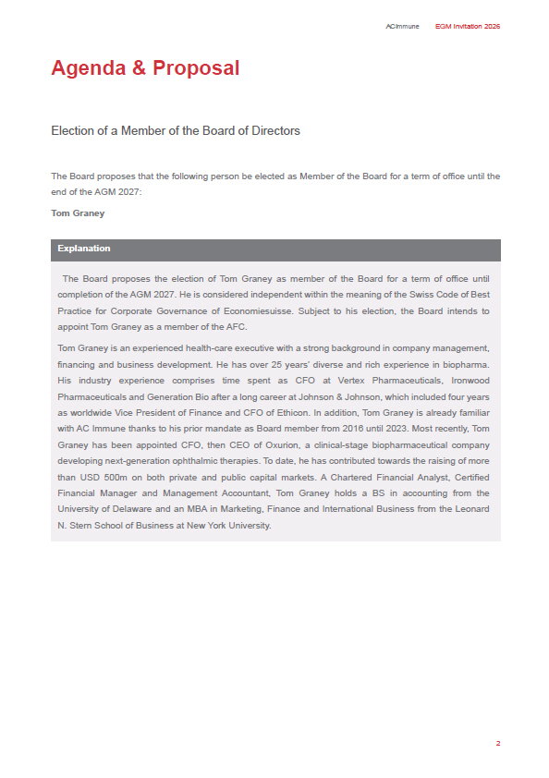
2 ACImmune EGM Invitation 2026 Agenda & Proposal Election of a Member of the Board of Directors The Board proposes that the following person be elected as Member of the Board for a term of office until the end of the AGM 2027: Tom Graney Explanation The Board proposes the election of Tom Graney as member of the Board for a term of office until completion of the AGM 2027 . He is considered independent within the meaning of the Swiss Code of Best Practice for Corporate Governance of Economiesuisse . Subject to his election, the Board intends to appoint Tom Graney as a member of the AFC . Tom Graney is an experienced health - care executive with a strong background in company management, financing and business development . He has over 25 years’ diverse and rich experience in biopharma . His industry experience comprises time spent as CFO at Vertex Pharmaceuticals, Ironwood Pharmaceuticals and Generation Bio after a long career at Johnson & Johnson, which included four years as worldwide Vice President of Finance and CFO of Ethicon . In addition, Tom Graney is already familiar with AC Immune thanks to his prior mandate as Board member from 2016 until 2023 . Most recently, Tom Graney has been appointed CFO, then CEO of Oxurion, a clinical - stage biopharmaceutical company developing next - generation ophthalmic therapies . To date, he has contributed towards the raising of more than USD 500 m on both private and public capital markets . A Chartered Financial Analyst, Certified Financial Manager and Management Accountant, Tom Graney holds a BS in accounting from the University of Delaware and an MBA in Marketing, Finance and International Business from the Leonard N . Stern School of Business at New York University .

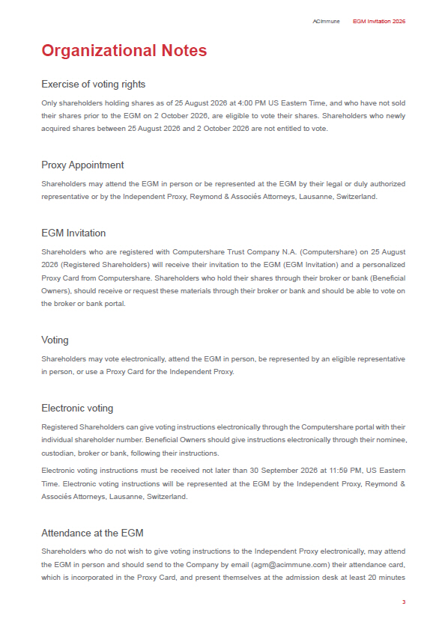
3 ACImmune EGM Invitation 2026 Organizational Notes Exercise of voting rights Only shareholders holding shares as of 25 August 2026 at 4 : 00 PM US Eastern Time, and who have not sold their shares prior to the EGM on 2 October 2026 , are eligible to vote their shares . Shareholders who newly acquired shares between 25 August 2026 and 2 October 2026 are not entitled to vote . Proxy Appointment Shareholders may attend the EGM in person or be represented at the EGM by their legal or duly authorized representative or by the Independent Proxy, Reymond & Associés Attorneys, Lausanne, Switzerland. EGM Invitation Shareholders who are registered with Computershare Trust Company N . A . (Computershare) on 25 August 2026 (Registered Shareholders) will receive their invitation to the EGM (EGM Invitation) and a personalized Proxy Card from Computershare . Shareholders who hold their shares through their broker or bank (Beneficial Owners), should receive or request these materials through their broker or bank and should be able to vote on the broker or bank portal . Voting Shareholders may vote electronically, attend the EGM in person, be represented by an eligible representative in person, or use a Proxy Card for the Independent Proxy. Electronic voting Registered Shareholders can give voting instructions electronically through the Computershare portal with their individual shareholder number . Beneficial Owners should give instructions electronically through their nominee, custodian, broker or bank, following their instructions . Electronic voting instructions must be received not later than 30 September 2026 at 11 : 59 PM, US Eastern Time . Electronic voting instructions will be represented at the EGM by the Independent Proxy, Reymond & Associés Attorneys, Lausanne, Switzerland . Attendance at the EGM Shareholders who do not wish to give voting instructions to the Independent Proxy electronically, may attend the EGM in person and should send to the Company by email (agm@acimmune . com) their attendance card, which is incorporated in the Proxy Card, and present themselves at the admission desk at least 20 minutes

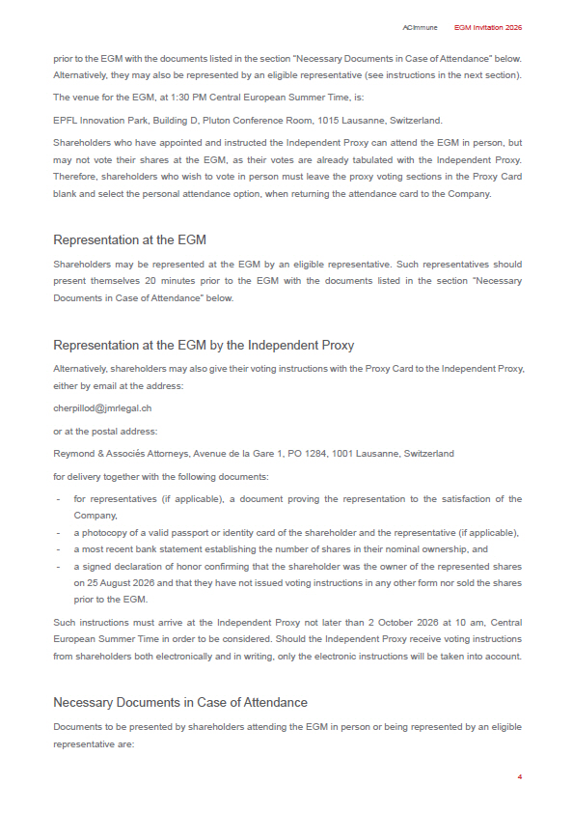
4 ACImmune EGM Invitation 2026 prior to the EGM with the documents listed in the section “Necessary Documents in Case of Attendance” below . Alternatively, they may also be represented by an eligible representative (see instructions in the next section) . The venue for the EGM, at 1 : 30 PM Central European Summer Time, is : EPFL Innovation Park, Building D, Pluton Conference Room, 1015 Lausanne, Switzerland . Shareholders who have appointed and instructed the Independent Proxy can attend the EGM in person, but may not vote their shares at the EGM, as their votes are already tabulated with the Independent Proxy . Therefore, shareholders who wish to vote in person must leave the proxy voting sections in the Proxy Card blank and select the personal attendance option, when returning the attendance card to the Company . Representation at the EGM Shareholders may be represented at the EGM by an eligible representative . Such representatives should present themselves 20 minutes prior to the EGM with the documents listed in the section “Necessary Documents in Case of Attendance” below . Representation at the EGM by the Independent Proxy Alternatively, shareholders may also give their voting instructions with the Proxy Card to the Independent Proxy, either by email at the address: cherpillod@jmrlegal.ch or at the postal address: Reymond & Associés Attorneys, Avenue de la Gare 1, PO 1284, 1001 Lausanne, Switzerland for delivery together with the following documents: - for representatives (if applicable), a document proving the representation to the satisfaction of the Company, - a photocopy of a valid passport or identity card of the shareholder and the representative (if applicable), - a most recent bank statement establishing the number of shares in their nominal ownership, and - a signed declaration of honor confirming that the shareholder was the owner of the represented shares on 25 August 2026 and that they have not issued voting instructions in any other form nor sold the shares prior to the EGM . Such instructions must arrive at the Independent Proxy not later than 2 October 2026 at 10 am, Central European Summer Time in order to be considered . Should the Independent Proxy receive voting instructions from shareholders both electronically and in writing, only the electronic instructions will be taken into account . Necessary Documents in Case of Attendance Documents to be presented by shareholders attending the EGM in person or being represented by an eligible representative are:

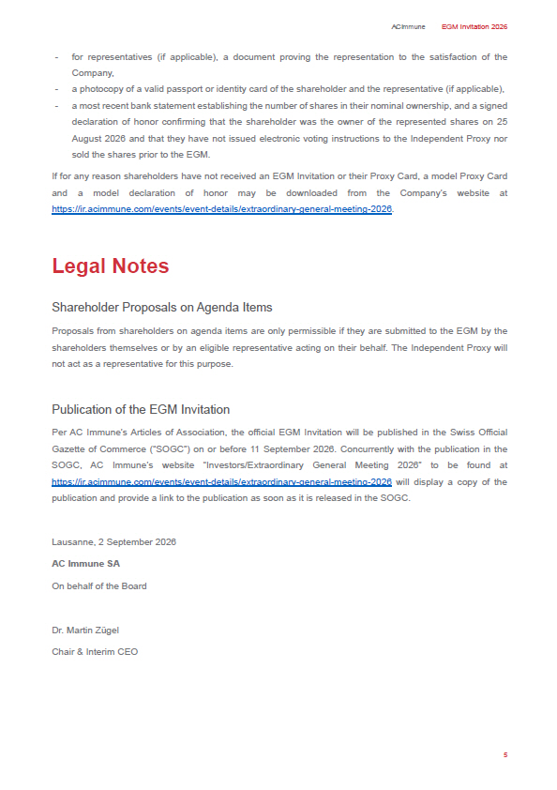
5 ACImmune EGM Invitation 2026 - for representatives (if applicable), a document proving the representation to the satisfaction of the Company, - a photocopy of a valid passport or identity card of the shareholder and the representative (if applicable), - a most recent bank statement establishing the number of shares in their nominal ownership, and a signed declaration of honor confirming that the shareholder was the owner of the represented shares on 25 August 2026 and that they have not issued electronic voting instructions to the Independent Proxy nor sold the shares prior to the EGM . If for any reason shareholders have not received an EGM Invitation or their Proxy Card, a model Proxy Card and a model declaration of honor may be downloaded from the Company’s website at https : //ir . acimmune . com/events/event - details/extraordinary - general - meeting - 2026 . Legal Notes Shareholder Proposals on Agenda Items Proposals from shareholders on agenda items are only permissible if they are submitted to the EGM by the shareholders themselves or by an eligible representative acting on their behalf . The Independent Proxy will not act as a representative for this purpose . Publication of the EGM Invitation Per AC Immune’s Articles of Association, the official EGM Invitation will be published in the Swiss Official Gazette of Commerce (“SOGC”) on or before 11 September 2026 . Concurrently with the publication in the SOGC, AC Immune’s website “Investors/Extraordinary General Meeting 2026 ” to be found at https : //ir . acimmune . com/events/event - details/extraordinary - general - meeting - 2026 will display a copy of the publication and provide a link to the publication as soon as it is released in the SOGC . Lausanne, 2 September 2026 AC Immune SA On behalf of the Board Dr. Martin Zügel Chair & Interim CEO

Exhibit 99.2

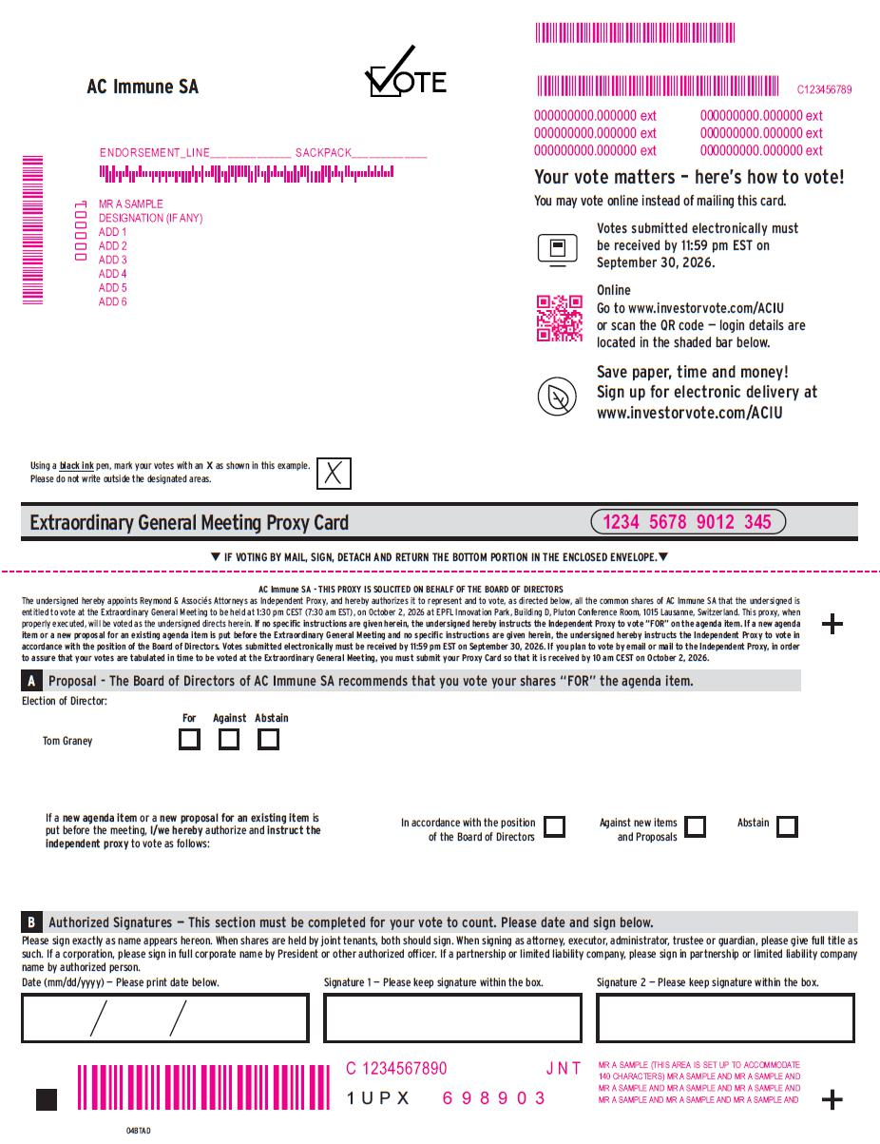
Tom Graney If a new agenda item or a new proposal for an existing item is put before the meeting, I/we hereby authorize and instruct the independent proxy to vote as follows : 1 U P X For Against Abstain In accordance with the position of the Board of Directors Against new items and Proposals Abstain AC Immune SA Proposal - The Board of Directors of AC Immune SA recommends that you vote your shares “FOR” the agenda item. A 04BTAD Election of Director: Please sign exactly as name appears hereon . When shares are held by joint tenants, both should sign . When signing as attorney, executor, administrator, trustee or guardian, please give full title as such . If a corporation, please sign in full corporate name by President or other authorized officer . If a partnership or limited liability company, please sign in partnership or limited liability company name by authorized person . Date (mm/dd/yyyy) — Please print date below . Signature 1 — Please keep signature within the box . Signature 2 — Please keep signature within the box . Authorized Signatures — This section must be completed for your vote to count. Please date and sign below. B Extraordinary General Meeting Proxy Card 1234 5678 9012 345 Using a black ink pen, mark your votes with an X as shown in this example. Please do not write outside the designated areas. T IF VOTING BY MAIL, SIGN, DETACH AND RETURN THE BOTTOM PORTION IN THE ENCLOSED ENVELOPE. T AC Immune SA - THIS PROXY IS SOLICITED ON BEHALF OF THE BOARD OF DIRECTORS The undersigned hereby appoints Reymond & Associés Attorneys as Independent Proxy, and hereby authorizes it to represent and to vote, as directed below, all the common shares of AC Immune SA that the undersigned is entitled to vote at the Extraordinary General Meeting to be held at 1 : 30 pm CEST ( 7 : 30 am EST), on October 2 , 2026 at EPFL Innovation Park, Building D, Pluton Conference Room, 1015 Lausanne, Switzerland . This proxy, when properly executed, will be voted as the undersigned directs herein . If no specific instructions are given herein, the undersigned hereby instructs the Independent Proxy to vote “FOR” on the agenda item . If a new agenda item or a new proposal for an existing agenda item is put before the Extraordinary General Meeting and no specific instructions are given herein, the undersigned hereby instructs the Independent Proxy to vote in accordance with the position of the Board of Directors . Votes submitted electronically must be received by 11 : 59 pm EST on September 30 , 2026 . If you plan to vote by email or mail to the Independent Proxy, in order to assure that your votes are tabulated in time to be voted at the Extraordinary General Meeting, you must submit your Proxy Card so that it is received by 10 am CEST on October 2 , 2026 . MMMMMMMMMMMM MMMMMMMMM 6 9 8 9 0 3 If no electronic voting, delete QR code and control # 000001 MR A SAMPLE DESIGNATION (IF ANY) ADD 1 ADD 2 ADD 3 ADD 4 ADD 5 ADD 6 ENDORSEMENT_LINE SACKPACK 000000000.000000 ext 000000000.000000 ext 000000000.000000 ext C123456789 000000000.000000 ext 000000000.000000 ext 000000000.000000 ext MR A SAMPLE (THIS AREA IS SET UP TO ACCOMMODATE 140 CHARACTERS) MR A SAMPLE AND MR A SAMPLE AND MR A SAMPLE AND MR A SAMPLE AND MR A SAMPLE AND MR A SAMPLE AND MR A SAMPLE AND MR A SAMPLE AND C 1234567890 J N T MMMMMMM Your vote matters – here’s how to vote! You may vote online instead of mailing this card. Votes submitted electronically must be received by 11:59 pm EST on September 30, 2026. Online Go to www.investorvote.com/ACIU or scan the QR code — login details are located in the shaded bar below. Save paper, time and money! Sign up for electronic delivery at www.investorvote.com/ACIU

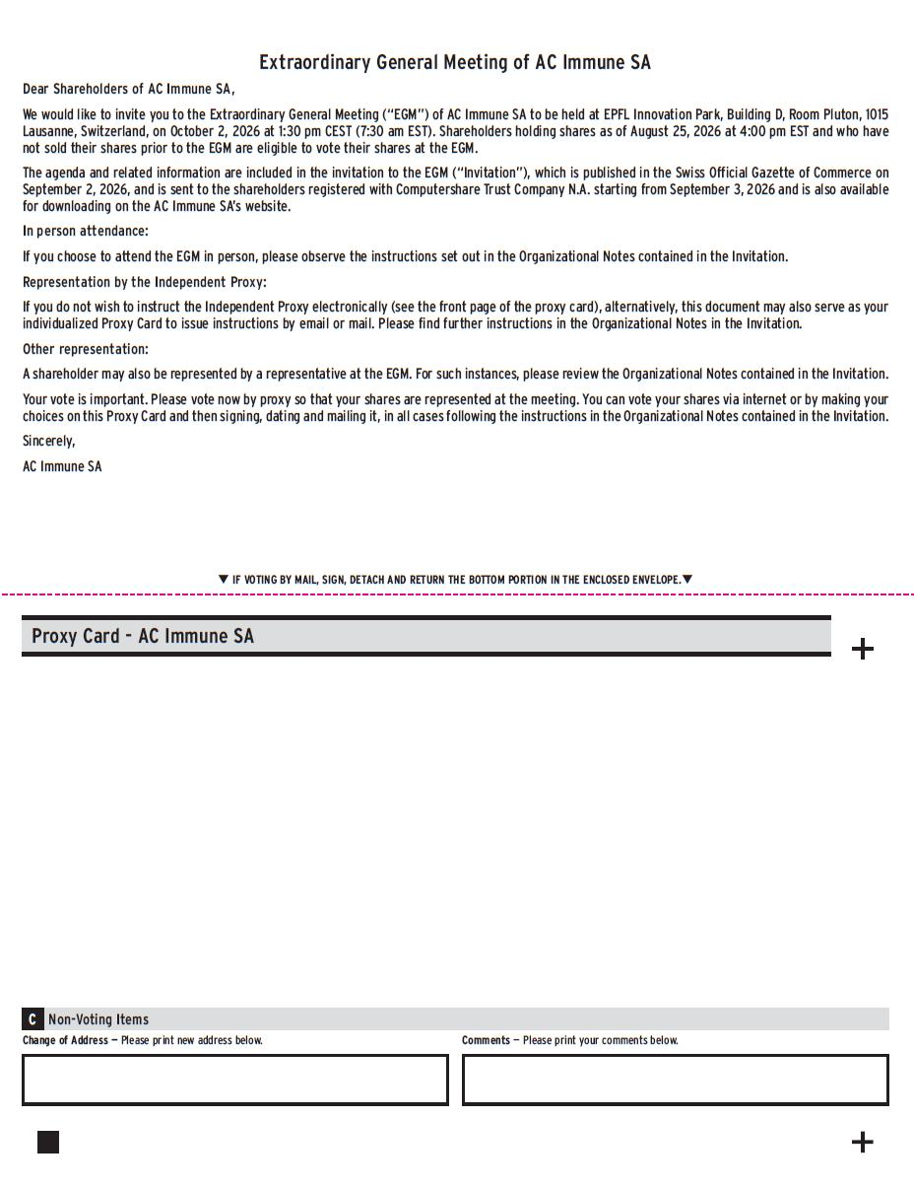
Proxy Card - AC Immune SA Non - Voting Items C T IF VOTING BY MAIL, SIGN, DETACH AND RETURN THE BOTTOM PORTION IN THE ENCLOSED ENVELOPE. T Change of Address — Please print new address below. Comments — Please print your comments below. Extraordinary General Meeting of AC Immune SA Dear Shareholders of AC Immune SA, We would like to invite you to the Extraordinary General Meeting (“EGM”) of AC Immune SA to be held at EPFL Innovation Park, Building D, Room Pluton, 1015 Lausanne, Switzerland, on October 2 , 2026 at 1 : 30 pm CEST ( 7 : 30 am EST) . Shareholders holding shares as of August 25 , 2026 at 4 : 00 pm EST and who have not sold their shares prior to the EGM are eligible to vote their shares at the EGM . The agenda and related information are included in the invitation to the EGM (“Invitation”), which is published in the Swiss Official Gazette of Commerce on September 2 , 2026 , and is sent to the shareholders registered with Computershare Trust Company N . A . starting from September 3 , 2026 and is also available for downloading on the AC Immune SA’s website . In person attendance: If you choose to attend the EGM in person, please observe the instructions set out in the Organizational Notes contained in the Invitation. Representation by the Independent Proxy: If you do not wish to instruct the Independent Proxy electronically (see the front page of the proxy card), alternatively, this document may also serve as your individualized Proxy Card to issue instructions by email or mail. Please find further instructions in the Organizational Notes in the Invitation. Other representation: A shareholder may also be represented by a representative at the EGM. For such instances, please review the Organizational Notes contained in the Invitation. Your vote is important. Please vote now by proxy so that your shares are represented at the meeting. You can vote your shares via internet or by making your choices on this Proxy Card and then signing, dating and mailing it, in all cases following the instructions in the Organizational Notes contained in the Invitation. Sincerely, AC Immune SA

Exhibit 99.3

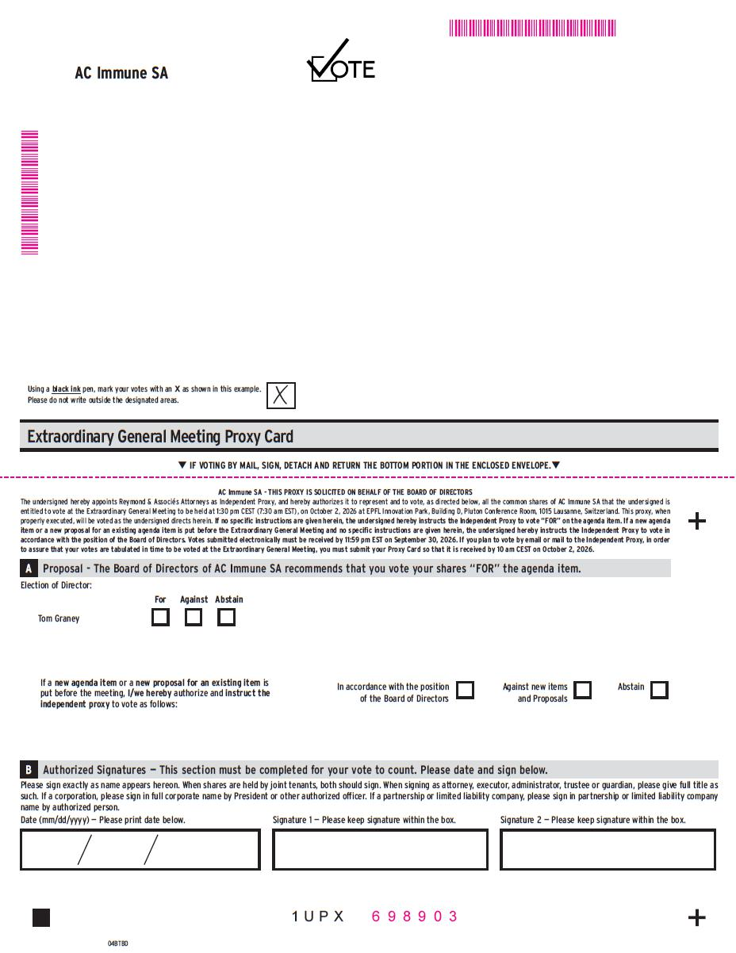
Tom Graney If a new agenda item or a new proposal for an existing item is put before the meeting, I/we hereby authorize and instruct the independent proxy to vote as follows : 1 U P X For Against Abstain In accordance with the position of the Board of Directors Against new items and Proposals Abstain AC Immune SA Proposal - The Board of Directors of AC Immune SA recommends that you vote your shares “FOR” the agenda item. A 04BTBD Election of Director: Please sign exactly as name appears hereon . When shares are held by joint tenants, both should sign . When signing as attorney, executor, administrator, trustee or guardian, please give full title as such . If a corporation, please sign in full corporate name by President or other authorized officer . If a partnership or limited liability company, please sign in partnership or limited liability company name by authorized person . Date (mm/dd/yyyy) — Please print date below . Signature 1 — Please keep signature within the box . Signature 2 — Please keep signature within the box . Authorized Signatures — This section must be completed for your vote to count. Please date and sign below. B Extraordinary General Meeting Proxy Card Using a black ink pen, mark your votes with an X as shown in this example. Please do not write outside the designated areas. T IF VOTING BY MAIL, SIGN, DETACH AND RETURN THE BOTTOM PORTION IN THE ENCLOSED ENVELOPE. T AC Immune SA - THIS PROXY IS SOLICITED ON BEHALF OF THE BOARD OF DIRECTORS The undersigned hereby appoints Reymond & Associés Attorneys as Independent Proxy, and hereby authorizes it to represent and to vote, as directed below, all the common shares of AC Immune SA that the undersigned is entitled to vote at the Extraordinary General Meeting to be held at 1 : 30 pm CEST ( 7 : 30 am EST), on October 2 , 2026 at EPFL Innovation Park, Building D, Pluton Conference Room, 1015 Lausanne, Switzerland . This proxy, when properly executed, will be voted as the undersigned directs herein . If no specific instructions are given herein, the undersigned hereby instructs the Independent Proxy to vote “FOR” on the agenda item . If a new agenda item or a new proposal for an existing agenda item is put before the Extraordinary General Meeting and no specific instructions are given herein, the undersigned hereby instructs the Independent Proxy to vote in accordance with the position of the Board of Directors . Votes submitted electronically must be received by 11 : 59 pm EST on September 30 , 2026 . If you plan to vote by email or mail to the Independent Proxy, in order to assure that your votes are tabulated in time to be voted at the Extraordinary General Meeting, you must submit your Proxy Card so that it is received by 10 am CEST on October 2 , 2026 . MMMMMMMMMMMM MMMMMMMMM 6 9 8 9 0 3

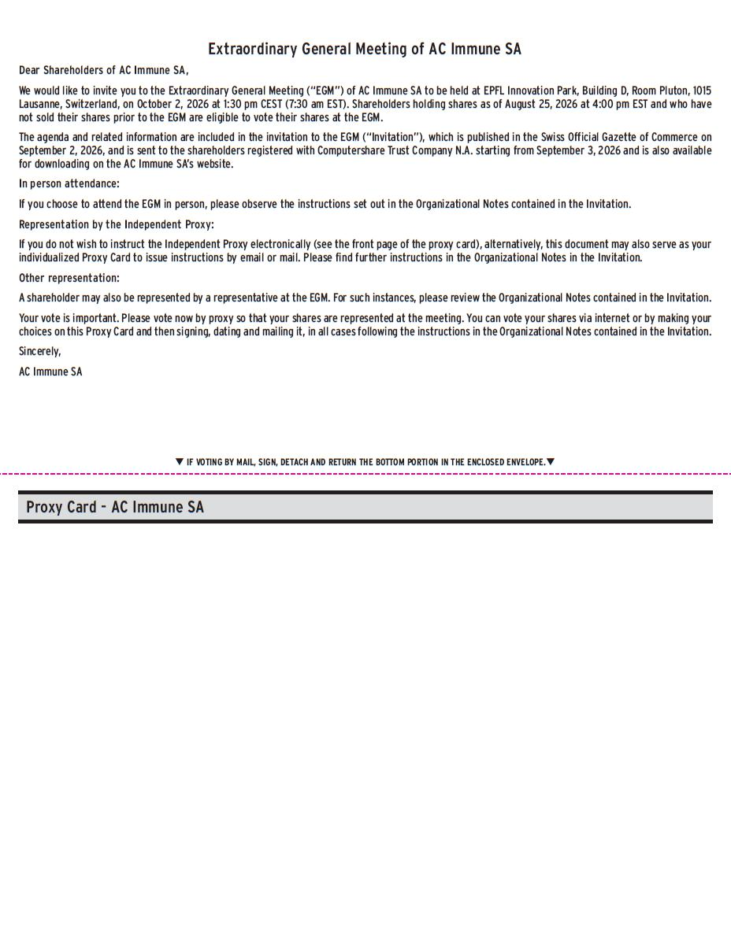
Proxy Card - AC Immune SA T IF VOTING BY MAIL, SIGN, DETACH AND RETURN THE BOTTOM PORTION IN THE ENCLOSED ENVELOPE. T Extraordinary General Meeting of AC Immune SA Dear Shareholders of AC Immune SA, We would like to invite you to the Extraordinary General Meeting (“EGM”) of AC Immune SA to be held at EPFL Innovation Park, Building D, Room Pluton, 1015 Lausanne, Switzerland, on October 2 , 2026 at 1 : 30 pm CEST ( 7 : 30 am EST) . Shareholders holding shares as of August 25 , 2026 at 4 : 00 pm EST and who have not sold their shares prior to the EGM are eligible to vote their shares at the EGM . The agenda and related information are included in the invitation to the EGM (“Invitation”), which is published in the Swiss Official Gazette of Commerce on September 2 , 2026 , and is sent to the shareholders registered with Computershare Trust Company N . A . starting from September 3 , 2026 and is also available for downloading on the AC Immune SA’s website . In person attendance: If you choose to attend the EGM in person, please observe the instructions set out in the Organizational Notes contained in the Invitation. Representation by the Independent Proxy: If you do not wish to instruct the Independent Proxy electronically (see the front page of the proxy card), alternatively, this document may also serve as your individualized Proxy Card to issue instructions by email or mail. Please find further instructions in the Organizational Notes in the Invitation. Other representation: A shareholder may also be represented by a representative at the EGM. For such instances, please review the Organizational Notes contained in the Invitation. Your vote is important. Please vote now by proxy so that your shares are represented at the meeting. You can vote your shares via internet or by making your choices on this Proxy Card and then signing, dating and mailing it, in all cases following the instructions in the Organizational Notes contained in the Invitation. Sincerely, AC Immune SA

